Historic Cleeve Prior
The ‘s on the route of this walk are to give you an idea of the activities and inhabitants to be found in Cleeve Prior during the 20th Century

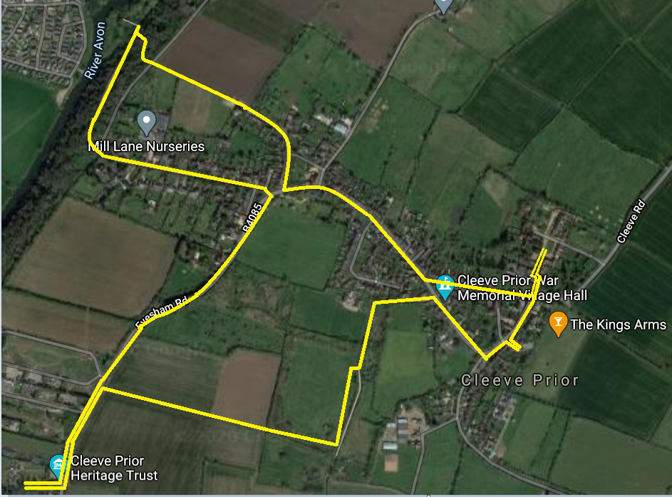

The Village
Cleeve Prior is an ancient village that until the coming of the railways, was totally isolated from the outside world. From census data we understand the following statistics
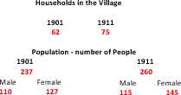

The structure and life of the village was very much determined by its isolation for the majority of the inhabitants. Kelly’s Directory gives an idea of the occupations of the upper classes in the village
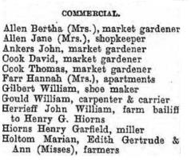
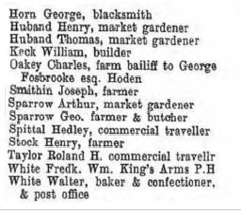

In order that the village could be self-sufficient it was reliant on the villagers to provide for themselves. We can see from the 1911 census, the following commercial trades & occupations
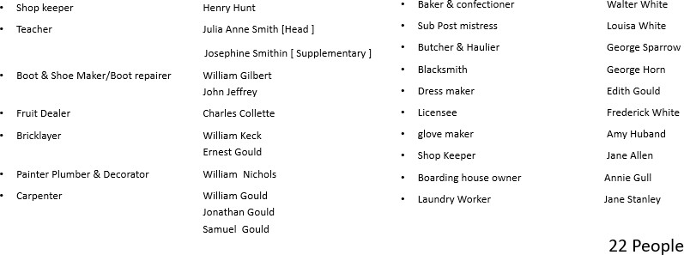

Apart from the above workers the majority were part of the agricultural economy. The 1911 census also lists the following occupations.
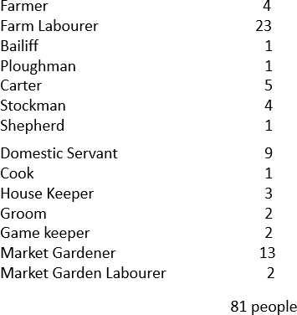
The agricultural workers in 1911 were working on 6 village farms & two in the hamlet of Hoden. The village farms were:

Bay Tree Farm Top Farm Kemises Farm The Laurels Home Farm Manor Farm
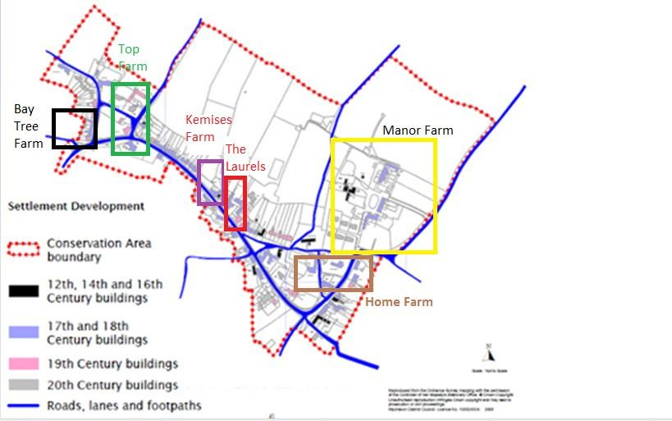

The farming economy was supported by The Mill on the River Avon
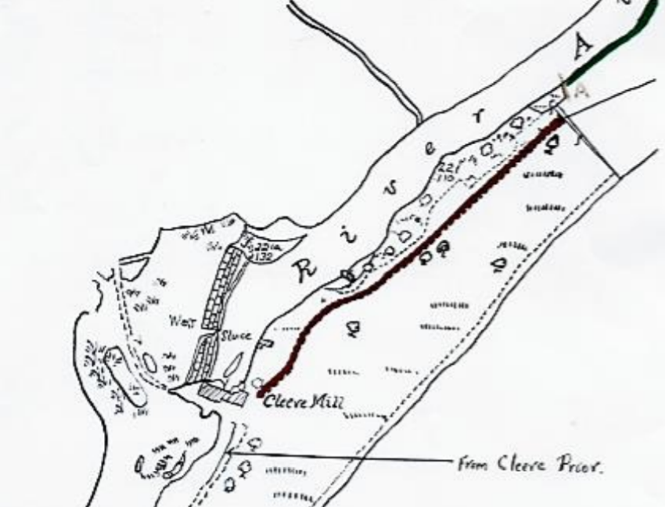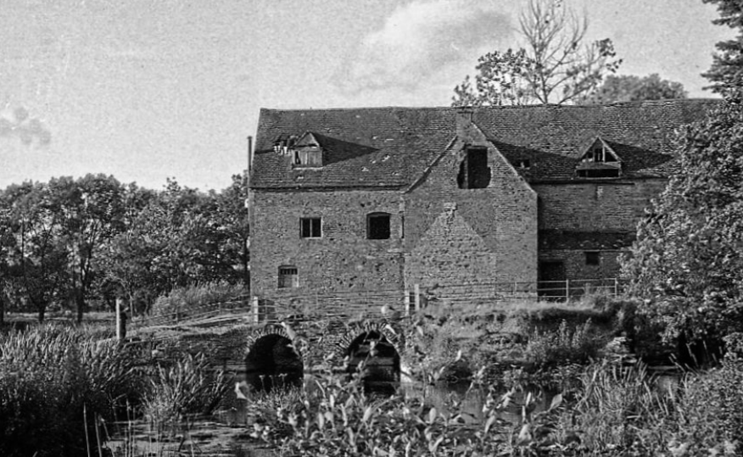

The mill was large, with two water wheels, and was located at the end of a stone Saxon weir. There was an old lock at the far end of the weir, to allow paddle cruisers and pleasure boats to pass down the river from Bidford. This can still be seen in the bank on the far side of the river. The weir was the means of crossing the river to the Salford Prior side of the river and to the railway at Salford Priors, along with the nearby Cleeve Prior Halt [as can be seen from the short clip of old video]

The history of the river, the mill and its association with the village can be found through the following link.
The economy was also supported by the quarry

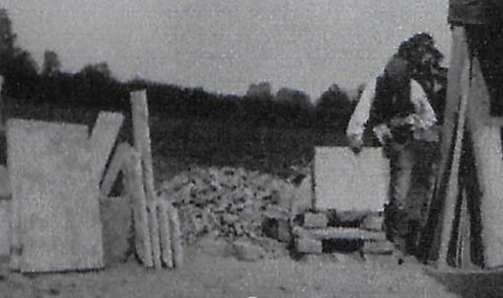
Stone mason cutting flagstones at the quarry

The quarry covered all the fields around the millennium green over to the Evesham Road. The quarry men would strip the top soil and excavate the stone by layer , tipping the rubbish into the previous hole covering it with topsoil.

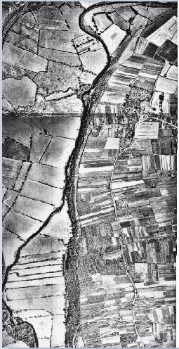
Market Gardening Strips in the Village

The Cleeve Prior Heritage Trust is an organization endeavoring to maintain the traditional Orchards in the Vale, and the public are free to walk around the orchards .

If you pass through the overflow carpark into the far orchard you will see a traditional Hovel or “Ovel” backing on to the road. These were sheds located at the end of the market garden plots, in which they kept their tools and even sometimes slept overnight.
Discovered when clearing scrub, the Trust, along with the Parish Council and Worcester County Council Archivists, have restored one of these “Ovels” along with its contents
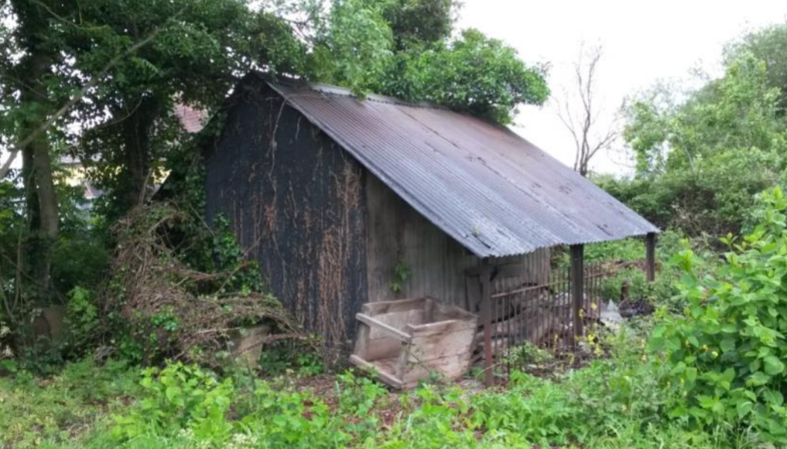
The Hovel When it was found

After the first world war and following the death of Mr. Hiorns at the Manor, all the land on the Evesham road was sold off in parcels, some was bought by individuals, but a large area was bought by Worcester County Council and was tuned into Market Garden strips. These were then rented to market gardeners who were returning from the Great War and who could not get Jobs. These strips were on both sides of the road and covered a vast area

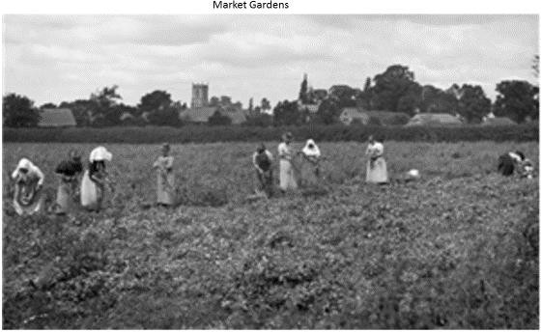
As we saw from the list of agricultural activities in the village, 15 of the workers in 1911 were occupied in market gardening. This was primarily taking place either side of the Evesham Rd going out to the Littleton’s, and we see below ladies picking peas on the fields opposite the Field Barn
Picture courtesy of Country Life Magazine

Thanks to relatives and local residents, we know a bit about the man who worked this strip of ground for nearly 50 years.
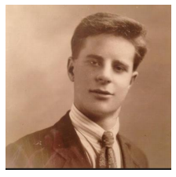
Born in the neighboring Littleton’s in 1905, Edgar Wheeler worked on the railway before becoming a fulltime market gardener. Whilst many growers rented their land, plots were increasingly sold off to individual gardeners and in 1946 Edgar purchased two narrow strips of market gardening land here in Cleeve Prior. Frank, his brother, worked the adjacent strip, although by all accounts the two brothers didn’t always get on. This hovel stands at the end of the southern plot, on which Edgar grew a wide range of crops, including cherries and asparagus. In order to protect his cherry trees from birds, Edgar sometimes slept in the hovel so he was there to scare them off at first light

Edgar Wheeler lived on East Side, North Littleton, and was a very strong Birmingham City supporter he lived with his Aunt Sarah and as Reg said he was “As honest as the day is long” He and his brother Frank were close and did a lot together but both Gillian and Reg confirmed that they fought like cat and dog. On one occasion Gillian remembered that Edgar asked Frank to go and buy some land while he was at work on the railway, but when he did not go, they ended up having a fist fight and one of them had their jaw broken. Gillian’s father would regularly come home and tell her that Frank and Edgar “were at it again”.

He bought his market garden strip on a 40 year lease from Chris Grey at the Manor in about the 40’s. The market gardening plots went all the way to the North Littleton Cross roads, and by this time most had been in their respective families for many years. Having bought the allotment he had about 2 acres on which he grew artichokes, onions, beans, sprouts, peas, asparagus, and wallflowers. Reg also confirmed that in the main the most important crop from the cross roads to Cleeve Prior was in fact fruit as this gave the best return. He recounts that when he was young, he had a seven-week holiday from Blackminster School, and he used to go and pick Pershore plums for the Hemmings. One year he managed to pick 7 tonnes in the holidays which earned him £146 “that was a lot of money for a kid”

Reg tells us that Littleton was famous for Asparagus due to the heavy clay salty soil. They used to treat the soil with salt or lime and on many occasions, they would take loads of soot which was brought out from Birmingham. They used to let this stand for a year before it was used. The hovels were made of tin and wood and were built individually by the gardeners themselves, they also used to line them with seed bags to keep them warmer.

Edgar and his gardening friends stuck together and would all meet together in one hovel at a lunch time to eat their bread and cheese, and to brag about who had the best produce. Gillian recounts how ever Sunday afternoon after dinner all the gardeners from Littleton and around used to walk line abreast down the Road to Cleeve, “As there were not many cars about in those days, where they went I do not know but in those days the pub would not be open,. One man called Stan, over the bank there, used to have a lot of men sitting around, and there was another man from middle Littleton a Gisborne used to cut the men’s hair in a shed along the road”

He seemed to trust every one and several times became the victim of some scams. One time he had a traveler come to decorate for him, and he took him to the bank and made him get out a cheque for over 700 pounds, all his money. When he told Reg, he rang the police and they tracked the man down and ripped up the cheque. He then borrowed some money from another Lady, which he knew he had to pay back, but she made him put her name on the deeds of his house, Reg had to get that taken off too, he was rather easily taken in. He was truly eccentric and one time took his stairs out of his house and put them up against an apple tree, he then used to use an ordinary ladder to go upstairs to bed. Photo of Edgar as a youth, long before he became a very eccentric bachelor! Photo of uncle Edgar as a youth, long before he became a very eccentric bachelor! Eventually he had to sell his house and move in to Durcott Lodge Home in Evesham. The house went up for auction, and they started the sale at £10 fortunately the bidding went on and it eventually sold for £27,000. He told Reg one time that he was impressed with the care home as he thought he had to pay them, but he said “ they pay, me look in that drawer” In the drawer was over £1500 . It transpired that he had the money in his pocket when he fell out of a tree and when he was taken to the hospital they gave it to the care home to return to him. He did not understand this, and thought the care home were paying him to live there. This was not the last time he was to fall out of a tree. Gillian tells how in the early 90’s he was again up a tree and he fell and had a heart attack. His friend Norman Willets put him in a wheel barrow and wheeled him to the ambulance on the road. She says that he did not last long after that and he died in 1993. “He was a bit eccentric, two pence short of a shilling, when we used to go round to North Littleton I will always remember him just stood in the doorway of his cottage, as he would reach the top, he never had much to say, he just grinned.” Evesham Journal archive Unfortunately football news reports don't say who the correspondent was, but Edgar does turn up as a club secretary in 1929 (reporting may have been part of this role) and he appears to have played for the team in October 1930. Both a B. Wheeler (probably the Benjamin Wheeler on the 1941 farm survey map) and L. Wheeler turn up too – they're not siblings or Edgar's father, so would be interesting to know how they were related. Interestingly, Edgar was caught riding a bike without lights in 1941, which suggests he might not have served during WWII. Market gardening was a reserved occupation over the age of 25, so he probably wasn't called up. This raises the question though of where his land was, as he's not on the 1941 farm survey map for Cleeve Prior or the north side of North Littleton

