Meeting of the trustees of the Cleeve Prior Millennium Green Trust
Date
Attendees
John Arkell Trustee
Brian Taylor Trustee

Ian Robinson
Clare Curry
Colin Greenwood
Gordon Davidson

- Formalisation of the existing trustees in the minute book for a further 4 years
- Appointing chairman
- Appointing new trustees for 4 years
  - Confirmation that they have received the Trust Document and there are no questions.
  - Confirmation that they have understood their responsibilities as trustees.
  - Sign the forms
- Statement on the running of the trust up to today.
- Agreement with the CPHT
  - The trust has been managed by CPHT in line with the 2007 agreement [ appendix1]
  - This covers insurance, maintenance and the claiming of all available grants
  - This agreement ran out 3 years ago

- Finances
  - The Trust has 4020 shares in an investment fund to generate an income to help maintain the land. In the published accounts this shows as £ 2.02 a share. On the current table, [ see above link] the share price is £2.74, which could see this investment as £11,015, if this holds
  - Review of payments made to CPHT
  - Review of income claimed by CPHT on Behalf of CPMGT
- Maintenance
Brian has kindly prepared a schedule of works required, and recognising the good work that the CPHT are doing we need to review.
  - How we can get a greater involvement of the community in to the maintenance of the area, ie work days
  - The schedule of works, how we execute them and priorities
- AOB
- Next Meeting /AGM in line with the trust

Appendix 1 -Accounts
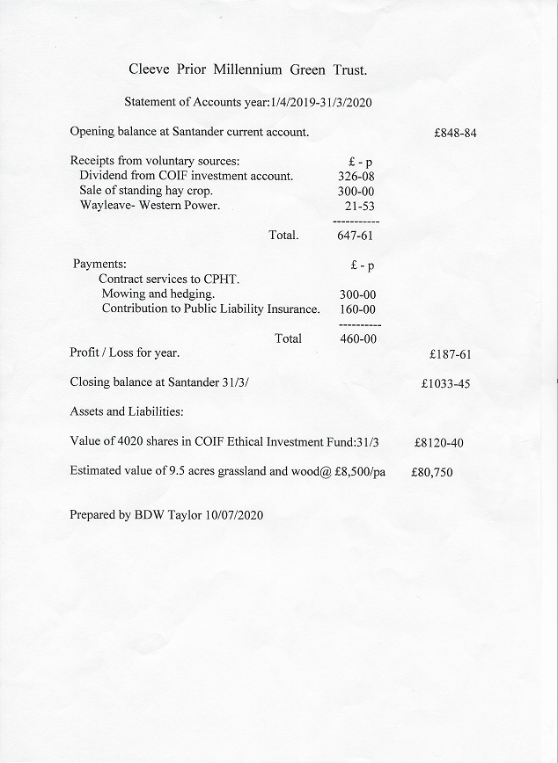

Appendix 2 - Schedule of Works
Priority | level | Description |  | Cleeve Prior Millennium Green Trust  Schedule of works for 2021
 | 5 | Urgent must be done
 | 4 | needs doing but will wait
 | 3 | Can be done if we have volunteers and funds
 | 2 | not that critical or important, can live without
 | 1 | should not be doing.
 | Item | Description | Date | Priority | Resource | Cost of priority | Cost | Comments
 | 1 | spray Lime Kiln and hedge margins with selective weed killer for Cow Parsley and Brambles. | Mar/Apr. | 3 | W.E. Work Party |  | £ 100 | weed killer
 | 2 | Trim hedges round gateways and style. | Mar/Apr. | 5 | W.E. Work Party
 | 3 | Remove Cow Parsley clumps from meadow. | Mar/Apr. | 2 | W.E. Work Party
 | 4 | Oil locks on gates. | Mar/Apr. | 5 | W.E. Work Party | £ 5 | £ 5 | oil
 | 5 | mow grass paths with Mid mounted Tractor mower. 3/5 times. | Summer: | 5 | JA
 | 6 | Strim weeds round gateways, style and benches. | Summer: | 5 | W.E. Work Party
 | 7 | Strim/ use Brush Buster on grass on Crescent Mound . 2 times. | Summer: | 4 | W.E. Work Party
 | 8 | Mow South Ride [alley] 2/3 times | Summer: | 5 | JA
 | 9 | Trim brambles/thorn encroaching on woodland paths . July. | Summer: | 5 | W.E. Work Party
 | 10 | Check hedges round gateways/style. | Autumn: | 5 | W.E. Work Party
 | 11 | Tractor flail edges of MG to reduce encroaching shrubs eg Blackthorn | Autumn: | 4 | JA
 | 12 | Dress paths and Gateways with woodchip. | Autumn: | 5 | W.E. Work Party
 | 13 | Arrange for Hedge trimming | Autumn: | 5 | MR | £ 120 | £ 120 | 1/2 day machine
 | 14 | Arrange for ditch clearance. | Autumn: | 3 | MR | £ 120 | £ 120 | 1/2 day machine
 | 15 | Organise working party to manage undergrowth in the woodland areas. | Autumn: | 2 | W.E. Work Party
 | 16
 | 17 | Paint benches, timber fencing, gates. | TBA | 3 | W.E. Work Party |  | £ 100 | treatment
 | 18 | Trim Yew bushes at entrance to MG. | TBA | 4 | W.E. Work Party
 | 19 | Manage regrowth of weed /shrubs in pond. | TBA | 2 | W.E. Work Party
 | 20 | Repair gates. | TBA | 5 | W.E. Work Party | £ 150 | £ 150 | Posts/ concrete
 | 21 | Cut back shrub growth round pond. | TBA | 2 | W.E. Work Party
 | 22 | Pollard willow trees on West edge of MG. | TBA | 3 | W.E. Work Party
 | 23 | Replace anti slip wire on Bridge and Style when needed. | TBA | 3 | W.E. Work Party |  | £ 10 | mesh/staples
 | 24 | Drainage of Paths by Lime Kiln and also the Pond area. |  | 3 | W.E. Work Party |  | £ 200 | 1/2 day machine gravel/?pipe
 | 25 | Drain area on path by the Yew Grove. |  | 3 | W.E. Work Party
 | 26 | Removal of Ash Tree stump on lime Kiln. |  | 3 | W.E. Work Party
 | 27 | Clear ditch on Quarry Lane and use spoil to reshape Crescent Mound for easier mowing/management. |  | 2 | W.E. Work Party |  | £ 120 | 1/2 day machine
 | 28 | Reseed Crescent Mound with creeping fescue grass mix for easier management. |  | 2 | W.E. Work Party |  | £ 50 | seed
 | 29 | Thin Alder Grove at South West corner. |  | 2 | W.E. Work Party
 | 30 | Take off metal gate at West corner and reshape. |  | 5 | W.E. Work Party
 |  |  |  |  |  | £ 395 | £ 975
Schedule 3 – Relevant Documents
- Deed of Trust
- Agreement with CPHT

