Evesham Abbey Trust

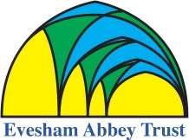

For educational use by
Schools participating in the project.

Produced by David Burnham
Creative Director Visionmix tv

Historical Talks 2020

Introduction - https://vimeo.com/497309241/88d90c12e6

The Abbey Site - https://vimeo.com/497311253/fdf4159881

The Almonry
https://vimeo.com/497317920/c23a19e34c

Bell Ringing - https://vimeo.com/497333370/3a48c0b764

The Battle of Evesham - https://vimeo.com/497334559/713d020155

