The Walk

The idea of this walk is to give you an idea of the activities and inhabitants of Cleeve Prior during the 20th Century

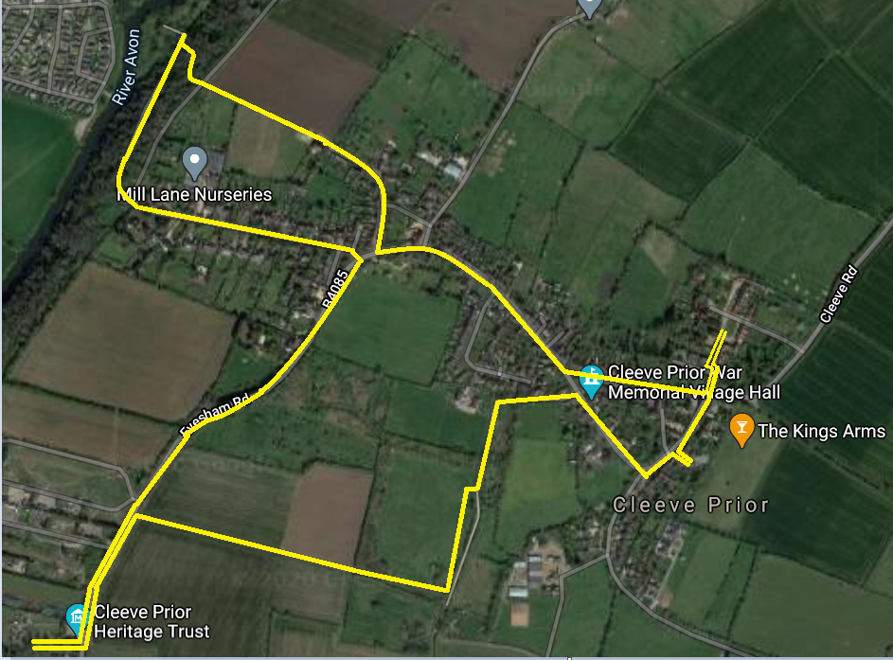

The Village
Cleeve Prior is an ancient village that until the coming of the railways, was totally isolated from the outside world. From census data we understand the following statistics
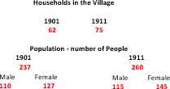

The structure and life of the village was very much determined by its isolation for the majority of the inhabitants. Kelly’s Directory gives an idea of the occupations of the upper classes in the village
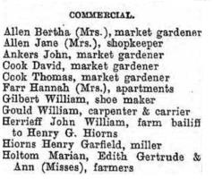
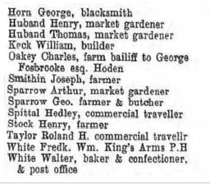

In order that the village could be self-sufficient it was reliant on the villagers to provide for themselves. We can see from the 1911 census, the following commercial trades & occupations
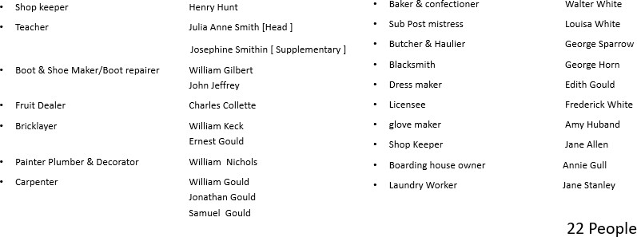

Apart from the above workers the majority were part of the agricultural economy. The 1911 census also lists the following occupations.
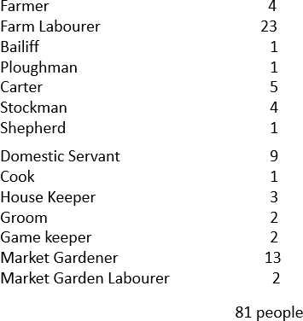
The agricultural workers in 1911 were working on 6 village farms & two in the hamlet of Hoden. The village farms were:

Bay Tree Farm Top Farm Kemises Farm The Laurels Home Farm Manor Farm
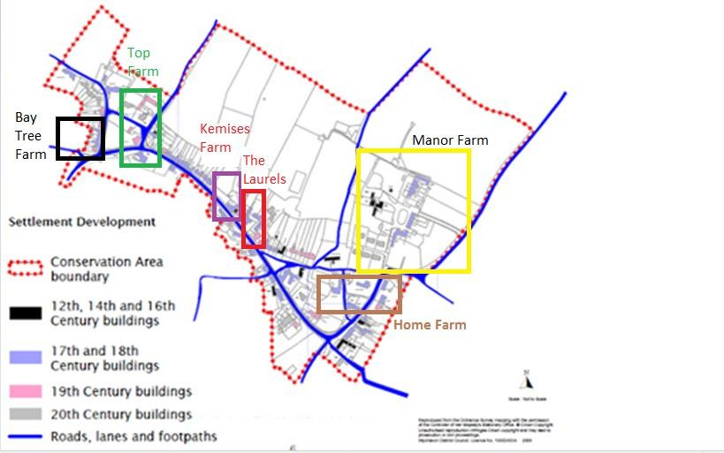

The Walk
As we walk out of The Kings Arms Car Park we turn left and walk to the end of Hoden Lane

The History
On the left, at the junction, we have Mill House which was the home of George Halford who
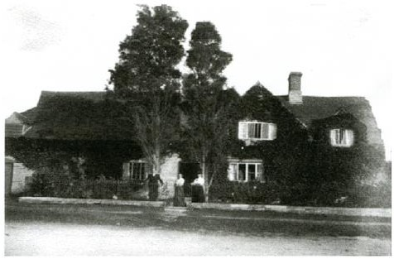
was the pioneer of orchestral concerts in Birmingham and was a renowned organist, sometimes playing in the Parish Church on Sundays. At Mill House he entertained famous musicians who used
to play with him in Birmingham, this included his friend Edwin Elgar. During the war years, 1914 – 18, they organized together a Red Cross fund raising concert in the Cleeve Prior Parish Church

Just past Mill House and the old garage in Hoden Lane was the Old Coach House comprising of three open fronted bays for carriages and two loose boxes. Mr. Gould, the wheelwright, who lived at a “Pile of Stones”, rented one of the loose boxes for his carpentry work, which included making coffins for the village & the surrounding areas.
He also had another workshop in part of the Cider Mill, next to the pub, where cider was still being made in the 1920’s by a horse pulling a large circular crushing stone round a trough filled with apples.

The Walk
Crossing Hoden lane and continuing along Main street we see on the left the school.

What is now the school field were the original village allotments which the village made over to the Church in order that the first village school could be built

The Walk
Moving up Main Street we reach the school
The History
Frank Vickeridge recalls:
“This was one large room divide by a curtain. Within the two sections the pupils were split into groups according to age. Children received their whole education here and left at fourteen. The building was heated by an old coke stove and so was very cold in winter.
Hands were washed under a cold tap in the coke store, and the elder children took it in turns to fetch a bucket of coke to keep the stove going. The lavatories were outside & were of the non-flush type. In the 20’s the teachers were miss Roberts & Miss White”

We presume the Miss White was one of the three daughters of Walter White, who was the Baker living o the green
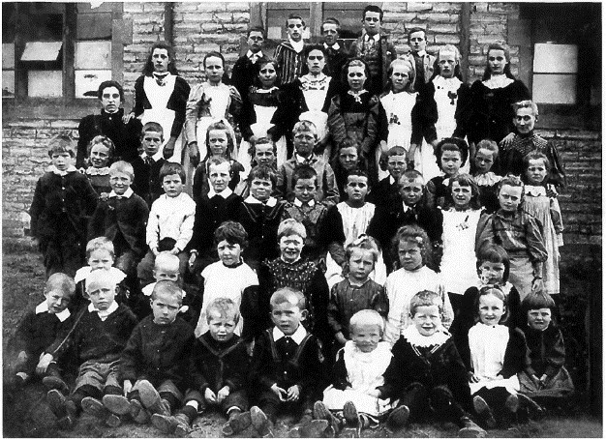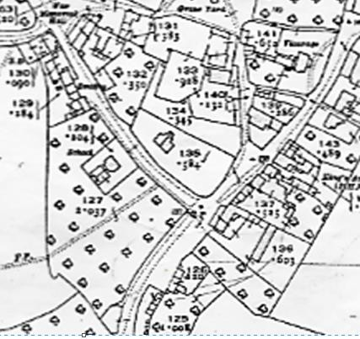

In 1858 the school had been established and the area of land below the footpath was allotments for
th
the villagers to grow their own produce, this was still the case throughout the early 20 Century.

The Walk
Past the old Smithy we reach Quarry Lane which led to the quarry.
Turn left, following the track round the bend and take the second opening on your right on to the Millennium Green. Follow the hedge past the mound that was the old lime kiln to the pond which was formed from the last hole dug by the quarry men. Just past the pond turn right and follow the hedge to the gate in the far corner which takes you across the farmers field to the Evesham Road

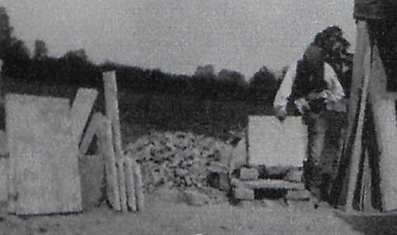
The History
Stone mason cutting flagstones at the quarry

The quarry covered all the fields around the millennium green over to the Evesham Road. The quarry men would strip the top soil and excavate the stone by layer , tipping the rubbish into the previous hole covering it with topsoil.

The Walk
On reaching the Evesham Road , turn left, walk past the first few council houses and Field Barn and cross the road and into the orchards of the Cleeve Prior Heritage Trust at the car park entrance.
The Trust was set up in the late 1900’s to preserve the old orchards, and the heritage of the vale .
The details of the Trust can be found on the above links.

The public are free to walk around the orchards and if you pass through the carpark into the far orchard you will see a traditional Hovel or “Ovel” backing on to the road. These were sheds located at the end of the market garden plots, in which they kept their tools and even sometimes slept overnight.
Discovered when clearing scrub, the Trust, along with the Parish Council and Worcester County Council Archivists, have restored one of these “Ovels” along with its contents
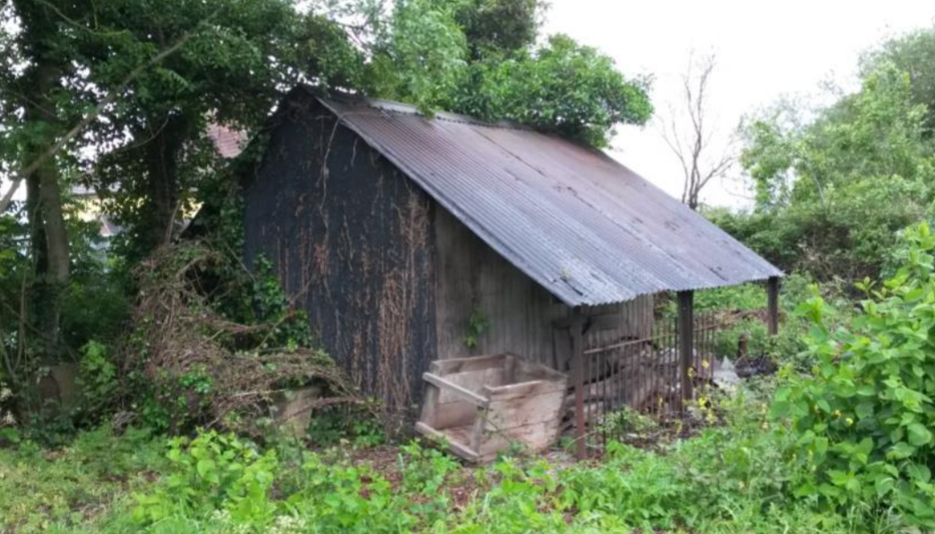
The Hovel When it was found

The History
After the first world war and following the death of Mr. Hiorns at the Manor, all the land on the Evesham road was sold off in parcels, some was bought by individuals, but a large area was bought by Worcester County Council and was tuned into Market Garden strips. These were then rented to market gardeners who were returning from the Great War and who could not get Jobs. These strips were on both sides of the road and covered a vast area
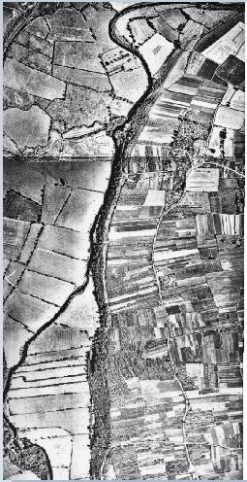
Market Gardening Strips in the Village
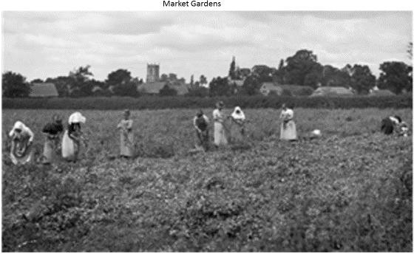
As we saw from the list of agricultural activities in the village, 15 of the workers in 1911 were occupied in market gardening. This was primarily taking place either side of the Evesham Rd going out to the Littleton’s, and we ee below ladies picking peas on the fields opposite the home in 1901.
Picture courtesy of Country Life Magazine
The Walk
Leave the Heritage Trust by crossing the road and following the footpath towards the village. The first house that we come to on the left-hand side, now behind gates and a large hedge, is Sunnyside, now known as Suncourt. This was the home of Miss Careless & Kate sheaf who owned & farmed Bay Tree Farm
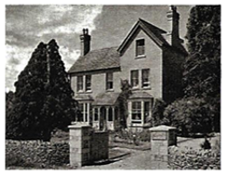
Sunnyside
This is followed by Bentley House, then owned by Leo Myers, which was subsequently turned into a women’s convalescent home. This is now two separate dwellings

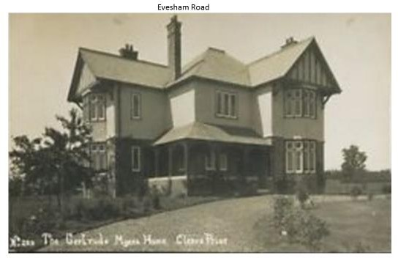
The History
Gertrude Myers Nursing Home

On March 15 1913, The British Journal of Nursing tells us
“A convalescent home at Cleeve Prior has been given to the Birmingham and Midland Hospital for Women by Ur. Leopold Myers, in memory of his wife, who was for many years an active member of the Women’s Hospital Committee. The gift consists of a beautiful house with 23 acres of land, and a well-stocked garden. The house is completely furnished, fitted
with electric light, and has cost upwards of £3,000. It has been called the ‘Gertrude Myers Home,” and a committee of eight members has been formed to manage it. It will be used for patients who have been inmates of the Women’s Hospital. Accommodation is provided for twelve patients, and it is estimated that the total annual cost of the upkeep will be under
£400. Mr. Myers and his friends have generously contributed in annual subscriptions nearly it
£200.”

The grounds of the nursing home spread all the way to Mill Lane and were used to grow food for the home. The land was subsequently sold off for housing in the 1960’s

The Walk
Continue your walk along the footpath to the junction of Mill Lane. On the, right down Mill Lane was a single pair of houses where the son and daughter of the Sheaf’s lived and worked Bay Tree Farm.

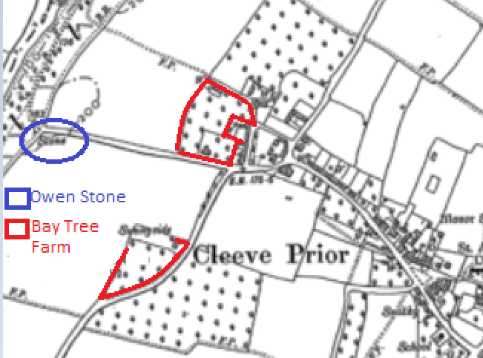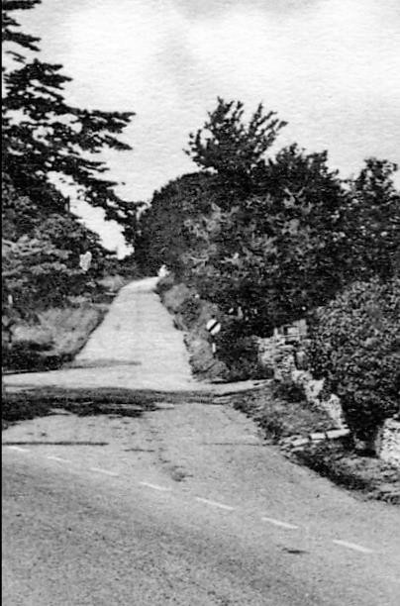
Bay Tree Farm - Link View down Mill Lane

The only other thing of note at the turn of the 20th century on Mill Lane was the Cherry orchard for top Farm. The picture above is the view back down the road from the junction with the main road.

Continue your Walk down Mill Lane, past Mill Lane Nurseries to the start of the descent to the river to the start of the conservation land on the left-hand side. If you walk through the gap and up to the right hand side you will find the Owen Stone. This is thought to be the base of an old saxon cross, with possible connections with the Battle of Evesham.

The History
Cleeve Prior was a crossing point prior to the Battle, used by Prince Edward who sent part of his army to the ford to ensure that “De Montfort’s” army did not escape along the south of the river and across at Cleeve to Kenilworth. Both forces eventually met at Greenhill and De Montfort's forces were crushed. There were many dead & wounded on both sides and some of the dead were reputedly buried near the Mill site. When the mill was demolished several skeletons were found which were presumed to be from this early battle, and these were reburied on the site of the Owen stone on the top of the Cleeve escarpment.
Unfortunately, it has been damaged by vandals, however it is the intention of the village to restore it in the near future.
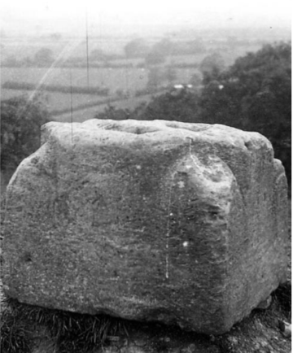

The Walk
Continue your walk down the hill to the site of the old Mill. The majority of the land by the river is owned by the Birmingham Anglers Association, who with village volunteers are working to maintain the area and the common land at the village wharf as an amenity for the village.

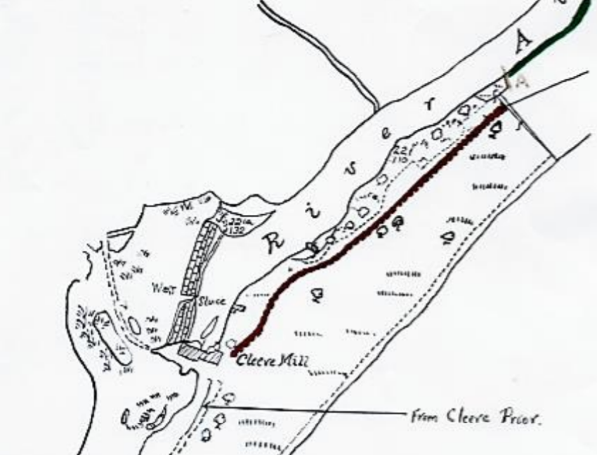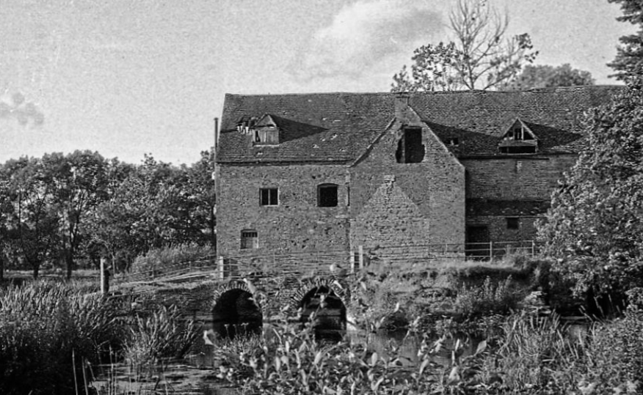

The History
The mill was large, with two water wheels, and was located at the end of a stone Saxon weir. There was an old lock at the far end of the weir, to allow paddle cruisers and pleasure boats to pass down the river from Bidford. This can still be seen in the bank on the far side of the river. The weir was the means of crossing the river to the Salford Prior side of the river and to the railway at Salford Priors, along with the nearby Cleeve Prior Halt [as can be seen from the short clip of old video]

The history of the river, the mill and its association with the village can be found through the following link.

The Walk

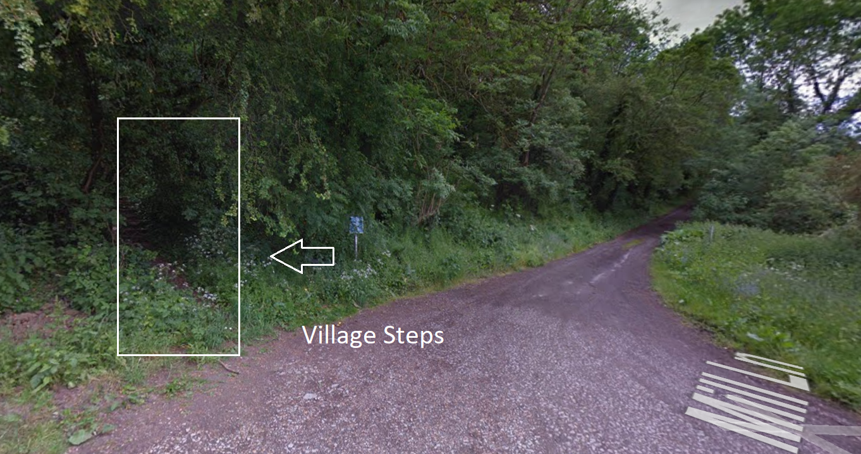

Leave the riverside up the village steps, following the path round until you reach the bridle path. Follow the path straight across and head back towards the village.

This route will bring you back in to the village down Nightingale Lane

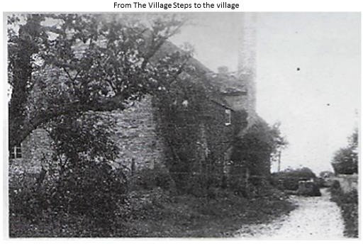
The History

The road was named after the six daughters of Charley Brooks who was a carter at Top Farm. They all lived in one of the small cottages that formed the building which is The Long House today. Charley was a character and he used to play the squeeze box and the girls who were called his nightingales used to sing at the socials in the village.

The Walk
From Nightingale Lane we move in to West End, and as we come to the main road we pass by the barns to Bay Tree Farm on our right hand side.

The History
On the1901/1911 census this was called Queen Street. The road is dominated by a fine Georgian building called, Upper House. As one of the most prestigious houses in the village it was owned by Louisa Newton who was an organist & played regularly in the church. She was born in Birmingham and by 1861 she was living in Cleeve Prior with her uncle & aunt, John & Louisa Rock, who by the 1891 census had passed away leaving her with Upper House and its lands. The Rock Family, the Smithin's of Top Farm, & The Bateman/Lunn Family had inter married over 200 years & by this time, owned or farmed a lot of the and in the village, not owned by The Manor. Just past Lydstep on the left was Priors Close, a shop in the early 1900’s, run by Mr. & Mrs. Howe
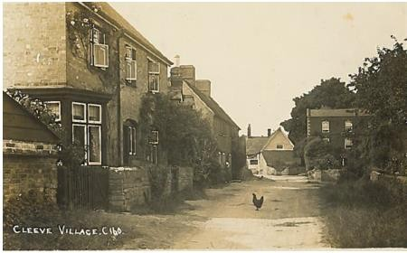

The Walk
Turning left down the main street we follow the line of the Garden wall to Cleeve Barn

The History
This is the site of one of the other old buildings in the village, Charlett’s House. Demolished in the 5o’s to widen the road, it had a strange history, for as long as anyone could remember, the old house had been vacant, and slowly falling apart. It was a fine example of a small, early seventeen century, English stone house, and even though works were carried out at the beginning of the 1900’s, no one lived there for 120 years . In 1903 it was owned by a Mrs Charles Lunn & the Lunns & Batemans lived there in previous years.
Charlett’s House
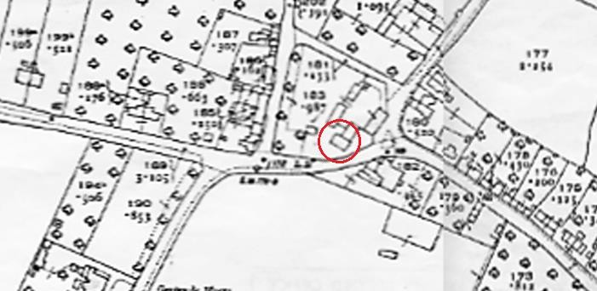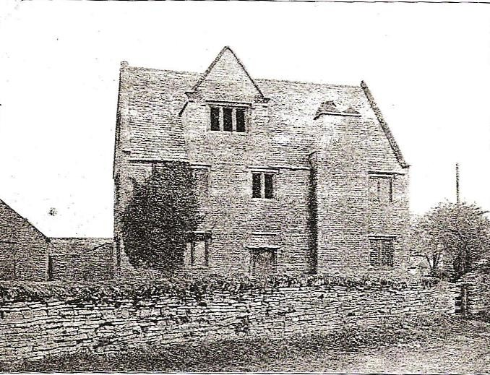
Location Map Audio Link
Over the road from Charlett’s House we had Top Farm, now called Prior House, which was run by the Smithin Family. The rest of the farm buildings comprised of Cleeve Barn & the dwellings and land on the left of Froglands Lane including “Top Farm”, which at this time were the old bull pens.
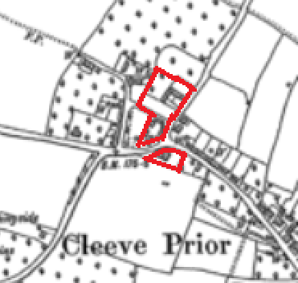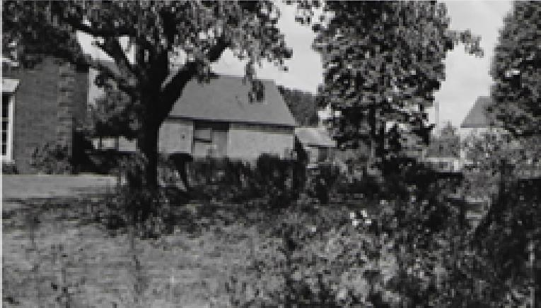
Top Farm
The Walk
Walking down the Main Street it is interesting to see the uninterrupted line of blue lias walls in front of each house. You pass “The Cottage” which was the home of William & Anne Keck, the bricklayer and builder. It is interesting that on the 1911 census, he has enlarged the house by one room, this was probably by the conversion of a lean to store on the end into a habitable room.

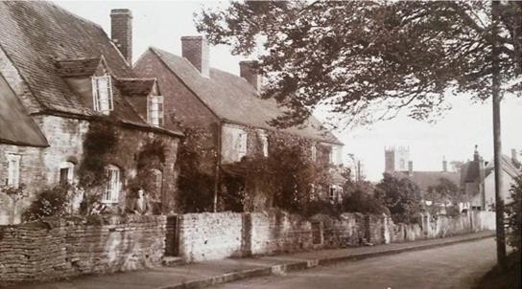

The entrance to the Close, was formerly the orchard to Top Farm on the opposite side was Kemises Farm

The History
In 1881 Kemises farm was being farmed by the Gair family but later became part of the Manor Farm There was a disaster in 1903, when Kemises farm burned down, when a spark from a threshing engine set fire to one of the corn ricks. Jack Stock tells how his father got up in the night and managed to put out a burning beam that threatened to burn down Miss Holtom’s House. Machines, ricks and buildings were destroyed
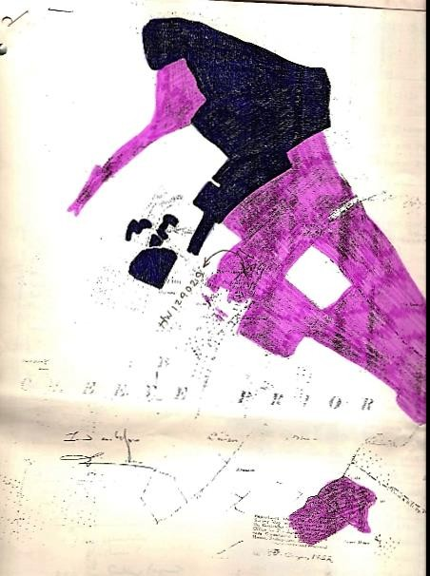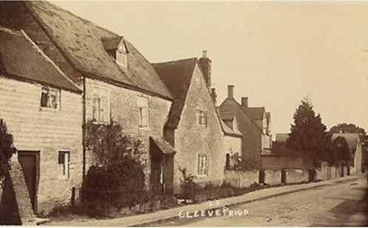

The black area on the plan below indicates the land that was Kemises farm, as indicated on the deeds from Cleeve Prior Manor, who bought the farm after the fire.

The Walk
Passing down Main Street the next large house on the left is The Laurels

The History

In 1800’s John Smith Holtom, married Anne Thomes, as the younger brother of William Holtom at the manor, he was the Miller. They had 4 daughters Marian, Edith, Gertrude & Anne, who we see as the owners of the Laurels at the turn of the century and along with it the stone quarries.
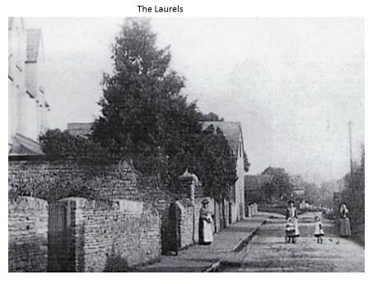

The Walk – Squirrel cottage to the green
Look to the opposite side of the road and you see squirrel cottage, which later in the 1900’s was to become a shop.

The History
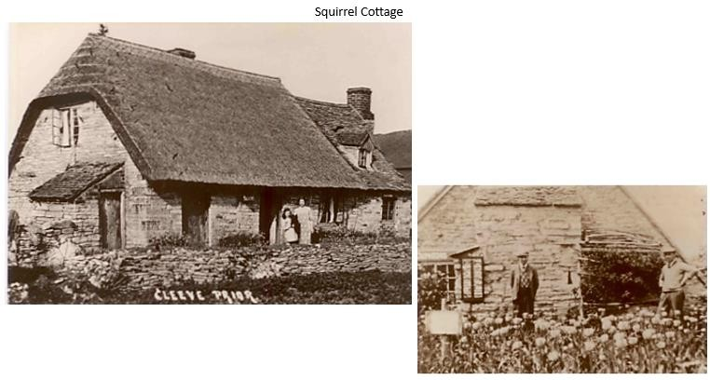

At the turn of the century there was a major footpath/ track which passed between Squirrel and “Pile of Stones”, which was eventually closed to enable the construction of the houses on The Close.
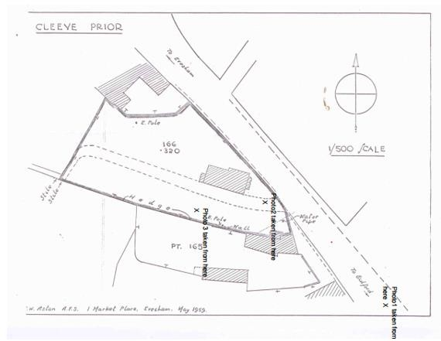
On the opposite side of the road was the old village shop & post office, which were owned by
Walter & Louisa White, Louisa being the Sub postmistress & Walter the Baker & confectioner. The bakery is now part of “Greens Cottage”, the current garage was the store & behind was located the bakery, with an entrance out to the rear of the shop. We can still see the village bread ovens in the cottage today.

The Old Post Office The Bakery
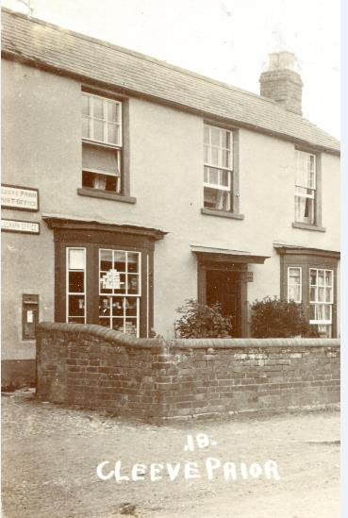
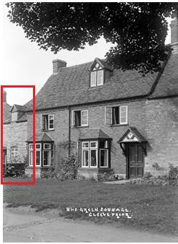

In the 1911 census we see a Mr. Thomas Mayer, 62, living at Annie Gull’s boarding house with her daughter Dorothy Gull, 29. Kelly’s directory also list Thomas Mayer as living at Orchard Cottage so we presume this was the boarding house. Thomas Mayer owned a factory in Birmingham & it was rumored that he was a millionaire. It was Thomas who gave half the funds £500 to enable the Malthouse to Peacock House to be turned in to the Memorial Village Hall.

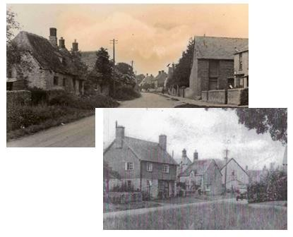
Orchard Cottage was originally the Cart shed to Peacock House. It was initially turned into a single storey cottage, before a later second storey was added. This can be seen in the photos below
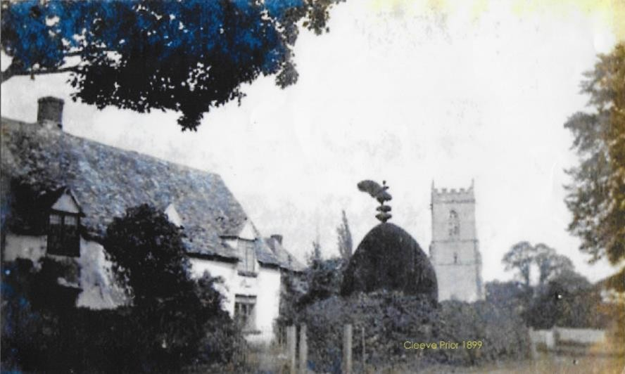

Peacock House

The other cottages around the green were all built for farm workers. Two cottages were knocked together to form Greens Cottage alongside Ashby Cottage & Nancot [now Candleberry Cottage]. Nancot was the home of the famous Newlyn Artist Edwin Harris, who died there in the village in 1906, although we are not sure whether he was here to paint or to recuperate from illness.
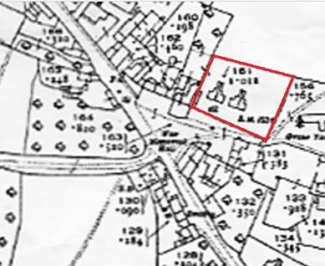
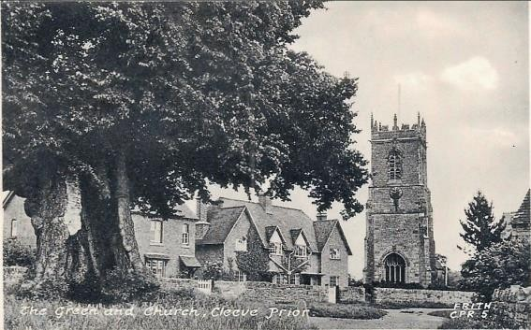

In 1901 there were only 4 cottages running up to the church, 1-4 the green, built by the Manor for their workers, it housed:
Samuel Hope shepherd Frederick Grafton Groom Gardener Charles White Carter
Charles Adams Waggoner on farm Opposite was fir tree corner again this was three cottages
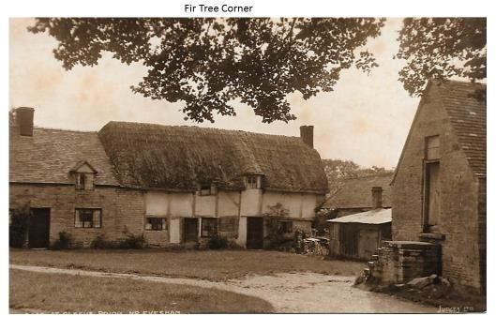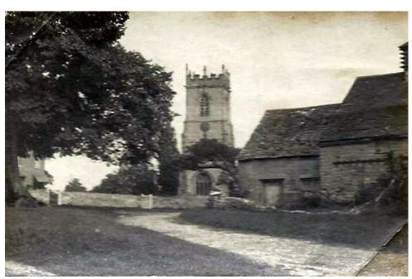
Fir Tree Corner

Backing on to Fir Tree Corner was the Malt House & the attached barn where George Sparrow butchered his meat

The Walk

Walk to the church and through the gate walking directly past the church and straight on through the churchyard

The History
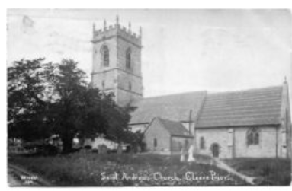
St Andrews Church -Link
The Parish name of Cleeve Prior comes from its close association with the Priors of Worcester Cathedral, the Prior & Chapter having been Lords of the Manor from the year 872, when Ethelred, elder brother of King Alfred, was king, until the Ecclesiastical Commissioners took their place and revenues in 1859. No doubt there was a church here in 872, and mention is made of the village priest in “The Doomsday Book” in 1086
The Walk
Leave the churchyard down the ginnel, to the Bidford Road. At the end of the path go down the steps and turn left and follow the drive and footpath in to the Manor
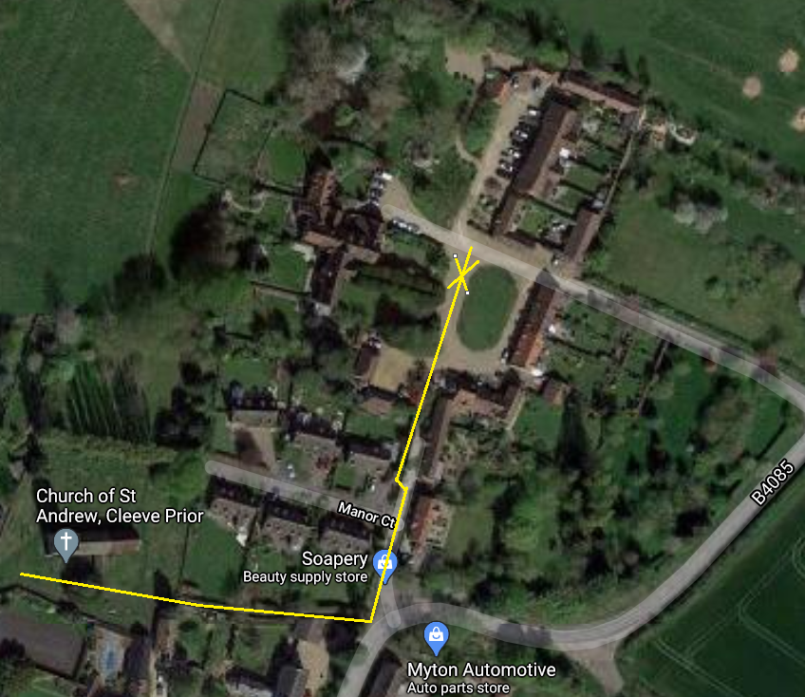

The History
At the end of the village is Cleeve Prior Manor originally owned by the Ecclesiastical Commissioners who sold it in 1917, to Henry Hiorns. Henry Hiorns married Julia, the daughter of William Fifield Holtom, who moved to the Manor in the 1830’s & was married to Juliana Thomes. They took over the Manor on the death of Julia's parents & remained there until Henrys death in 1921. Shortly after this Julia moved to Mill House where she died in 1945 at the age off 88.

-Cleeve Prior Manor-Pictures courtesy of Country Life Magazine
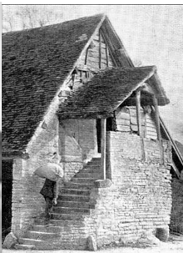
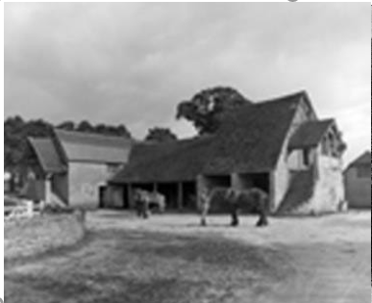
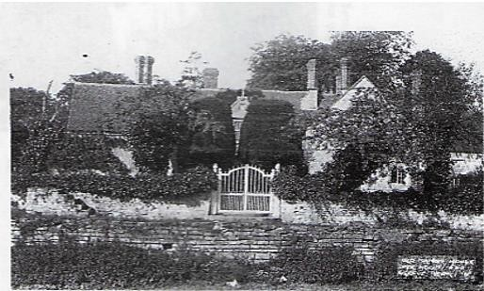
The Walk
Retrace your steps back out of the manor grounds, down the footpath to the main road. Being very careful of the traffic, cross over the road to the verge outside Sharrow. All the buildings at this side of the pub, with the exception of the two small cottages, which formed part of the Kings Arms, and the vicarage, were part of Home Farm

The History
Opposite the Kings Arms was Home farm. At the turn of the century owned by John Harris, a farmer from Inkberrow, he rented the farm to the Stock family. Home farm then included the barns opposite the pub and Sharrow. In 1904 he sold part of the farm yard to Clara Keen, the pub Landlady, for the construction of Lynwood.
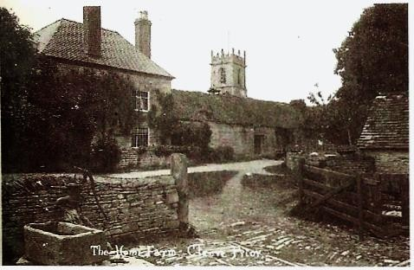

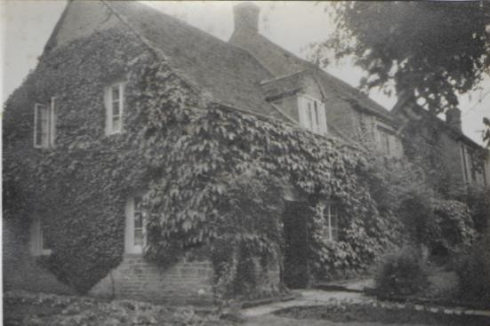
The Ankers Family tell us

“There was a huge tin and wood structure attached to the back wall of Sharrow, just inside the gates, and this was used to house the cart, trap, various bicycles, farm implements
and cradles for asparagus and loads of other items. The farmyard ran right across the back of Sharrow, out to the Bidford road (I believe the stable block can still be seen from the road. The cows were brought in either from Hoden Lane of Sett (or Dead) Furlong, which was at the end of Quarry Lane and milked in the stables, where the swallows returned each year. There was a chicken house (which included Bantams) pigsties, a harness and tack room and the trap house. There was a wood pile and a midden, all hidden behind Lynwood, and ducks and geese in the orchard to the right on the house a lovely place for a child. ”

th
On the 8 December 1864 the Ecclesiastical Commissioners records indicate that the premises at
that the two cottages, The Den & Huband Cottage, were indentured or contracted to Thomas Bissel, Charles Silvester & Richard keen are subsequently sold to Richard keen along with the Kings Arms. On his death he left the two cottages to his elder daughter, Anne Huband, & The Pub to his younger, Clara Keen. Clara subsequently ran the pub & then sold it with” The Den” to Fred White, the brother of Walter the Baker
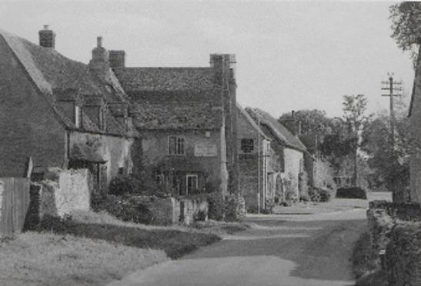
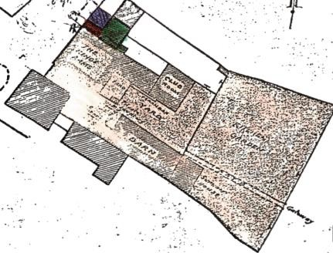
The Walk

You are now back at the Kings Arms; we hope you have enjoyed your walk. Please go into the pub and enjoy their fine food.

Should you wish to know more about the history of Cleeve Prior and its people there please go to the Cleeve Prior Chroniclers web site

