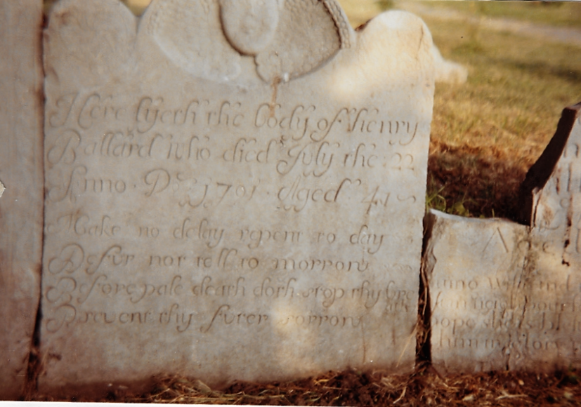

Introduction
The Chroniclers were very grateful to recently receive a box of old archive documents from Elizabeth Newman who in the 1980’s lived in Prior House. Amongst these was a project carried out by her 10 year old son, Oliver, in 1983, to document the gravestones in the church yard along with their inscriptions.
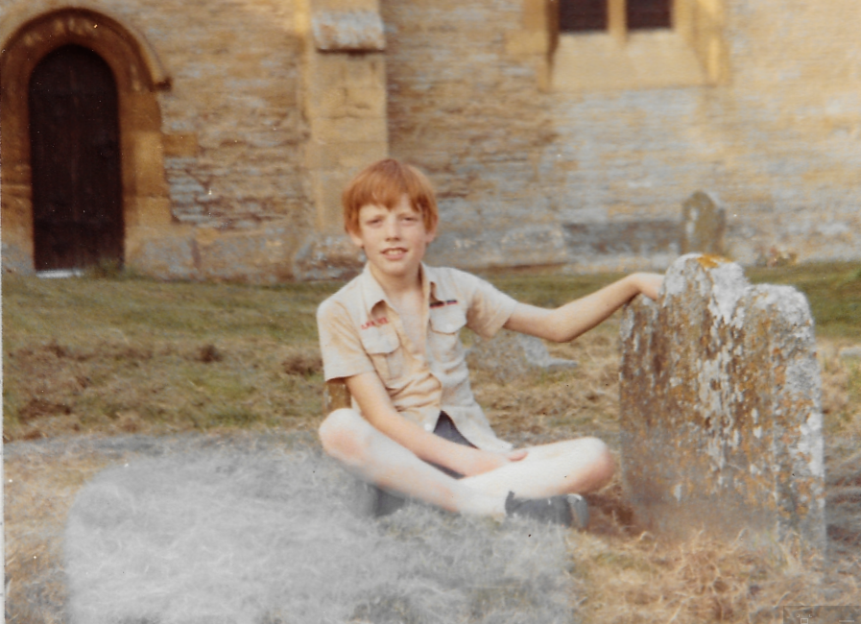
This document has been transcribed as it was prepared, the only change made by the chronicler was to list the names in alphabetical order, to allow them to be quickly referred to through the use of the navigation page, which can be switched on in the “view” tab.
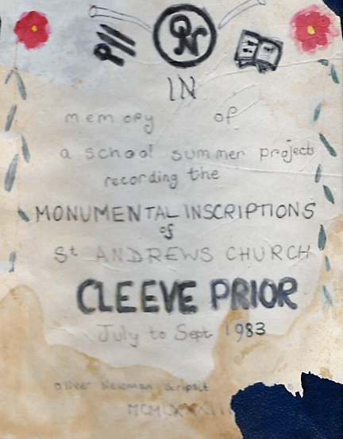
Last year when I was counting the poplar trees in the churchyard, my friend Juliet was reading the tombstones out. We thought it would be interesting to write them all down
The old ones were made of Cleeve stone, like our house, and it’s quite soft. The weather and pollution are rotting them away. Each year they are worse and the writing is disappearing

I found a plan made by an architect, of the church yard, and I copied out a list of names and plot numbers4I asked the vicar for permission, and I wrote to the Bishop of Worcester to see if he keeps lists of inscriptions. Then I found out a society wanted the work done for genealogists, I also wrote to them for advice. I have seen genealogists working at the Worcester County Records Office, so I know that they would find a list of inscriptions useful, especially in a few years. Some of our tombstones are vandalised now and we shall never know what was on them.
The recording took a long time because there is a lot of writing on gravestones. I did one area at a time and left the oldest part till last as they were the hardest to see. I knew that there were famous monumental masons in this village and the surrounding ones. I hoped to find their names on the older stones, on the bottom left side, so I was very excited to find Ballard- Aldington carved on one I recorded.
The Church 1930 photograph

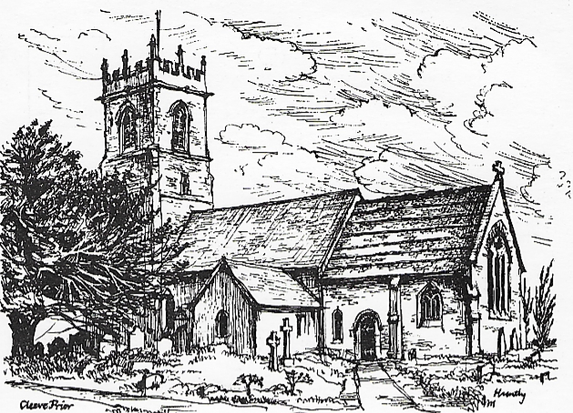
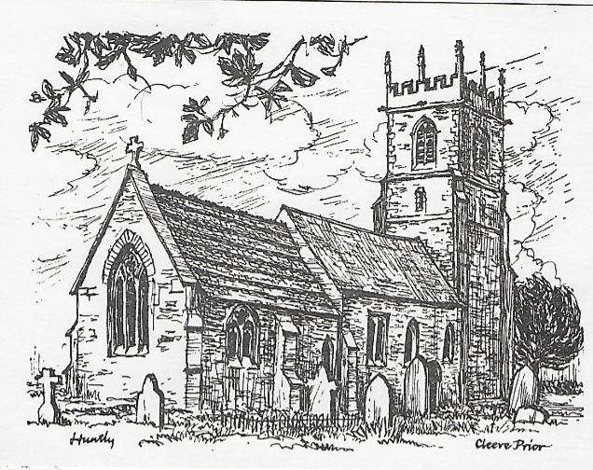

The Church in 1904
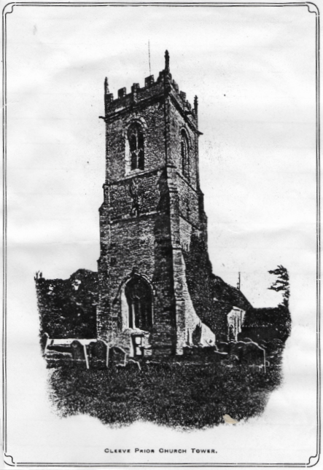
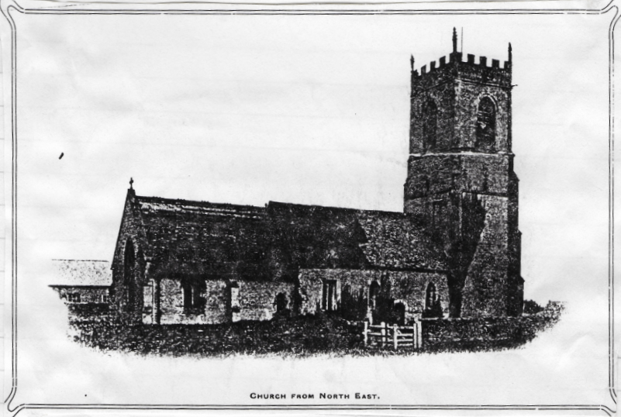
1904 Photographs

The Cleeve burial ground was consecrated on 10th October 1315

They Raised funds for the restoration of the Church

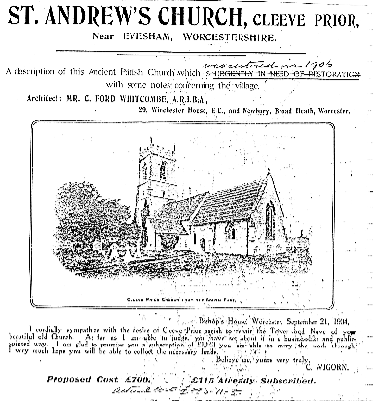
Chroniclers Note:
The writing at the bottom says that the actual cost of the restoration was £883-11s-8d

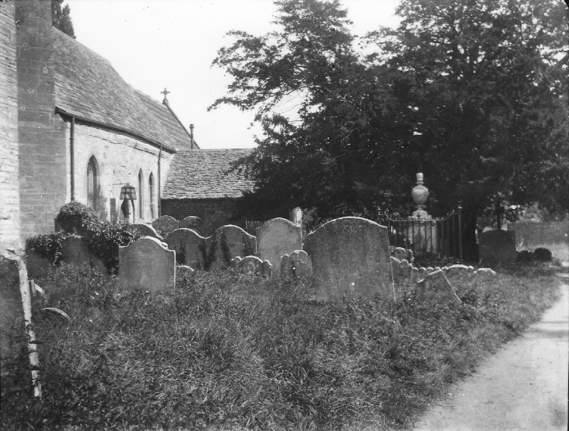
1911 Photograph
The Monument inside the railings is now a few flat slabs. I cleared away the ivy and elderberry from it, but there was no inscription to be seen. Nobody seemed to know what it was.
Mrs Baylis gave me a 1911 photograph which showed it intact, she said it was there 30 years ago. I went to see Mr Eric Wheeler of Marlcliffe, who is about 80 and was church warden years ago.
He said it was the Laughton family tomb and there was a vault under it. When he was young he had put a rod down and could not find the bottom. I had wondered where the vault was as it mentioned one on the Thomas Laughton Tablet in the church
The Cost of an engraved Tombstone
“Ye 12 Dec^{r} 1781 pd Mr Laughton for Mrs Lanes gravestone £4-4s-0d”
This is shown in the accounts of Mr Fermor, Lord of the Manor of Childswickham
It is in the churchyard at Childswickham and says:
“Sacred to the memory of
Mary Lane who departed
this life Oct 12 1741
aged 33 years”

[Why is it 40 years late being paid?]

Today’s Cost
I visited the monumental masons in Stratford –upon- Avon and they said a similar stone today would be £1000 or more and would take 2 weeks of carving
Not all memorials were of stone below is a rubbing of a wooden tomb
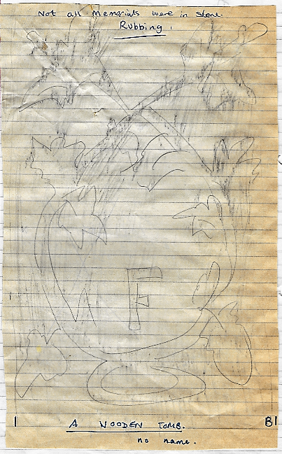
The Cleeve Prior Masons
I found the names of Ballard [of Aldington and Littleton], Thomas Laughton and Davis [Bidford] on the older stones. The oldest one [earlier than 1740] are deep in the ground and I cannot dig to find a sculptors signature on most. They are usually signed at the bottom on the left
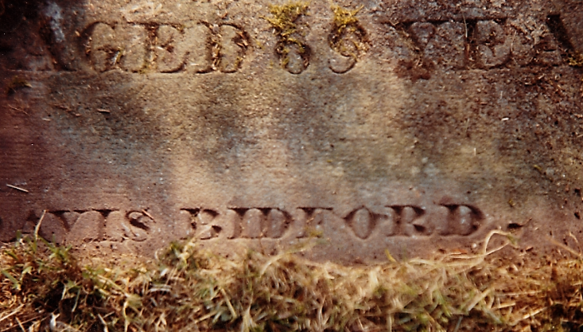
I know Michael Campden was a monumental Mason because his tombstone says so, and his tools are carved around it. It is under the Yew tree by the church door, but has been vandalised, 1738.
Mummy and I found an inventory at the CRO last year of Richard Squire and it says he was a mason and well off.
I went to St Helens, the County record office in Worcester, to look to see how many masons were recorded on the 1841 and 1851 census. They were on Microfilm and I had to put them in to a special viewer. It was fun using it to read them.
In 1841 - I found 7
S Aston Stonemason
Joseph Nicholls Stonemason
Thomas Moore Stonemason
Charles Hemming Mason
………Marriott Mason
………. Hubert Stonemason
William Vickeridge Stonemason
In 1851 – I found only 3
Thomas Moore Stonemason
Charles Hemming, 42 Parish Clerk Mason
George Hemming Mason

Chroniclers Notes:
A stonemason is one who works in stone while mason is one whose occupation is to build with stone or brick; also, one who prepares stone for building purposes.
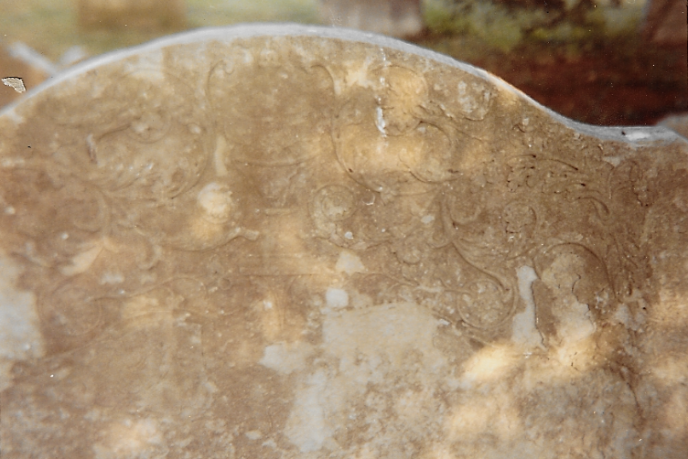

Laughton Stone
In both case Thomas Laughton was shown as a farmer with 123 acres, employing 4 men & 7 boys. Thomas Laughton [ I ] died in 1824 and left a will as did Thomas Laughton [ II ] in 1853.
Michael Campden also left a will in 1742 but he is shown as a resident of North & Middle Littleton.

The Laughton family first appeared in the registers in 1613.Thomas Laughton was the last member, and when he died he left his lands to his sister, Mrs Smith of Ailston. [Near Atherstone on Stour]

R.F.Tomes in 1901 said that the Laughton and other masons in the area were influenced by the designs of John and Robert Adam [1728 – 1784], who provided designs for cornices chimney pieces etc. for a house for Thomas bennet in South Littleton. He calls Charles Oldacres stone the best design.

In Bidford Church is a wall tablet to Slatter of Bickmarsh, it is signed at the bottom.
Thos. Laughton Cleeve Sculptor
One other similar is not signed but the others in there have Davis-Bidford on them.
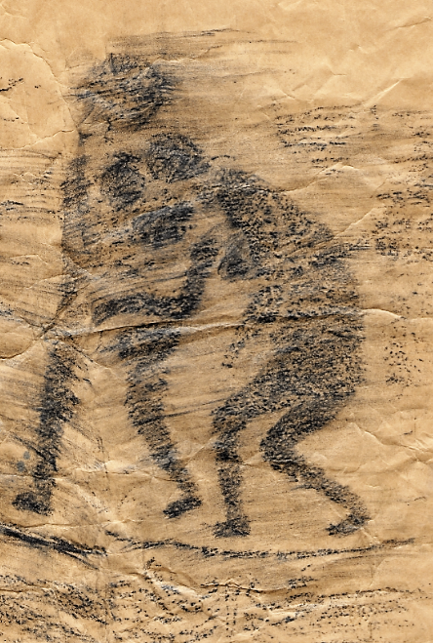
This rubbing above was done by Mr Wheeler some years ago. It shows the expulsion of Adam and Eve from Paradise [Canon J.E.H.Blake 1925 article], it is on the top of the now vandalised stone to Elizabeth Melen,
She was buried on February 6th 1793 and the very next day her husband, Thomas, who was the tenant of the Manor and churchwarden, married a lady from North Littleton called Margaret Brookes!
He then moved to her house.

A Laughton Stone
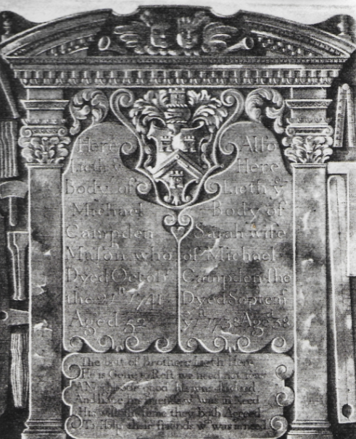
Made by John Laughton of Cleeve. It is 51” x 42” and shows his masonstools.it is under the yew tree and now vandalised

The Tombstone of Michael Campden, Mason 1741
A Masons Will
Richard Squire was a mason too. His will and inventory of his goods is in the Worcester CRO. I found it by accident when mummy was looking for something else.
He died in 1687, and left £40 to each of his daughters, Martha, Margaret, Hannah and his son Thomas

Inventory
One ffat pig - £ 1 – 17 – 00
All in rooms by old barn and in close
All in stone and slat att the quarry and at the house barn £12 - 0 - 00
All in att the lime kiln £13 - 0 - 00
Half a flitch of bacon 5/-
All in house £ 3 - 0 - 00
Wearing apparel and money in purse £ 4 - 0 - 00
In all many implements of house and hall not herin appraised 10/8
---------------
£57 - 10 - 08
Witnessed: Anthony Philiper
Richard Charlett
In Hall
Wood table and wood joined stools, 4 chairs, 1 skilit, a fine shovel and a tongue …..
Lower Chamber
Brass pole and warming pan, Skillet and brass ladle, 3 coffers, 1 chest one cupboard, 6 barrels, feather bed.
Meal House,
Loft Chamber,: feather bed, green chair, carpet, 2 cupboards
Little Chamber: 1 Flocked bed half headed bedstead, 4 bolsters, 3 pillows, 2 coffers and 1 cupboard
In Room over the Hall
Lyner cloth, lyner yarn, one coffer, half headed bedstead, flock bed & blanket
In the Shoppe
[Missing]
The Tombstone is small and plain in thick Cleeve stone.
The Stone Trade
Many Cleeve men have worked in stone, some of them to leave fine pieces of work in village churchyards throughout the area. There was also a good trade in rough stone for roads, the Vestry meeting Highway Surveyor each year was instructed to negotiate a rate for the carriage of this stone. In 1848 they used stone from Brodway Piece – now the left hand side of Mill Lane Lime and building stone was also sold (Eli Ankers said the lime kiln in Quarry Lane was last used in 1908 )
Free stone could be collected from Stone Close and most houses are not made of dressed stone, a noteable exception being the Vickerage.
Many houses still possess flagged floors, a bind to polish, and some stone mantelpieces and fireplaces, polished up the Cleeve Stone looks like dark grey marble. These slabs were cut from the quarry near to the present sewerage farm and took 3 to 4 hours each to dress.

.
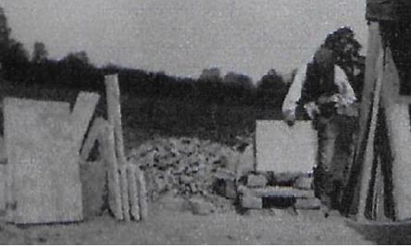
Quarryman Vickeridge dressing stone
In the graveyard is a carved tombstone to Michael Campden, mason and his wife, showing the tools of his trade. The Laughton’s were stonemasons here living at Peacock House at the time of the enclosure, and also in Littleton, where a beautiful stone with tools on, is preserved in the church at South, [1754].
John & Thomas Laughton [buried in Cleeve] have tombstones with their marks on all over the area, [bottom L.H. corner]. It seems likely that the stone was transported by river as it crops up in place like Fladbury.
Miss Holtom’s [Laurels] farmed the Quarry Land,
“ It was agreed no further stone should be lifted and delivered to the Highway that not been previously bought by the Surveyor. The price for drawing the materials should be 8/- for 3 horses and 1 cart, and 10/- for 4 horses and 2 carts, and all labourers employed should be paid at the average wage of the time”
Previously the Highway Surveyor had the right to enter any land to collect stone, but not gardens or orchards.

The Correspondence with the Projects Sponsoring bodies
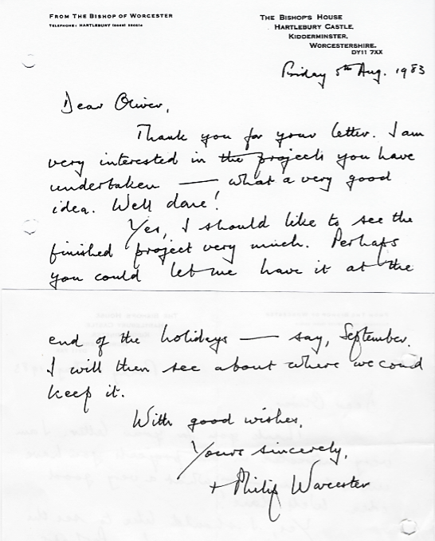
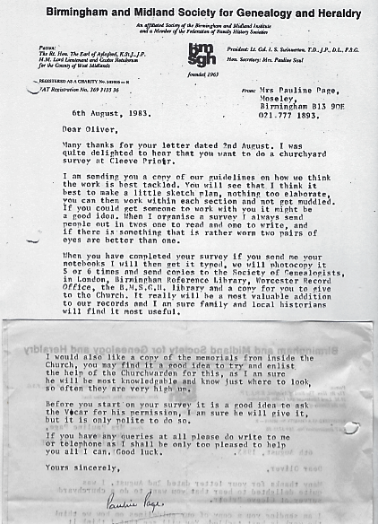
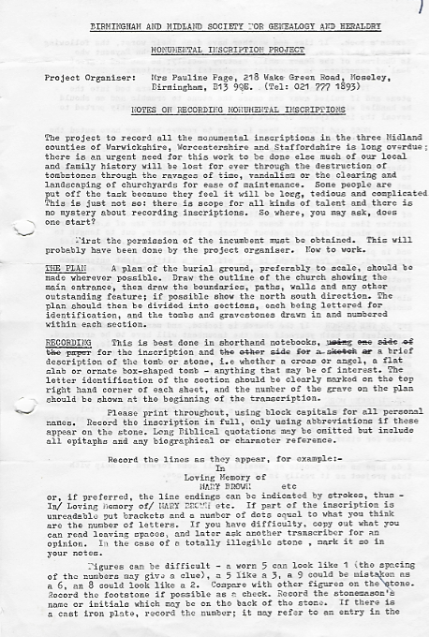
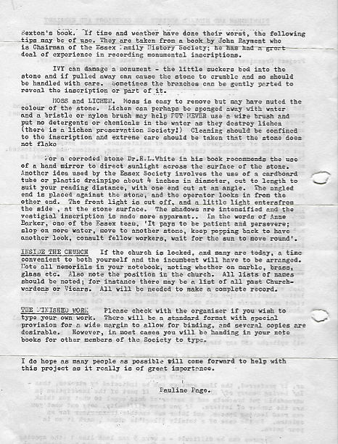

Layout of the Graveyard
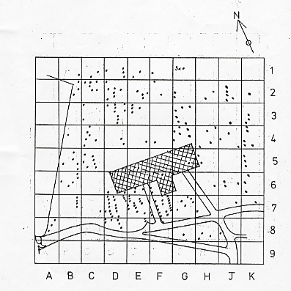

NAME Grave position

Adkins Thomas & Sarah H5
Sited by T.Laughton- Cherub flying, deeply sculpted cleeve stone with flowered border

Sacred
In memory of
Thomas Adkins
Son of………..
…………………..
Of this place 1843
[and wife Sarah 1876]

Ankers Richard John & Esther H6

In loving memory of
Richard John Ankers
Died June 25th 1923
aged 39 years
and his beloved wife
Esther Elizabeth
Died October 10th 1956 aged 69 years

“Abide with me fast falls the eventide;
The darkness deepens;
Lord, with me abide”

Archer Elsie Elizabeth D4

In
Loving memory of
Elsie Elizabeth Archer
1890 – 1975

Archer Mary Elizabeth D4
In loving memory of
Molly
Mary Elizabeth Archer
Died Feb 14th 1971

Archer Herbert Edwin D4
Top
In Loving memory of
LHS
Herbert Edwin Archer died April 7th 1934
RHS
“Rest in Peace”

Badham Susana H4
In loving memory
Susana Badham
Who died 19th of February 1783
Aged 89

Baldock Albert Hardwick B6

LHS
In memory of Albert Hardwick Baldock who died Oct 2nd 1922 aged 27
RHS
Of the Rifle Brigade 1914-18

Ballard…………? F8
……….the body
……………..the wife of
…………..Ballard who
…………….ye 13 1729
Aged 65
…..loving wife and mother tender
………….for did mend her
……………………?
Will………………..….come

Ballard Ann F7
Also in memory of
Ann wife of Richard Ballard
She died the 30th day of Oct
1762 aged 79 years
A careful prudent wife and mother
We never shall find out such another
Loving to her children and true to her friends
And so she made a good and godly end

Ballard Henry F8
Old cleeve writing with a head on the top and a sun either side
Here lyeth the body of Henry
Ballard who died July the 22
Anno Dom 1701 aged 41
“Make no delay repent today
Defur not till tomorrow
Before pale death dose stop thy breath
Prevent thy further sorrow”

Ballard Richard F8
Here lyeth the body of Richard
Ballard who departed this life
January the 8 Anno Dom 1680
etatis aged 55
Prevent thy further sorrow
Sorcery in Cleeve?
The Church wardens presented at the Dean & Chapter court in 1669, Richard Ballard
“For neglect of receiving Holy Communion, frequent profaning the Lords Day by journeying and riding forth, losing the benefit of the ordinances; for being an excessive drinker sweare and curser and also…… a slanderer and a liar; for going after sorcerers and cunning people for goods lost, for recovering a diseased mare and for curing his sick child and for abusing the scripture by spells.”
He was buried by the path to the church door in 1680, it is the oldest stone

Ballard Richard F7
……….memory
Of Richard son of
Henry and Mary Ballard who
Died
The 26th day of August 1755
Aged 6 years

Baskett Charles Frederick & Rose H8
Charles Frederick Baskett
Died
24th May 1962
Aged 66
And his wife Rose
Died Jan 30th 1970
Aged 67
“Reunited”

Bateman Elizabeth B6
In
Affectionate Remembrance of
Eliz ^{th} Bateman
Who died June 25th 1875
Also of Ann Keen
Who lies interred in
Badsey Churchyard
Aged 53 years

Baylis Ann, Charles & Rebecca B4
In Affectionate Remembrance of
EMMA
Wife of Jephson Potter. M.A.,M.D.
Toxteth, Liverpool.
Daughter of
Charles and Rebecca Baylis
Who died July 21st 1868
aged 30 years.
Also of
Stella Maud Sargeant
Granddaughter of the above
Charles and Rebecca Baylis
And daughter of
Charles William and Emile Sargeant Baylis
Who died August 21st 1868
Aged 6 weeks

Also as part of above:
In Affectionate Remembrance of
Ann Baylis
Who died July 12th 1844
Aged 5 years
In Affectionate Remembrance of
Charles Baylis
At Bevington and Cleeve Prior
1804 – 1875
Also Rebecca his wife
1807 – 1878
And of their son Stephen
1852 – 1873
In Affectionate Remembrance of
Mary Baylis
Who died
February 15th 1844
Aged two years

In Affectionate Remembrance of
William Rouse Baylis
Who died
April? 14^{h} 1857
Aged one year

Baylis Wendy E1
In ever
loving memory of
Wendy Leonie?
Wife of
Rodney Baylis
Died Nov 19th 1976
Aged 29

Be… V…. & Temperance E7
V…. Be….
Who died 178..
Also Temperance
Who died 1779
Aged ………….

Beetching, Vera Valentine K7
V.V.B.
1901- 1960
Buried 30/6/1960

Belcher Nathaniel F7
Here lyeth the body of
Nathaniel Belcher
Who departed this life
September 17 ANN DOM 1695
Aged 66
“The Night is past, the……remain
Man that dyes shall live again”

Bennet Alice E8
Here lyeth ye body
Of Alice ye daughter of
John and Alice Bennet
Who died May 13th 1719
Aged 17 years
Greave not for me my glass is run
It is the Lord and let his will be done,
Short was my race long is my rest
………………………… whom he……..

Writing worn and the rest of the inscription under the soil: Cleeve stone old type of print

Bennett Child? F7
vandalised top thought to refer to the Bennett family
………………….
John and Sarah B……
Who died May the 29th 17……
Aged 27 years

Bennett Frances B7

Also here lieth the body
of Frances the wife
of Thomas Bennett who de-
Parted this life the October the 22nd 1722
Aged 91 years
“Weep not for us our glass is run
It is the lord his will be done
therefore prepare make no delay
……………………………………..”

Bennet John and Sarah E7
Here lieth  The body of  John Bennet  Who died Oct  The 28 1729  Aged 63 years | Here lieth  The body of  Sarah the wife of  John Bennet  Who died Nov  the 17 1729  Aged 46 years
Our children do not lament for wee
But cheare up your hearts
And strive that you may come to wee
Where we shall never part
You will find all things will work for good
If you the lord will fear
This all the charge we do leave
With you oure children dear
Old type of Cleeve engraving

Bennett Mary E6
Old grave of cleeve stone with plain print
In memory of Mary
The wife of William
Bennett who died July
The 30 1724 aged 28
“A loving husband and babe most dear
God took me from and laid my body
Here but god I trust he will be kind
And bless them that he left behind”

Bennet Temperance and Susan E6
Sculptor Davis- Bidford, Cleeve Stone surface coloured red.
Sacred to the Memory of
Temperance, daughter of
Thomas Bennet and Mary-Ann Tomes
Who departed this life
February 13th 1847 in the 16th
Years of age
Also of Susan, their Daughter
Who died May 28th 1848
Aged 22 years
Sweet sister……and in their lives
And not in death……………meet
Each blooming…………….here, and..
how quick the ………….silent tomb

Bennett Thomas B7
Here lieth the body of
Thomas Bennett who de-
Parted this life the 27th
Day of December in the year of our lord 1698
Aged 78

Bennett Thomas F6
Red Coloured, sculptor Davis-Bidford
Sacred
To the memory of
Thomas Bennett
Son of
Thomas Bennet & Sarah Tomes
who departed this life
April 21st 18…
Aged 15 months

Bennet William E7
In memory of William
The son of John & Sarah
Bennet who died aged ye 24
1723 aged 15 years
“Whilst here on earth I did remain
My later end was grief and pain
Until the lord did think it best
To take me to a place of rest”

Bogget Sarah F7
In memory of Sarah wife
of John Bogget who died
Sept 30th 1769 Aged 48 years

Bovey John D6
Here lyeth the body of John
Bovey who departed this Life
The 8th day of March
1728 in the year ?????
aged 54.
“Keep death and judgement in thine eye
None is fit to live but who are fit to die.
Make use of present time, thou must
Shortly take up thy lodging in the dust”

Bradshaw Sarah D2
Beneath
This stone are deposited
The remains of
Sarah Bradshaw
Who departed
May 27th? 1855
Aged 75 years
“Prepare to meet thy god”
Sculptor Davis of Bidford on a flat stone

Brookes Charles and Lucy C4
In loving memory of

Charles Brooks who died July 12th 1947 aged 81 And Lucy Ann Brookes who diedJuly 25th 1943 aged 78

“Just Sleeping”

Brookes Frederick Charles C4
Frederick
Charles
Brookes
Died
February 22nd 1976
Aged 70 years

Brookes Samuel D8
Very Worn
In ……………..
of Samuel Brookes
who died M……
Aged …….

Brookes Sarah D8
In memory of
Sarah the wife of
Mr Samuel Brookes
She departed this life
January the 28th 1791
Aged 22 years
Also two of their children who died in infancy

Brookes Winifred Margaret C4
Winifred
Margaret
Brookes
Died
April 12th 1944
Aged 5 months

Brotheridge Beatrice Emily C2
In Loving Memory of
Our dear mother
Beatrice Emily Brotheridge
Beloved wife of Reginald
Passed away May 3rd 1968
Aged 75 years
Grant unto her O Lord
Eternal rest

Brotheridge Reginald C2
In Loving Memory of
A dear husband and father
Reginald Brotheridge
Died 21st May 1966
Aged 75 years
Grant unto him O Lord
Eternal rest

Brown Hubert Edward E2
In
Loving memory of
Hubert Edward Brown
At rest Dec 31st 1941
Aged 76
R.I.P.

Brown Mildred Anna E2
Mildred Anna
Brown
Born Nov 24th 1877
Died Nov 18th 1972

Brown Winifred Mabel E2
Winifred M
Brown
June 24th 1957

Chronicler adds
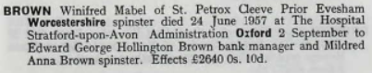

Burford Frances & Hesta D8
In Here lyeth the body of
Frances ye wife of David
Burford who departed this
Life March ye 7th 1720 aged 25.
Also Hesta her daughter departed March 7th 1720 aged 1 year and up

Burford George D7
In memory of George Burford who departed this life April 4th 1725 aged 86years
Also in memory of
Martha the wife of George Burford
Who departed this life
November 11 1719
Aged 66 years

Bushell Diana G5
Memorials inside the church in front of the altar
In memory of
Diana Bushell
The Relict of Robert Bushell esq^{r}
She departed this life
April 18th 1728
Aged 63

Bushell Edward [Gent] - No Monument
thought to be under the choir stalls
Edward Bushell [Gent] died Sept 25 1671 aged 65

Bushell Elizabeth No Monument
thought to be under the choir stalls

Elizabeth wife of Edward Bushell, eldest daughter of John Savage of Edgioke Esq, died Sept 14th 1684 aged 73
She had issue 4 sons and 3 daughters

Bushell Joyce G5
Memorials inside the church
Here lyeth the body of
Joyce the wife of Thomas Bushell
Who departed this life
The 6th December 1656
Aged 87

Bushell Robert G5
Memorials inside the church in front of the altar
In memory of
Robert Bushell esq^{r}
Who departed this life
The 3rd day of October 1720
Aged 67

Bushell Robert – Mural Monument in church now gone
Robert Bushell Esq died May 12th 1720 aged 67
Note the above dates are according to Nash

Bushell Thomas G5
Memorials inside the church
Here lyeth the body of
Thomas Bushell [Gent]
Who departed this life
The 16th July 1656
Aged 75

Bushell Thomas G3 [In the Church]
Here lyeth the body of
Thomas Bushell
Son of Anthony Bushell
Lieutenant- Colonel to his
Majesty King Charles the First
He departed this life
17th day April 1701
In the 50th year of his age.
“Memorae Sacrum Antoni Bushell
Generosi qui post multa subacta
Vexillis fortiter gesta placide
In domino ??? mivit
Anno Domini 1662 Dec 20”

Translation
“Sacred to the memory of Antony Bushell, who
after accomplishing many valiant deeds under the kings
standard, peacefully fell asleep
in the year of the Lord 20th Dec 1662”

Cairns Joseph Henry F2

In loving memory of
Joseph Henry Cairns
Died June 26th 1978
Aged 81

Careless Ann D2 Sculptor Davis of Bidford
Sacred
To the Memory of
Ann daughter of
John & Sarah Careless
Who departed this life
Sept 9th 1855
In the sixth year of her age
“Dear Child! It was a saviours love Which called thee to the realms above How can we murmur, or repine, That such felicity is thine ! “

Careless John & Sarah D2
Sacred
To the memory of
John Careless
Who died August 4th 1886
Aged 78 years
“Lord remember me” Luke XX111 42
Also of Sarah
Widow of the above
Who died June 27th 1892 aged 82 years

Careless Sarah & Martha D3
Sacred
To the memory of
Sarah
Daughter of John and Sarah Careless
Who died Dec 19th June 19 th 1860
Aged 14 years
“We all do fade as a leaf”
Isiah LXllV 6
Also of Martha
Daughter of
John and Sarah Careless
Who Aug 3rd 1928
Aged 80 years

Charge Ruth Rebecca E3
In
Loving memory of
Ruth Rebecca
Charge
Born 24-4-1893
Died 7-11-1976
“Rest in Peace”

Charlett John, Anne, John [son] G5
Memorials inside the church –
John Charlett
Departed this life
Feb 13th 1693
Aged 39
Also here lyeth the body of
Mrs Ann Charlett
Wife of Mr John Charlett
Who was buried June 27th 1720
Aged 72 years.
Likewise here lyeth the body of
Mr John Charlett
Son of Mr John and Mrs Ann Charlett
Who was buried ye Nov 8th 1728
Aged 41
Also here lyeth the body of
Mr John Charlett
Son of Mr John and Mrs Ann Charlett
Who was departed this life
Aug 8th 1759
Aged 34 years

The Chronicler helps to clarify the number of John Charletts
According to Nash there was a Mural Monument in church now gone showing:
Mr John Charlett died Feb 2nd 1685- aged 85
Mr John Charlett died Feb 17th 1698 aged 59

From Ancestry
- England, Select Births and Christenings, 1538-1975
BIRTH, BAPTISM & CHRISTENING
Record information.
Name | John Charlett
Baptism | 20 Nov 1724 Cleeve Prior,Worcester,England
- England, Select Births and Christenings, 1538-1975
BIRTH, BAPTISM & CHRISTENING
Record information.
Name | John Charlett
Baptism | 17 Oct 1747 Cleeve Prior,Worcester,England
- England, Select Births and Christenings, 1538-1975
BIRTH, BAPTISM & CHRISTENING
Record information.
Name | John Charlett
Baptism | 02 Jun 1746 Cleeve Prior,Worcester,England
Death | 09 Aug 1747
- England, Select Births and Christenings, 1538-1975
BIRTH, BAPTISM & CHRISTENING
Record information.
Name | John Charlett
Baptism | 02 Feb 1610 Cleeve Prior,Worcester,England

Charlett John F7
Here lieth the body of John
Charlett ye sonne of John Charlett
by Mary his wife who departed
this life feb 13 Anno Dom 1693
Aged 1 year ?? Months
This child most sweet lies here asleep
To put us all in mind
That one day we must turn to dust
When grim death doth us find

Charlett Joseph E5
Memorials inside the church – very worn
Here lyeth the body
Of Joseph Charlett [gent],
Who departed this life April 18th 1741
Aged ?.

Charlett Katherine D7
Here lieth the body of Katherine
Wife of Richard Charlett
Who departeth this life the 4th day
of April Anno Do 1691
Aged 72
“All you that here my grave do see
………………………………..”
Oliver recorded that the rest of the poem was under the ground”

Charlett Magdalen – Mural Monument
Mural Monument in church now gone
Magdalen Charlett died Feb 9th 1675

Charlett Mary E5
Memorials inside the church –

To the memory of
Margaret Charlett
Wife of Joseph Charlett
Who was interred here
Feb 1st 173^{2/3}

Charlett Richard D7
Here lieth interred the
Body of Richard Charlett the Younger
Who departeth this life the 7^{h} day of February
Anno Do 1671.
His age was 36 years
“Man that is born of woman
………………………………..”
Oliver recorded that the rest of the poem was under the ground”

Charlett Sara D7

Here lieth the body of Sara Charlett the daughter of Richard
Who departeth this life the 6th day of October Anno Do 1693
Aged ??
“God who by death do my grief assuage
Took me away in my flourishing age
To rest in my grave free from all pain
………………………………..”

Oliver recorded that the rest of the poem was under the ground”

Charlwood Joseph & Leah A8
Sacred to the
loving memory of
JOSEPH CHARLWOOD
(late of B’ham)
The dearly loved Husband of
LEAH CHARLWOOD
Who Passed to the Home eternal
July 30th 1936
Aged 60 years
“Not goodbye only goodnight
His life was gentle and the elements so mixed in him,
that nature might stand up, and say to all the world,
This was a man”
LEAH CHARLWOOD
Died March 14th 1954
Aged 77 years
Reunited

Coldicott Francis Holt K3
Top
In loving memory of
LHS
Francis Holt Coldicott died January 1st 1936 aged 45 years

Daniel John B6

In Memory of
John Daniel who departed
This life November 13th 1787
Aged 54 years
(..)of Ann wife of the above
Who departed this life (..)
(..)1787 aged 52 years
(..)(..)(..)and (..) of Par(..)
(..)(..)(..)(..)(..)(..)
Blessed that are at rest
With Christ for evermore

Sculptor believed to be Ballard of Aldington, Cleeve stone, carved top, sides, and bottom corners.

Edwards William Leonard E1

In ever
Loving memory of
William Leonard
Edwards
Beloved husband of
Zadie

At Rest

F “HF” C5
HF

F “GF” C5
GF

F “MF” C5
MF

F “HF” C5
HF

Fairfax William F6
In
Memory of William Fairfax
He died Jan ^{y} the 3rd 1703
A husband aged 55 years
“Kind & father dear
A faithful friend lies buried her”

Fairfax William H7
White marble stone with no visible writing on it
To William Fairfax c 1900

Farr Mary Annette C5
Sacred
To the loving Memory of
Mary Annette Daughter
Of Frederick William and
Sarah Gainett Farr
Who died February 17th 1851
Aged 18 months
Also of
William Henry
Their Son
Who died March 4th 1851
Aged 3 months

Field? William D6
Here lyeth the body of
William the son of
William & Ann Field
Who departed this life
Dec ye 6 1716

Mary Finch K4
In memory
Of
A dear wife and mother
Mary Finch
Passed away
March 29th 1964
Aged 46

Fletcher William & Elizabeth C4
In
Loving Memory of
William Fletcher
Who died on Oct 27th 1939
Aged 63 years
And of his wife
Elizabeth
Died December 13th 1966
Aged 86 years
Rest in Peace

Garrett James C2
In
Loving memory of
A dear husband and father
James Garrett
Who died 14th July 1969
Aged 65 years

Garvie Mathew Allen D3
In
Loving memory of
Our baby son
Mathew Allen
Garvie
Born Aug 21st 1977
Died Oct 6th 1977
Aged 6 weeks

Gibbs Mary Jane H4
In loving memory of
Mary Jane Gibbs
Who entered into rest Dec 27th 1897.
Aged 36 years

“She is not dead but sleeping”

Gilham Melanie Jane C2
In
Loving Memory of
Melanie Jane
Gillham
Beloved Daughter of
Michael and Gloria
Died 4th May 1970
Aged 4 years
With Jesus

Godfree John, Penelope, Joseph, William F7
Godfree John,
Godfree Penelope,
Godfree Joseph,
Godfree William
1697

Godfrey John D8
Here lyeth the body of John Godfrey the Elder
Who departed this life a true servant of the lord
Hoping for a glorious resurrection,
Old type of Cleeve carving

Granger William & Frances J7
In loving memory of
William James Granger
Who died March 2nd 1904
Aged 56 years
“Heaven's morning breaks, and earth's vain shadows flee;. In life, in death, O Lord, abide with me”
Also of Frances Emily
Wife of the above
Who died June 23rd 1910

Halford Frank & Wallace K3

In Thanks giving
For the
Memory
Of
Frank
Son of
George and Janet Halford
1890 - 1913
Also Wallace Halford
1886 - 1956

Halford George John K4

Jesus hominum salvator
George John Halford
B.Mus-Dunelm

Halford Janet K4

In loving memory
Of
Janet Mary Halford
Wife of
George John Halford
Dec 14th 1864 - March 24th 1940

Harcourt Thomas & Sarah B7
In memory of
Thomas Harcourt
Late of this Parish
Died February 8th 18o?
aged 81 years
Also Sarah his wife
Died Feb………………

Harris Edwin K4
Edwin Harris
Died January 5th 1906

Harris Thomas & Elizabeth E2
In memory of
Thomas Harris

Died Nov ^{r} 18th 1869
Aged 70 years

Harvey James Herbert & Claribel C1
In
Loving Memory of
James Herbert
Harvey
Who died Nov 22nd 1966
Aged 72 years
And his dear wife
Claribel
Who died Jan 14th 1968
Aged 75years

Hemming Ellen & George G3
sculptor Davis-Bidford
In
Loving memory
of
Ellen wife of
George Hemming
Who died March 16th 1907
Aged 74 years
Also of
George Hemming
Who died April 17th 1918
Aged 81 years
“Blessed are the dead which
die in the lord”

Hillard Kathleen D3
Kathleen Hillard
Died
Dec 8th 1948
Aged 25 years

Hobbins Ann E7
Also
Near this place
Lyeth Ann the
Wife of William
Hobbins who
Died April ye 21
1721 aged 80

Hobbins William H4? E5?
In memory of
William Hobbins
Who died ye 13th
day of February 17 ^{15/16}
aged 70

Holtom Ann J2
Sculptor ….m.s. Shipston
In loving memory
of
Ann Holtom
The Devoted wife of
John Smith Holtom
Who entered into her rest
May the 22nd 1884
aged 42 years
“Blessed are they that hear the word of god and keep it”
St Luke X1.7.8

Holtom Anne K2
Flat Stone hard to read
Anne Holtom
Died 7th April
1865

Holtom Dorothy [Dolly] J2
In loving memory
of
Dolly Holtom
Died Jan 3rd 1970
aged 78 years
R.I.P

Holtom Emma , Sarah ,John, Edith J2
RHS
Emma Frances Holtom died Dec 19th 1893
Top
Sarah Anne Holtom Died Dec 11th 1902
LHS
John Holtom died Dec 27th 1907
Edith Holtom died July 11th 1943

Holtom Stephen Godson K3
Sculptor Davis Bidford

In memory of
Stephen Godson Holtom
Died Oct ^{r} 4th 1888
Aged 58 years

Holtom John Smith J2
John Smith Holtom
Died Aug^{st} 30th 1890
Aged 51 years

Howes William & Ellen G4
sculptor Davis-Bidford
`
In loving memory of
William Howes
Who entered his eternal rest
February 26th 1847
Aged 50 years
“Watch and pray”

Also of Ellen his wife
Who departed this life
April 2nd 1903
Aged 56 years
“Her children rise up and call her blessed”

Howe William Henry & John Rowland G4
LHS
William Henry How died Nov 4th 1932 aged 24 years
RHS
John Rowland Howe died March 13th 1929 aged 20 years
Top
In memory of John Roland Howe and William Henry Howe twin brothers

Huband Mary D7
In………memory
Mary wife of John Huband
……………………..of John Rouse
Who departed this life 30th Jan 1747
aged 52 years
“Verse not readable”

Oliver recorded that the stone was very worn; Laughton type stone

Hunt William G7
Here lieth the body of William
Hunt who died October
The 19th 1729 aged 30 years
………….Wife now collect………
…………lyeth ere the Christ appears

Huse? Elizabeth F6
Memorials inside the church –
Here lyeth the body of
Elizabeth the wife of
Thomas Huse
Who departed this life 2nd June 1681
Aged 54

Jinks John E1
In
Loving memory of
John Jinks
Loving father and husband
died Feb 27th …
aged 50.

Jones Catherine F5
Memorials inside the church –
Here lyeth the body of
Catherine the wife of
Charles Jones Esq
Who died Dec 24th 1738

Jones Mary E5
Memorials inside the church
Here lyeth the body
Of Mary the Eldest daughter of Charles
Jones Esq and Catherine
His wife and only daughter
Of Joseph Charlett of this Parish[gent],
Who departed this life March 14th 172?
In the ? year of her age.

Kearton Eliz ^{th} Maria F7
Sacred to the memory of
Eliz ^{th} Maria Kearton
Who died the 12th of
October 1858
[at Cleeve Prior]
aged 61 years
“Blessed are the dead which
die in the lord”

Keck William Thomas G3
In
Loving memory of
William Thomas Keck
Who departed this life
June 23rd 1916
Aged 58 years
“Not my will but thine be done”

Also of Ann
Beloved wife of the above
Who fell asleep Sept 9th 1918
Aged 71 years
“Watch for you know not what a day may bring forth”

Keen Joseph B5
JOSEPH Son of
Henry and Mary Keen
Who died June 9th 1802
Aged 7 years and 7 months.
“My tender life was much desired
But God above the father required
So do not repine and grieved be
But soon prepare to follow me”

Keen Richard B6
In affectionate
remembrance of
Richard Keen
Who died
Feb 14th 1876 [or 1870]
Aged 71 years
“Blessed are those which die in the Lord”

Kemp Richard F7
In memory of Richard
The son of Richard
and Ann Kemp who
died May 21st 1729
aged 26 years

Key Lydia Mary G7
To
the Memory
of
Lydia Mary Key
Died October 11th 1960
aged 86 years
“At rest”

Langston George William G3
I remembrance of
My dear husband
George William Langston
Who fell asleep Oct 31st 1952
Aged 69 years
“My Love”

Laughton Family?? D7
Oliver recorded that the stones were very worn; all have a hour
Glass in the centre of a circle with roses and leaves still clear down each side
Other stones in the sector

Top broken off …………….……
Ann…. Joseph died April
1726 aged 1.. years
William died in 1721 aged ….year
Anne died April 1737 aged 32 years

Laughton Thomas D8
Here lyeth the body of
THOMAS LAUGHTON the Son of
William Laughton
John Godfrey the Elder
Who departed this life ye 8 April Anno Dom 1688 aged 6
“Behold the place where
I lie as thou art …..”
Balance of verse below the ground; Old type of Cleeve carving

Laughton Thomas & Sarah E7
There is a further plaque in the church, a simple script of block capitals, not signed
SACRED TO THE MEMORY OF THOMAS LAUGHTON
Who died
NOVEMBER 13TH 1852
aged 62 years
SARAH Relict of
Thomas Laughton died January 1st 1877
aged 88 years

Lott Charles Wilfred C1

In
Loving memory of
Charles Wilfred
Maylott
Passed away August 28th 1970
Aged 81
Beloved husband of Ada
Rest in Peace

Ludlow, Neville Broughton & Helen G2
In
Loving memory
of
Neville Broughton Ludlow
Born 1885 died 1970
Helen Florence Ludlow
Born 1890 died 1973

MacIver Mackintosh CBE MD, Jean D2
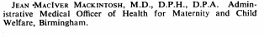
In
loving memory of
My dear Sister
Dr. Jean MacIver Mackintosh
CBE MD
Who passed away
On the 23rd March 1971

May Doris F1
In
Loving memory of
Doris May
Died Sept 3rd 1971
Aged 73

Mills Mary B5
IN
Affectionate Remembrance of
Mary Mills
Who died Jan 28th 1878
Aged 73 years
“Blessed are the meek”

Morton Eliza Ann H2
Sacred
To the dear memory of
Eliza Ann Morton
The good wife of
John Morton Clerk
Vicar of this Parish
Who entered into her rest
The 13th day of May AD 1869
Aged 56
“There remaineth therefore a rest to the people of God” Hebrews 4: 9-16

Newton Louisa Harriet G7

Also remembered in the stain glass window
to the left of the organ in the church

In loving memory of
Louisa Harriet Newton
Died June 14th 1933
Aged 90 years
“ Abide with me”

Nichols Alfred, Edith & Gwen J2

In loving memory of
Alfred Nicholls
1885- 1965
Also wife Edith
1888 – 1966
And daughter Gwen
1910 -1967

Nicholl Henry & Elizabeth B5
5 feet tall, elaborate carving worn Cleeve stone
Unreadable

Also of Henry Nicholl
(..) and Elizabeth
Who died Nov (…) 18..

Nicholls Joseph Edwin & Ellen C3
In
Loving Memory of
JOSEPH EDWIN NICHOLLS
WHO DEPARTED HIS LIFE
Dec 1st1906
Aged 61 years
“Our friend, our earthly friend is gone,
A father dear and kind;
Death came and snatched his life away,
And we are left behind,
Weep not for me my children dear,
For you I laboured many a year,
I always strove to do my best,
And now I’m gone to take my heavenly rest.”
Also
ELLEN NICHOLLS
Wife of the above
Died Feb 14th 1932 aged 82 years

Nicholls Ann C3
Sacred
To the memory of
Ann wife of
(…) Nicholls
Died April 18th 1846

Chroniclers note: Oliver wrote in his project
“This stone has fallen over. I rang Mr Edwin Nicholls and told him. We are
going to see if we can mend it. [Sept 17th he is going to have help to put it back next week]

Nickson Grace B2
In
Loving memory of
Grace Nickson
Died 22nd August 1967
Aged 52

Oakley Susannah D3

Sacred
To the memory of
Susannah
Wife of James Oakley
Who died October 3rd 1855
Aged 77 years
“ in such an hour as ye think not
the Son of Man cometh”

Oakley James D3

Sacred
To the memory of
James Oakley
Who departed this life
June 19 th 1857
Aged 81 years
“Be ye also ready”

Oldaker Charles F7
Carved Cleeve stone, Laughton Cherub Head with crown on urns each side, leaves running down
In memory of
Charles Oldaker
He departed this life
March 18th 1776
Aged 69

Also Elizabeth wife
of Charles Oldaker
She departed this life
Oct 10th ? 1787 ?aged 70
Also five of their children
that died in infancy

Orme Mary Hemming & Thomas E4
Top
In Memory of
LHS
In memory of Mary Hemming Orme died Jan 31st 1948 aged 79
RHS
Thomas Orme died May 10th 1935 aged 71 years
Bottom
Thy will be done

Orvis Geoffrey B5
In
Ever Loving Memory
Of
A dear husband
Geoffrey Orvis
Died Nov 26th 1976
Aged 76 years

Parkes Joseph H8
In
Loving memory of
George Joseph Parkes
Called to Rest
20th March 1958
Aged 38
“His suffering was great
His end peace”

Partridge Margaret Alice D1
In
Loving memory of mother
Margaret Alice
Partridge
Passed away 22nd Feb 1975
Aged 86 years
Also of beloved Father
Arthur Partridge
Passed away 28th October 1957
Aged 73 years

Perkins Daisie Annie G1
Memorials inside the church
In loving memory of
Daisie Annie
Perkins
Died Dec 14th 1981
Aged 69
“Always in our thoughts”

Perkins Louis Victor B1
In Memory of
A dear husband & father
Louis Victor Perkins
Died 10th Dec 1965
Aged 62
“At rest”

Philips John D7
Here lieth the body of
John Philips the son of
John Philips he died May 19
1736 aged 40 years
“Farewell my wife and child most dear
I have gone to rest you have no cause to fear
My time was short I could no longer stay
My dearest redeemer called me away”

Phillips Mary E6
Here lieth
the body of Mary wife of Anthony Philips who departed this life…
…………………………………….

Phillips William E6
Here resteth
In hopes of
A glorious resurrection
To eternal life, the body
of
William Phillips
Who died
May ye 5th 1722
aged 68

Philips William and Ann D7 [E7?]
Neare this place was buried William
Philips and Ann his wife who had
issue 10 children 7 sons and 3 daughters.
“Stay rede hard and spend a tear
Upon the dust that stayeth here
And while read the state of ??
Think of the glass that runs for thee
For as you are so are we
[and as we are??] so must you be”

Oliver recorded that the “Rest of the inscription under the soil”

Philips William and Mary D7
In Memory of
William Philips
Who departed this life Jan 12th 1802
Aged 71 years
Also Mary
Wife of William Philips
Who departed this life May 1802 aged 62 years
“Blessed are the dead which die in the lord”

Oliver recorded that the memorial was of Cleeve stone, Laughton type layout and print”

Potter Emma B4
In Affectionate Remembrance of
EMMA
Wife of Jephson Potter. M.A.,M.D.
Toxteth, Liverpool.
Daughter of
Charles and Rebecca Bayliss
Who died July 21st 1868
Aged 30 years.
Also of
Stella Maud Sargeant
Granddaughter of the above
Charles and Rebecca Bayliss
And daughter of
Charles William and Emile Sargeant Baylis
Who died August 21st 1868
Aged 6 weeks
Also as part of above:
In Affectionate Remembrance of
Ann Baylis
Who died July 12th 1844
Aged 5 years
In Affectionate Remembrance of
Charles Baylis
At Bevington and Cleeve Prior
1804 – 1875
Also Rebecca his wife
1807 – 1878
And of their son Stephen
1852 – 1873
In Affectionate Remembrance of
Mary Baylis
Who died
February 15th 1844
Aged two years
In Affectionate Remembrance of
William Rouse Baylis
Who died
April? 14^{h} 1857
Aged one year

Rice William G7
Here lieth the body of William
Rice who departed this life
The 9th day of August 1687
He was servant of Mr Thomas Bushell
And Cecelia[?] his wife of 17 years in
Memory…………his many good deserts

Rickinson Susan Carol D1
In Loving memory of
Susan Carol Rickinson
Died Nov 14th 1975
Aged 28

Roberts Edith Elaine D1
In ever
Loving memory of
Edith Elaine
Roberts
Died Aug 11th 1972
Aged 84

Rock John & Ann E7
Flat Stone
In memory of
John Rock
Who died 2nd of
Feb 1828
Also of Ann His wife
Who died 30th July 1814
Ryland who died in his
aged 61

Rock John G7

In
loving memory of
John Rock
Who died April 7th 1885
Aged 69 years
“Blessed are the dead
which die in the lord”

Rock Louisa G7
[Sculptor] W. & S. GARDINER, EVESHAM.
In loving memory of
Louisa Rock
Who died June 29th 1889
Rest in the Lord wait patiently
For him- Psalm XXXV11:7

Rogers Ernest & Bertha A8
ERNEST ROGERS
The beloved and devoted
Husband of Bertha
11th October 1961
BERTHA
Beloved wife of Ernest
5th July 1964

Rouse John D7
John Rouse
…………………..
Also William their son who
departed this life the 25th day……….
Oliver recorded that the the stone was very worn

Rudge Mary Ann H2

Sacred
To the memory of
Mary Ann Rudge
Who died February 9th 1871
Aged 18 years

“Not lost but gone before”

Ryland Edward & Eilin E7
Double Tombstone
Here lyeth the  Body of  Edward Ryland  Who died ye 9 of  December 1721  Aged 77 | Here lyeth the  Body of Eilin er  Ye wife of Edward  Ryland who died  August ye 1712  Aged 60

Ryland John E7
Chronicler confirms that Ann Ryland married Thomas Bennett and was the mother of Sarah Charlett
In memory of John
The son of Richard and Hannah
Ryland who died in his
Infancy July 15 1716
1723 aged 15 years

Ryland Mary E7
Carved Cleeve stone with angel in the centre & scrolls either side
In memory of
Mary Ryland
daughter of Richard
and Hannah Ryland
she died April….
Infancy July 15 1716
1734 aged 15 years
“Weep not my friends tho’ sudden death
Bereft me of my vital breath”

Sale John & Mary? D7
John Sale  Departed this life  March the 7  1717  Aged 63 years | Also Mary[?]  His wife  Died June the 6  1715  Aged 56 years

Sheaf Francis Robert, Kate& Ann G4

Francis Robert Sheaf
Who died January 14th 1893
Aged 40
Also Kate wife of the above
Who died Aug 19th 1942
Aged 84 years
Also of Ann
Daughter of the above
Who died Feb 2nd 1964
Aged 75
“R.I.P.”

Sheaf John D2

In loving memory of
John Sheaf
Died 17th March 1971
Aged 85
And his wife
Jane
Died 15th Dec 1971
Aged 76

Sheaf Louisa G3
Sculptor Davis-Bidford
Sacred
To the memory of
Louisa Sheaf
Who died April 21st 1899
Aged 76 years
“There remaineth the rest for the
people of god”

Sheaf Louisa G4
Sacred
To the memory of
Louisa Sheaf
Who died April 25th 1932
Aged 96 years
“O rest in the lord”

Sheaf Rosina D2
Top
In loving memory of
LHS
Rosina Sheaf who died June 29th 1942 aged 64
Bottom
Life’s work is done rest in heaven

Sheldon Edward James & Maud J6
Edward James Sheldon
June 1st 1892
June 9th 1965
Maud Sheldon
29th July 1982
aged 88 years
“Reunited”

Shuter William G2
Sculptor Davis-Bidford
In memory of
William Shuter
Who died July 9th 1880
Aged 56 years
Also of Sarah
Daughter of the above
Who died 1860
Aged 20 years
Prepare to meet thy lord

Silvester Eliz ^{th} D7
Here lyeth the  Body of Eliz ^{th}  Wife of Robert  Silvester, she departed  This life Sept……  1732 aged 26  She was the daughter to  Charles and Catherine Squire | W………. I come  She lived in love,  And died in peace  We hope her joys  will never cease

Silvester Henry C7
Worn Stone
Henry Silvester
Who ……………………
…………………………

Silvester John E7
John Silvester
Died
March 2?
1853
Aged 69 years

Silvester John E7
John Silvester
Died
Sept 1842
Aged ????

Silvester John E7
Charles Silvester
Died
October 26th 1868
Aged 7

Silvester Mary D7
Here lieth the body of Mary
Wife of Robert Silvester
And daughter of
John and Mary Stevens [?]
She died December ye
14 1764 aged 31
Also here lyeth the body
of Henry, son of ye afore
Robert and Mary Silvester
He died Jan 8 1737 aged 2 months

Silvester Mary E7
Mary Silvester
Wife of
John Silvester
Died Aug 28th
1852
Aged 68 years

Slaney Margaret J6
LHS
Margaret Slaney passed away June 3rd 1946 aged 60 years
Bottom
“Rest in Peace”

Slaney Sergt Samuel J6

In
Remembrance of
My husband
Serg^{t} Samuel Slaney
Who died March 4th 1919
Aged 31 years
“Peace Perfect Peace”

Smith Elizabeth & William B4
Sacred to the memory of
Elizabeth Smith
Late of this Parish
Died 24th Dec 182[?]
Aged 58years
[..] [..] dead [..] die in the Lord
Also William son of the above
24 th 7 1837
aged 27 years

Smith Henry Edwin & Helen J7
In loving memory of
Henry Edwin Smith
Died Oct 3rd 1935
Aged 69
“Peace Perfect Peace”
Helen Mary Smith
Jan 15th 1941 aged 7

Smithin Emeline & Robert Arthur K6
Emeline
Smithin
Passed on
Feb 14th 1947
Aged 55 years
Robert Arthur
Infant Son
Passed on
May 23rd 1929

Smithin, Josephine, Joseph & Laura Jane K6
[Flat stones difficult to read]
Josephine Smithin
Born April 23rd 1887
Died May 1st 1925
Joseph Smithin
Born 1884
Died 17/4/1930
Laura Jane Smithin
Born 1884
Died Feb 24th 1940
1929
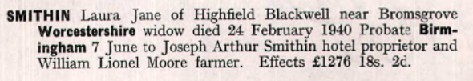

Squire John F7
Chronicler: oldest Stone in the church yard
Here lieth the body of
John Squire who departed
This life 21st day of Oct
A.D. 1671

Squire Richard D7
Here lyeth the body of Richard of
Richard Squire who departed this life December 1697

Squire Thomas & Sarah D7
In memory of Thomas Squire who died September ye 27th 1757
Aged 56 years
Also here lyeth the body of Sarah ye daughter of
Thomas & Esther Squire
Who departed this life
Nov ye 15 1760 aged 23 years
“Blessed are the dead which die in the lord”

Staff Helen, Thomas Ida & Marion K6
In  Loving memory of  Helen Staff  Died 21st May 1936  Aged 64 years  Also of Thomas Staff  Died 6th Nov 1939  Aged 73 years  And Ida G. Staff  Died 12th March 1954 | Also of Marion Staff  Died 7th May 1978  Aged 82

Stanley Maria & John Charles C4

In Loving Memory of
Maria Stanley
Who passed away on
September 20th 1956
Aged 77 years
Also
John Charles Stanley
April 18th 1957
Aged 80 years
“Reunited”

Stanley Raymond Wilfred J4

In memory
of
Raymond Wilfred
Stanley
Pilot RAC.
Royal Flying Corps
Killed when Flying 17th Jan^{y} 1917
Aged 26 years
Younger son of Isaac & Annie Stanley
Cleeve Prior & Walsall

Stock Ethel Violet B5
IN
Loving memory
Of
(Bobbie)
Ethel Violet Stock
Who died April 20th 1968
Aged 63 years

Stock Fanny Maria B5
IN
Ever Loving Memory
Of
Fanny Maria Stock
Passed away July13th 1953 Aged 82 years

Henry Stock,
Died October 28th 1938 aged 71 years
“Abide with me”
Reunited

Suffield Joseph J4
LHS
Joseph Willey Suffield passed away April 11th 1919
RHS
“Thy will be done”

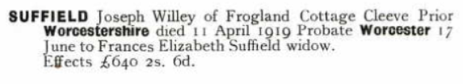

Sutor Jane? F7
Here lyeth the
body of Jane
The wife of Thomas
Sutor…………..

Taylor Henry John D3
In Loving memory of
Henry John Taylor
Beloved husband of
Elizabeth
Died July 23rd 1972
Aged 86 years
“In Gods keeping”

Taylor John & Ann D3
In loving memory

John Taylor died May 26th 1888 aged 49 years also of Ann Taylor his wife died Nov 24th 1907 aged 77 years

Taylor Job Albert & May E3

Job Albert
Taylor
Died Sept 8th 1963
Aged 70
“Forever with the Lord”
Also his wife
Lilian May Taylor
Died March 26h 1978
Aged 75

Taylor Job Alfred & Mary Priscilla D3
In Loving Memory of  Job Alfred Taylor  Fell asleep Dec 29th 1944  Aged 88 years  “ Until Day Break” | In Loving Memory  of  Mary Priscilla Taylor  Dearly beloved wife of  Job Alfred Taylor  Fell asleep Feb 28th 1932  Aged 76 years  “ Nothing in my hand I bring, simply  To thy cross I cling,  rock of ages cleft for me,  let me hide myself in thee”

Taylor Florence May E3
Florence May
Taylor
Passed away
June 24th 1972
Aged 84
“At Rest”

Taylor Judith G5
Memorials inside the church -in the centre of the altar
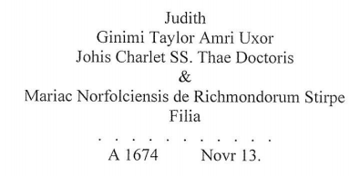
Translated
Judith
Beloved wife of Ginimi?[James?] Taylor
Daughter of John Charlet doctor of Divinity
And Mary Richmond of the family of Norfolk
a.1674 Nov 13

Tomes John Fisher K4
In
Affectionate
Remembrance of
John Fisher Tomes
Who died April 3rd 1885
Aged 35 years
“Thy will be done”

Tombs : Philip Arnold & Norah B2
In
Loving memory of
PHILIP ARNOLD TOMBS
Died Feb 10th 1965
Aged 50 years
And of Norah his wife
Died Dec 19th 1977

Thomson Robert Patterson C2
In loving Memory
Of
Robert Patterson
Thomson
Who died 9th Sept 1970
Aged 62

Tomes Thomas Bennett J4.
Chronicler presumes it is he

In loving memory of
Thomas B………….
Who died ………18…

Tuckley Alfred George B2
In
Loving
Memory of
Alfred George
Tuckley
Who died May 15th 1965
Aged 70years
Sadly missed by wife and children

Unknown Chris B6
Carved worn Cleeve stone
(..)(..)(..)(..)(..)(..)
Chris(…..)

Unknown F7
Vandalised Stone
Here ……………
………………….
The body of………..
Who departed this life
October 1884 aged 6

Valentine Edgar G1
In loving memory of
Edgar Valentine died Jan
5th 1979 aged 88 years
“Rest In Peace”

Vellender Edgar C2
In
Loving memory of
Edgar Vellender]
William
Died Jan 5th 1978?
Aged 88
Rest in Peace

Vickeridge Albert J5
Top
To the memory of
LHS
Albert only son of J & E Vickeridge who died October 21st 1918 aged 32
RHS
“R.I.P.”

Vickeridge Charles & Susan F4
HS
In loving memory of our dear parents Charles Vickeridge
Bottom
Passed away July 17th 1934 aged 74 years
RHS
And of his beloved wife Susan, passed away April 3rd 1937 aged 72 years

Vickeridge Dorothy Mary J5
Top
In Loving memory of

LHS
Dorothy Mary Vickeridge who died April 3rd 1937 aged 20 years

Vickeridge Harry A8
In loving memory of Harry Vickeridge *
Died 2nd April 1958 aged 66 years
Olive Lucy, died Jan 13th 1971 aged 82

*The above are written along the kerbstones

Vincent William D2
In Memory of
Our father and mother
William Vincent
And
Sarah Thornton
“God of mercy Jesus blest
Grant them both eternal rest”
[died 1936]

Walker John & Mary C4
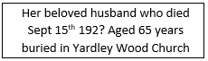

Walker Joseph – Mural Monument in church now gone

Joseph Walker, Vicar of this Parish died Oct 3rd 1715

Wellon Fred & Amy K4

In loving memory of
Frederick John
Wellon
Died 18th April 1962
Aged 77 years
Also Amy his wife
Died 13th Jan 1973
Aged 83 years

Wheeler William D3
In loving remembrance of
William Wheeler
Who passed peacefully away
Dec 1937 aged 69 years
Also his wife Nora Ellen Wheeler
Died feb 22nd 1958
Aged 74 years
White Dorothy G3-
In memory of
Dorothy
Beloved daughter of
Walter & Louisa White
died Feb ^{y} 20th 1904
Aged 5 years
“God knoweth best”

White George William G3
LHS
George William White who passed 22nd May 1911 aged 55 years
RHS
Also Annie Maria White March 28th 1937 aged 82 years

White, Norman Frederick Clive G3

In Loving memory
of
Norman Frederick Clive
White
died
22nd February 1940
Aged 25
“He being made perfect in a short time fulfilled a long time”

White Sarah & Charles F2
RHS
Sarah Sophia White in to rest Feb ^{y} 1958 aged 77 year
LHS
And Charles Kenworth White who entered in to rest Jan ^{y} 1958 aged 86 years
Bottom
Forever with the Lord

White Walter Henry & Selena Louisa G3

In
Loving memory
of
Walter Henry
White
Beloved Husband of
Selena Louisa
White
Who passed away
January11th 1942
Aged 61 years
“And to where I wait
Come bravely on”

Also of his
Dearly beloved
wife
Selena Louisa
January 13th 1936
“Reunited”

Williams Wilfred C2 [G1]

In
Loving memory of
Wilfred [Freddie]
William
Died Jan 27th 1981
aged 79
Sculptor Davis Bidford

Willes William G5
Memorials inside the church
in 1861 he was a market gardener in Bidford
Here lyeth the body of
William Willes
Who departed this life
Oct Anno Dom…..

Wright Thomas F7
In memory of Thomas
Son of Edward and Ann Wright
Who died
May 21st 1743 Aged 23

Notes
The writing & spelling was unusual. An old Type S was often written f, and the spelling was often wrong. Sometimes the same word was spelt differently on the same old stones[not the Laughton ones] Sometimes they ran out of space and wrote the letters over the top ie Le^{ave} or Fri^{iend}
Date Change
Until 1st January 1752 the year began on the 25th March.
So Jan 1750 followed Dec 1750, so Jan, Feb and unto march read Jan 1750/1 or Feb 170^{0/1}

Age
All monuments were after the time of Oliver Cromwell [1641-61] with the exception of the Bushell ones of 1656.

Nash
A Historian Called Nash looked at the church and noted some of the memorials in the church in 1799. The ones that have vanished are possibly covered by the choir stalls and these are:
Dorothy Norton [nee Bushell], Widow died April 1654 aged 69
Edward Bushell [Gent] ,died Sept 25 1671 aged 65
Elizabeth Bushell, wife of Edward Bushell, eldest daughter of John Savage of Edgioke Esq, died Sept 14th 1684 aged 73
She had issue 4 sons and 3 daughters

Nash [1799] also mentions a mural monument which has now gone, it was to:
Bushell Robert Esq died May 12th 1720 aged 67
Joseph Walker, Vicar of this Parish died Oct 3rd 1715
John Charlett died Feb 2nd 1685
Magdalen Charlett died Feb 9th 1675
Mr John Charlett died Feb 17th 1698 aged 59

Mural Tablets inside the Church
- On the South wall of the Chancel
To the memory of
Thomas Bushell Esq.
Son of Edward Bushell Esq
And Elizabeth his wife
Who departed this life
January 13 171^{2/3}
Also of his widow and relict
Cecelia Bushell
The daughter of Francis
Sheldon esq. and Mercia his wife
Of Abberton in this county
died Oct 2 1716

They were persons of exemplary conversation,
Hospitable to their friends
Charitable to the poor
Good to all

In a vault near
this place are deposited the remains
of Thomas Laughton
Of this parish
Who died 20th April 1824
Aged 76 years
He was an affectionate husband
A tender father and an honest man.
Also of Ann relict of
Thomas Laughton
Who died 20th Dec ^{r} 1842
Aged 80 years
Also of Thomas Laughton
Their only son
Who died 18th Nov ^{r} 1852
Aged 65 years
And Sara his widow
Died 1st Jan^{y} 1877
Aged 88 years

Epidemics
There were many epidemics that killed lots of people especially children.
1727 - Fever “very mortal” recorded in Littleton
1740’s - Smallpox
1792 - “ Pestifer Annus” is recorded in the register
1831 -32 - Cholera
1849 -53 - Cholera 293 deaths all over the country

The Chronicler has added the following article written by the Late Don Archer

During the incumbency of the Revd. J R Whitaker I was allowed to look at the church records of burials in the hope, unfulfilled, of some clue as to why Charlett’s House was abandoned. I expect these records, which began in 1603, have now been photo copied, but then the originals were kept at the vicarage and were so fragile that I hardly dared touch the first two or three sheets of parchment.

With the help of the vicar, though, I made a long list of the deceased Charlett’s, but far from solving the mystery, I discovered another which has intrigued me ever since. For many years burials had numbered four or five as year, normal for a village of Cleeve Priors Population. Then in the 1720’s numbers rose steeply and in 1729 reached a peak of no less than 43. I remember discussing this with Mr Whitaker, who could only suggest that there must have been some kind of epidemic. Well, if that is the explanation, it must have been the most tragic episode in Cleeve Priors History, lasing about four years, it took about a third of the population, yet it seems to have been ignored by local historians. Even the learned John Humphries, who must have seen the records when researching for his “History of Cleeve Prior” has nothing to say on the subject.

Since writing, the forgoing Don Warren has unearthed some information that proves our locality was indeed struck by a serious epidemic. South Littleton lost 14 inhabitants in 1729 and 14 again in 1732 and the vicar wrote “pestifer annus” [year of the plague] in the register. An even closer parallel to Cleeve Prior is mentioned in the book about a Bredon Village by the Late Fred Archer- “Some could remember 1728 when 45 people died suddenly of swelling of the throat, more folks than in the 20 years before” So it could have been Bubonic Plague, as that is one of the symptoms, though official history says had died out a hundred years before.

Conclusion by Oliver Newman
It took a long time to do all the monumental inscriptions especially the old ones. I have sent the neat copy to the genealogical society for typing.
It was best at late afternoon for when the sun was low it it made better shadows oin the faint letters. I poured on some water which helped and scraped off some litchen carefully. It was amazing how you could work out most of the words after some practice. When I saw the old ones first I thought I would never read them. Often I had to lie on the ground close to look up and read them.
I know now that my survey will be of help to researchers and help people looking for their family graves. Copies of it will be typed and put in the Evesham Library, the CRO, The Birmingham Reference Library, The Church The parish Chest. The Parish council may print and sell copies.

IT WAS A WORTHWHILE PROJECT

TOTALS
Inside the Church
2 wall Tablets
16 Floor monuments
[1 wall & 3 floor ones recorded by Nash are gone]
In Church yard
234 Monuments with writing
[2 inscriptions found in Parish Chest not visible now]

Bibliography
English Churchyard Memorials [1963] Frederick Burgess
A History of Cleeve Prior R.F.Tomes
Birmingham Archaeology Society Transactions 1925
Evesham Notes & Queries E.A.B. Barnard
Monument inscriptions of St Lawrence Church, Bidford

