[Information gained from individuals & through web sites]

Adams
Then there were carters. They started at 5.30 too, to give the horses bait and to fill up the fodder racks. Charley Adams & Bob Payne were the carters. Lads left school at 11 years old. I [Eli Ankers] with Frank Farley started work driving horses, four in a team, Jolly, Boxer, Sharper and Turpin, ploughing up and down the field, six miles a day. It was better than school. The carter learnt us.
From Eli Ankers recollections

Correction in our report last week of the sale of a Cleeve Prior property. We stated lot 8 was bought by Mrs. Harris, this was an error it was bought by Mr George Adams of Cleeve Prior
From Evesham Journal ? 1919

Adkins
Henry Adkins owned Charlett house
[see Bennet]
Married at Cleeve Prior on 17th July by the rev Robert Lunn Vicar of Marton cum Grafton, York’s, brother of the bridegroom Charles Lunn of Edgbaston to Amelia Sophia, only daughter of Henry Adkins of Cleeve Prior
From Evesham Journal July 1866

‘To be sold at Auction on 21st September the abundant crop of choice fruit growing in the orchards known by ‘Nursery’ and ‘Upper Orchard’ by order of H Adkins, Cleeve prior. Sale at 5 o’clock.’
From Evesham Journal September 15 1866

Allbright [See Nicholls & Stephens]
I am trying to find the origins of my Grt-Grt-Grt-Grandfathers name: Allbright Stephens and what happened to him.
He was born in 1814, Cleeve Prior/North Littleton. Married Ann Nicholls in 1839 Cleeve Prior Church, had numerous children then seemed to disappear!!
Stonemason by trade, as was his father Thomas. I don’t know how he got the name, but it runs in three generations, and I would like to find why!! I am starting to assume it was his mother’s Maiden name perhaps?
Can anyone help me? Many thanks
Albright’s wife was called Ann Nicholls- daughter of Joseph and Sarah Nicholls? Ann’s sister was Susannah Teague married to John in 1846.
Genes reunited

My grandfather Edwin Jesse Nicholls came from Cleeve Prior.
I have information that says that in 1839 Joseph Nicholls a stonemason married Emmeline Lester who died and that he remarried Sarah Teague a widow. By 1843 it appears that he was widowed again and went on to marry Lucy Edwin. They had 5 children. The youngest Edwin was my grandfather killed in the Ist World War and awarded the Military Cross. Doesn't help you but kind a interesting all the same.
Genes reunited
Chroniclers Note: See first World War Casualties & the details of the Grave Search In the First World War

Allen
William and Jane Allen - Cleeve Prior
[Chroniclers Comment see Keck]

Re: William and Jane Allen - Cleeve Prior
« Reply #5 on: Monday 09 April 07 23:10 BST (UK) »
The interesting connection here is Enstone I think.
Enstone was where Thomas Bushell from Cleeve Prior manor built some amazing water works in the 1620s and 30s. [Chroniclers Comment see entry for Bushell]
The part of Cleeve Prior where William first turns up as a bachelor aged 27 on the 1861 is at the end nearest the Manor House and land.
As the 2 places are so far apart geographically - there must have been a connection, although the Manor House was occupied by tenants of the Fettiplace called Holtom at this time.
The connection with Enstone might be to do with the Keck family. There are Kecks living in Cleeve Prior in 1861 and 1871 and Keck was the maiden name of William Allen's mother-in-law from Enstone. There of course may be some connection with Thomas Bushell - it would be great to think there was.
The local records office hold the Parish minute books for the period around 1890 - possibly William's name would be in the minute books he may have been the parish clerk.
Henry son of William [labourer] & Jane Allen baptised CP March 1st 1864
John bapt May 30th 1866
Rosanna bapt May 17th 1868
David Charles bapt Dec 1st 1870
Alice bapt Jul 27th 1873
Henrietta bapt Aug 25th 1875
Frank bapt Oct 4th 1877
William Albert bapt Dec 25th 1879
On April 29th 1897 Alice married Charles Mildenhall A Police Constable from Birmingham in Cleeve Prior, father William Allen, Gardener, Witnesses John Allen Rose Allen
On Nov 17th 1898 John Allen, Gardener married Rose Quarell of Birlingham , in Cleeve Prior father William Allen labourer, Witness Henrietta Allen
On Jan 25th 1900 in CP David Charles Allen , gardener, married Victoria Collett of Cleeve Prior, father William Allen Parish Clerk, again Henrietta Allen was a witness
Gardener here may well mean Market Gardener as this is a village in the Vale of Evesham.
Unlikely there is a Will but this can be checked online at www.nationalarchives.gov.uk.
Parish Councils on came into being around 1891 and in Cleeve Prior only held an Annual Parish Meeting at the time, this was where the doings of the Village Fire Brigade [who never had a fire to extinguish] and the covering of the open ditch down Main Street were endlessly discussed. Soon they got themselves into problems with a footpath claim which led to the High Court.
Parish Clerk could mean Clerk to the Parish Council or Clerk to the Church Council
Genes reunited

Ankers
Albert Ankers
Was the gardener to Janet Halford, his father was the miller
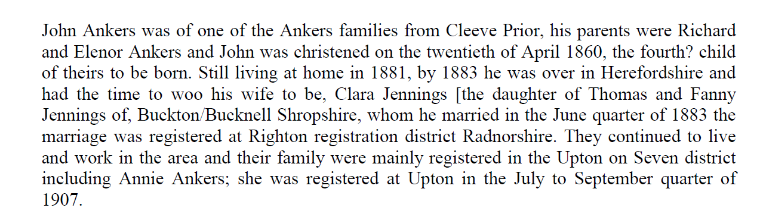
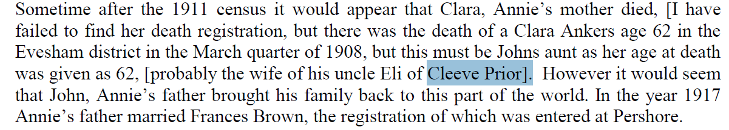
Information From Genes Re -united
- From: Jacqueline Ankers  Hello  I am afraid I do not know anything about Albert Ankers other than he lived at Fir Tree Corner/Cottage and had a granddaughter named Beryl and a daughter Jessy.  There were two strands of the Ankers family in Cleeve Prior and I belong to the other one - the family from the Kings Arms and Lynwood. I do know a little about the village and some of the people from the past  You have probably heard most of the stories but if you would like to give me a call I would be more than happy to have a chat and I also have some old photos.  Look forward to hearing from you  Regards Jackie Riches (Ankers)  Further from Jackie Riches (Ankers)  My grandparents, Esther and Richard (often known as jack) Ankers, had the land known as Rocks Ground, which was to the right of the Evesham Road council houses from the front. On this they had an apple and plum orchard and also grew Brussels sprouts and salad veg in season. The apples would be picked and put into pot boxes and transported back to Lynwood by horse and cart for sorting and onward transmission to Birmingham Central Market or sold locally. Produce was put into chip baskets or pot boxes and crates and left by the roadside for collection by one of the local transport companies (Marshalls is one I remember, also Langstons of Marlcliffe) to be taken to the above market. Business was conducted on trust and payment arrived in due course from the market. Dad was still using a horse and cart in 1954, also Old Bill, the cart horse was still being used to plough the land, including the fourteen or so acres in Hoden Lane. My granny did not like change which made life extremely difficult as the years went by. They grew asparagus, strawberries and cultivated blackberries, along with the usual wheat and cabbages, etc. The bower from the asparagus was cut and bundled and sent to BC Market to be sold for use in flower arranging.  Hope this is not too boring but not sure what you want to know.  Lynwood was built for Clara Ankers and was situated in what was essentially a farmyard. I am not sure if the double gates are still at the top of the drive but these blocked the farmyard from the road and village and were very effective as they were quite large. There was a huge tin and wood structure attached to the back wall of Sharrow, just inside the gates, and this was used to house the cart, trap, various bicycles, farm implements and cradles for asparagus and loads of other items. The farmyard ran right across the back of Sharrow, out to the Bidford road (I believe the stable block can still be seen from the road. The cows were brought in either from Hoden Lane of Sett (or Dead) Furlong, which was at the end of Quarry Lane and milked in the stables, where the swallows returned each year. There was a chicken house (which included Bantams) pigsties, a harness and tack room and the trap house. A wood pile and a midden, all hidden behind Lynwood. There were ducks and geese in the orchard to the right on the house A lovely place for a child. My parents left Lynwood in 1949 I think and rented a cottage from Mrs. Sadie Edwards who lived at Kemises Cottage opposite the village shop. The cottage was named Hill crest (now Almond Cottage I believe). It was very old and had a twisting stone staircase, a lot of woodworm (mum always said she could hear the deathwatch beetles ticking in the beams. I seem to remember there was a door in the wall of the entrance passage and seeing Mrs. Taylor (who ran the shop) coming through the door in her bathrobe to have a bath in the bathtub which stood in the middle of the kitchen (covered with a large wooden board which mum used as a table). There was an outside bucket lavatory which dad had to creep out to in the middle of the night and empty into a hole which he had to dig!  Mr. Stevens had an orchard which ran under my bedroom window on the right as you look at the cottage in which he kept goats (the smell was awful, just like old fashioned fish paste- yuk).  I could go on for hours but hope I have not bored you stiff.  When Clara and Eli were the innkeepers at the Kings Arms they would let the village people use their large ovens to cook food to save fuel (they were green even then). They also had a very good off licence business (cider) which was made at the cider mill next door. Pigeons were kept in the dovecote above the barn for use in the kitchen.  When I was growing up there was an Eli Ankers who lived in Nightingale Lane, along with his wife, they were childless. Eli's sister Rose also lived with them.  She lost her sweetheart during the first world war and had what we would term a breakdown. She was put into a local mental hospital for many years and Eli had a great deal of trouble obtaining her release because she was such a good worker. She was an absolute delight, childlike in a sweet and gentle way - everyone loved her. It would take a while to put the Ankers family tree on here for you but I can have a go if you wish in the future.  I have a lot of memories of people in the village, Mr. Welland, Mr. Vickerage, etc. I do not want to bore you so let me know if you would like any more info - like dad I can go on and on.  Please be in touch  Jackie  Chroniclers note: Jackie Riches kindly has given us the following Photos  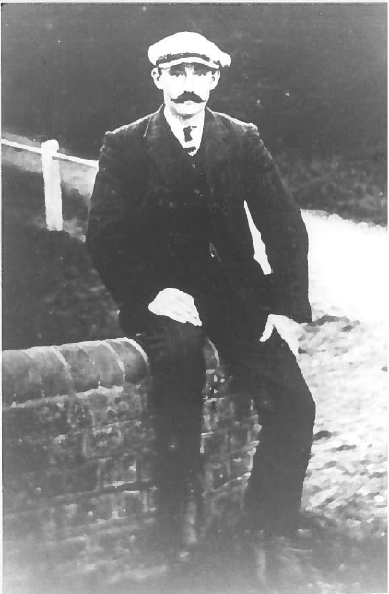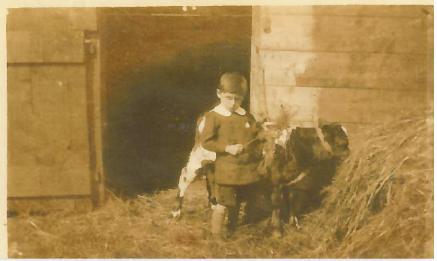  Richard John Ankers of Lynwood John Thomas Ankers k/as Jack at Lynwood [often known as Jack]  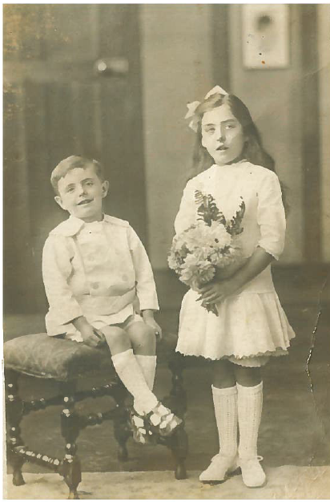 Molly & Jack Ankers  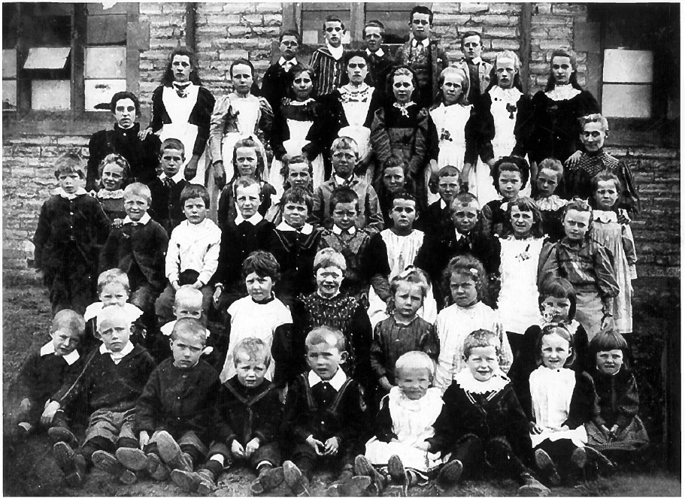  Cleeve Prior C of E School date unknown  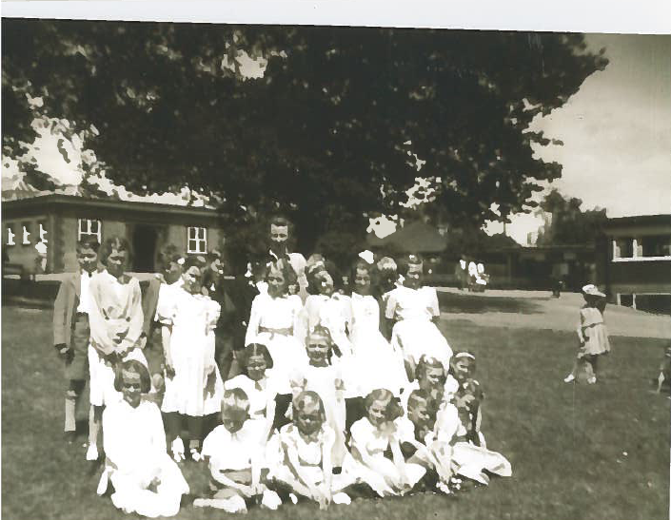  Cleeve Prior trip to Wixstead Park Probably 1953/54 Jackie can name them if we require | 16 Jul 2014
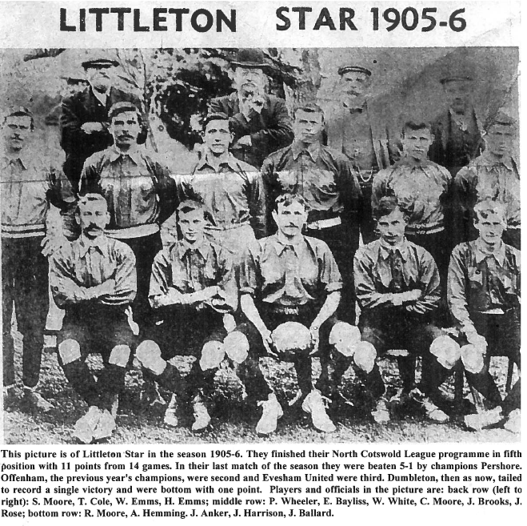
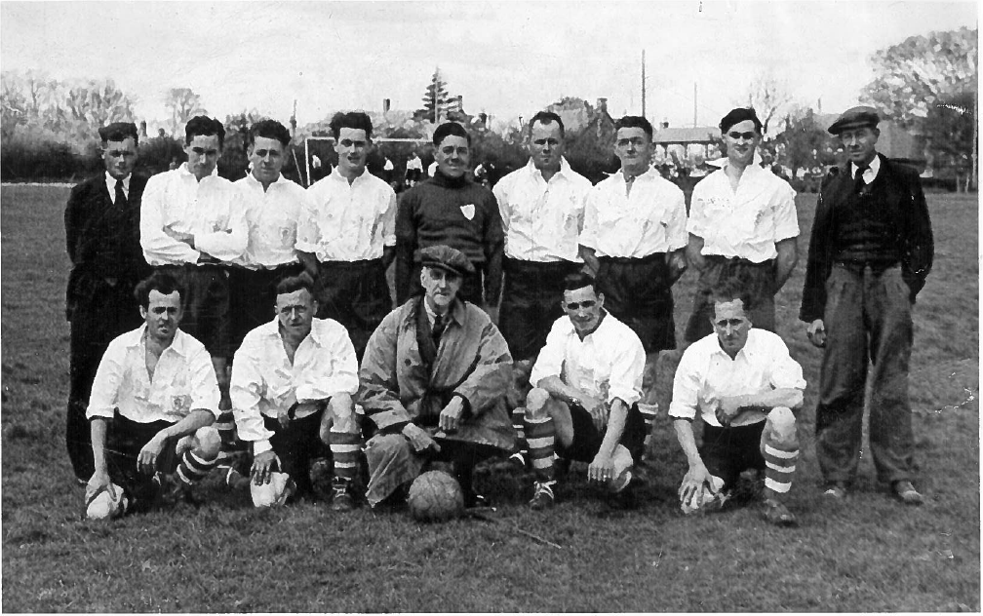
L-R Back Row | L-R Front Row
Alfred Selby | Jack Ankers
Ralph Hammond | J. Watson
Fred Ballard | Danny Brown
Gordon Selby | Vic Childs
Phil Moore | J. Haskins
Tom Hathaway
Jack Hiatt
Eric Carter
George Porter

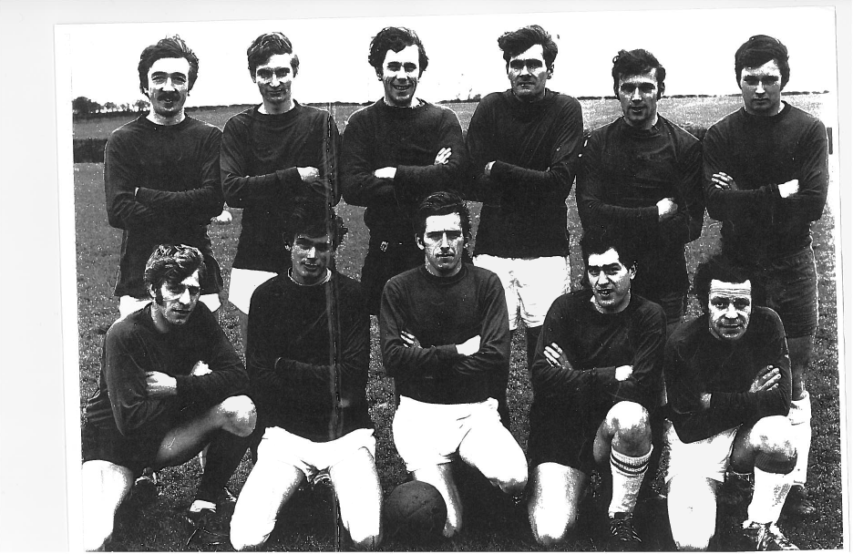
Subject unknown thought to be local team.
Chronicler note: does anyone recognize the team or players?
L-R
Fred Basket
Cyril Bunn
Len Edwards
Norman Fairfax
Jack Ankers
John Sheaf
Eric Carter
Fred Brooks
Eli Ankers
Peter Milward
Jack Wilks
Dave Spiers

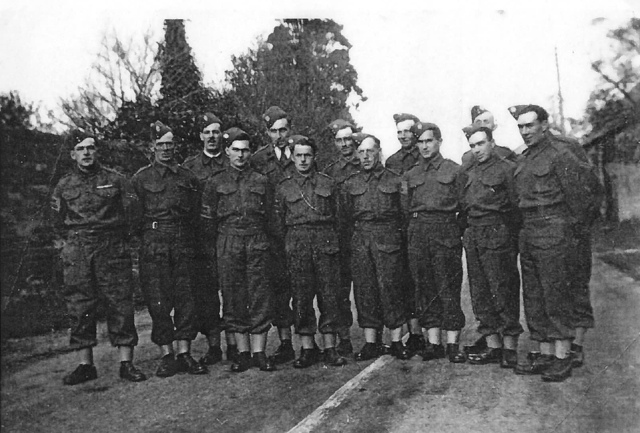
Note on picture
To Mr. & Mrs. Ankers From Herr & Frau Steegen To Remember from P.W. Herbert Steegen 31 12 1948
[POW who became like family]
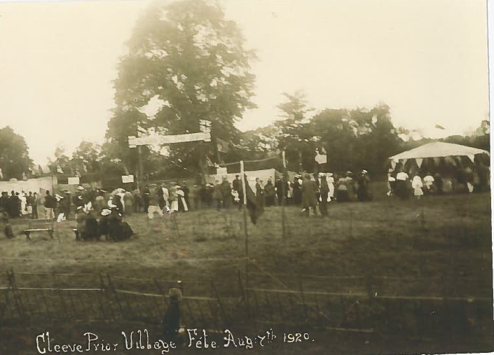
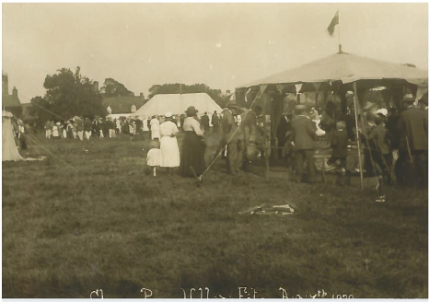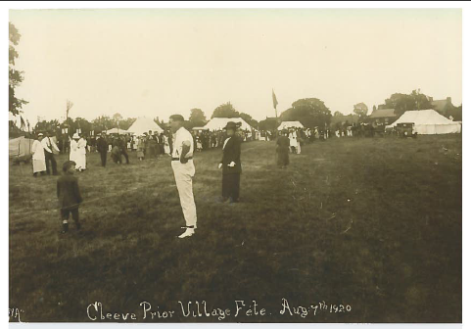
_______________________________________________________________________________
From Shirley Talboys (nee Harwood)
My mother was born at Peacock House in 1914, the daughter of Arthur and Mary Sparrow. Mary's maiden name was Ankers and her parents kept the Kings Arms. Mary had a sister named Clara and a brother, Richard. I believe Richard lived in Cleeve Prior until his death. I also believe the Ankers had Lynwood built and moved there when they retired from the Kings Arms. Most of my mother’s relatives, Ankers and Sparrows are buried in the churchyard at Cleeve.

Asteley John
1555 6th October. Given lands in trust by Christopher & Ann Pylkyngton, namely a messuage [ the Laurels], cottage, dovecote, two gardens, one orchard, eighty acres of arable, eight acres of meadow, one acre of wood in Cleeve Prior. Asteley to ensure that the Pylkyngon children should inherit, or in the event of Ann dying childless, that the heirs of Christopher should inherit
from “the Laurels” by Lloyd J Edwards

Bacon John
1693 September, Married Ann Taylor art Ettington
16th March 1719-20 Yeoman of Armscott Warwks. Brother of William Bacon & father of Ann. Paid Nathaniel Rouse £300.0.0 and John Rouse £100.0.0 for the messuage [ the Laurels], close,, dovehouse, yardland, halfyardland A Cottage, and tythes from four lands “heretofore” of Richard Squire in Cleeve Prior, two gardens, one orchard, eighty acres of arable, eight acres of meadow, one acre of wood in Cleeve Prior.
From “the Laurels” by Lloyd J Edwards

Bacon William
16th March 1719-20 Yeoman of Upper Ettington Warwks. With William Rouse he leased the messuage [ the Laurels], close,, dovehouse, yardland, halfyardland A Cottage, and tythes from four lands “heretofore” of Richard Squire in Cleeve Prior, two gardens, one orchard, eighty acres of arable, eight acres of meadow, one acre of wood in Cleeve Prior from Nathaniel Rouse for 5s 0d for one year from 29th Sept 1719.
From “the Laurels” by Lloyd J Edwards

Baldwyn Bernard
11th June 1860 Gentleman of Aston Mill Farm, Kemerton, Gloucs. With his sister Frances he paid Henry East £3000 for Charles Baylis’ mortgages on the Laurels
24th June 1863 was granted the Copyhold estate of “The Laurels”
30th July Charles Baylis purchased the freehold of the Copyhold estate of “The Laurels” and assigned back as security for £3000 loan
15th June 1864 loaned Charles Baylis further £500 against the farmstead & lands in Cleeve Prior
8th Jan 1866 was paid £3500 by Charles Baylis to redeem above mortgages
From “the Laurels” by Lloyd J Edwards

Ball
From The Evesham Journal Feb 28th 1920
Double Military wedding. Smithin-Mayer and Ball- Sheaf

Basket
Fred Basket was in the Home Guard during the second world war, but in the 1930’s he was the Caretaker at Cleeve House, on the bridleway , owned by a Birmingham company “Brades”, a house for the workers to use for holidays & breaks.

Bayliss

Bayliss Ann
4th February 1825. Under the will of her half-brother Thomas Rouse IV, she was to receive £200 following the deaths of both her half sister Mary Rouse and their Mother Ann Rouse, late Baylis. In the event of their mother pre deceasing Mary she was to look after her.[Mary pre deceased their mother]
1st Jan 1853 following the death of her mother Ann received her £200
9th June The daughter of Ann [later Rouse] and William Baylis, and the sister of Charles & George Baylis, and the half-sister of Thomas & Mary Rouse. She had been left £200 in the will of her late half-brother Thomas Rouse IV
1871 lived at the Laurels with her nephew Thomas Rouse Baylis and his wife. She was 65 born in Bidford.
From “the Laurels” by Lloyd J Edwards

Bayliss Charles
Born 1809 4th Feb 1825. Under the will of his Half-brother Thomas Rouse IV, he was to receive the latter’s freehold and copyhold estates in Cleeve Prior, but would have no control over them until after the deaths of both his half-sister Mary and their mother Ann Rouse, late Baylis.
24th October 1832 of Cleeve Prior and 23 years old, with Henry Haywood, he was granted the Reversion of the Copyhold Estate in trust for the use in the Will of Thomas Rouse Deceased
22nd October 1834, 25 & yeoman of Cleeve Prior, together with John Haywood he was granted the Reversion on the above copyhold estate, previously granted on 24th October in 1832, in trust for the same uses.
4th April 1845 Gentleman of [Wood] Bevington, Warwks, paid John Humphrey Haywood £500 to redeem the mortgage of 29th Sept 1823 on “The Laurels” and lands in CP to the late John Hayward
25th October 1848 as Yeoman of CP with Henry Hayward he was granted possession of the Copyhold estate, Hayward was the tenant.
3rd June 1853 Gentleman of [Wood] Bevington, Warwks. He mortgaged messuage [the Laurels], close,, dovehouse, Cottage, freehold & copyhold estates in CP to £2000. Together with Henry and John Hayward and William Robert Smith they held the estate in trust for William East
9th June 1853 Gentleman of [Wood] Bevington, Warwks. Son of William & Ann Baylis, Brother of George & Ann Baylis. Half-brother of Thomas Rouse IV and Mary Rouse. He inherited “The Laurels” and its Freehold and copyhold estates in CP, following the deaths of Thomas [1825], Mary [1830]] and their mother Ann [1852]

25th July 1854 He had not paid the mortgage of £2000 owed to William East now rcd a further £1000 against the same security to be paid by 3rd Dec that year or at interest of 5% thereafter
11th June 1860 he transferred the above mortgages from H East to Frances and Bernard Baldwyn.
24th June 1863 see Bernard Baldwyn
3rd July He purchased the freehold of the copyhold estate from the Ecclesiastical Commissioners & assigned it to Bernard Baldwyn
8th Jan 1866 Bernard Baldwyn
9th January mortgaged freehold to William Haydon Loxley for £2500
13th June 1870 son Thomas Rouse Baylis is tenant of freehold estates. Mortgage transferred to Mrs. Keep Messrs. Geard & Hollyer who loaned him further £1000
8th March 1872 loaned further £500
14th March 1873 Mortgaged lands in Bidford to FH Goldney for £500
20th August 1873. Now living at “the Laurel’s” borrowed further £925 from Goldney against CP Estate and property in Marlcliffe
11th May 1874 moving mortgages to C Prance of Evesham & requested further £1000
9th January 1875 Goldney still not received monies
21st December 1875
Defaulted on the principle sums, Prance foreclosed & sold the freehold estate to John Smith Holtom. Not known what happened to Marlcliffe estate.
1875 Died
From “the Laurels” by Lloyd J Edwards

Baylis George
George Baylis was born about 1814 in Cleeve Prior, Worcestershire, England. About 1864 he was a Farmer. In 1871 he was a Farmer.
Spouse: Sarah Lovelock. Sarah Lovelock and George Baylis were married after 1841. They appeared in the census in 1861. Children were: Letitia Baylis, Caroline Baylis, Ann Baylis, George Baylis, Ellen Baylis, John Hurst Baylis.

Bayliss Rebecca
Married Charles Baylis [son Thomas Rouse-Baylis] 13th June 1870
From “the Laurels” by Lloyd J Edwards

Bayliss Thomas Rouse
Son of Charles & Rebecca 13th June 1870 tenant of freehold estate in Cleeve Prior, not sure if he lived at the Laurels
20th August 1873 no longer tenant of estate [census]
From “the Laurels” by Lloyd J Edwards

Bayliss William
4th June 1840 butcher in Bidford married Ann Rouse widow of Thomas Rouse III
1820 recorded with his younger brother as farmer in CP [Directory of Worcester p380]
1824 he died
From “the Laurels” by Lloyd J Edwards

Bennett

Bennett Ann
18th July 1670 Widow of Charles Bennet II left all his “Lands tenements, goods, chattels, horses, cowes, cattell, and implements of household & husbandry” 16th August 1672 she purchase back part of land not bequeathed to her part of 99 year lease on Halfyardland B
18th June 1674 paid her sister in law Elizabeth Bennet £100 in lieu of bequests to her from her brother & Father [Charles Bennett 1 &2]
1675 1st March took over whole of 99 year lease on Halfyardland B as the other party defaulted on the mortgage. She then sold the whole to Thomas Pilkington II the defaulter for £100
1679 Married Thomas Harris at South Littleton
From “the Laurels” by Lloyd J Edwards

Bennett Charles I
24th Jan 1852 Miller from Salford Priors Purchased land known a s Halfyardland A with John Squire from Thomas Pilkington for £167 10s
19th Sept 1658 He also held one land plus another on Oden Hill in the East field and one land in Churwell in the west field all at CP. Died 1668
From “the Laurels” by Lloyd J Edwards

Bennett Charles II
23rd August 1668 Surgeon in South Littleton inherited all lands with sisters from father Charles Bennett I died 1670
From “the Laurels” by Lloyd J Edwards

Bennett Edward
24th Jan 1652 he had 1 land in east field Cleeve Prior
1668 presumably dead left his nephew Charles Bennett his estate which he “lived upon”
From “the Laurels” by Lloyd J Edwards

Bennett Elianor
Father Charles Bennett miller of Salford Priors, Sister of Thomas, Charles, Woodchurch, Mary & Elizabeth Bennet & party to all their transactions
22nd Dec 1676 now wife of William Lane the younger they were party to sale of 19 acres of land & common Pasture to William Rouse I ,they therefor agreed a levy or fine
From “the Laurels” by Lloyd J Edwards

Bennett Elizabeth
Father Charles Bennett miller of Salford Priors, Sister of Thomas, Charles, Woodchurch, Mary & Elianor Bennet & party to all their transactions
29th January 1676 she sold all her interests in Halfyardland A to William Rouse I
From “the Laurels” by Lloyd J Edwards

Bennett Frances
With husband Thomas & son William sold freehold of Halfyardland A to William Rouse I incl 16 acre arable, 1 acre meadow 2 acre of pasture &common pasture
From “the Laurels” by Lloyd J Edwards

Bennett John I
19th September 1658 his Lands in CP comprised one Land in the yellow furlong of North field, one land near Bickmarsh hedge in the east field one land on Oden Hill in South Field, One Through-shooter in Wett furlong and one Toftte near Richard Charlett’s hadland in West field
From “the Laurels” by Lloyd J Edwards

Bennett John II
24th April 1777 Held buildings now kings Arms gardens & Malthouse in trust with John Rock for the beneficiaries of Charles Squire.
From “the Laurels” by Lloyd J Edwards

Bennett Thomas I
1662 paid 2s 0d for 2 chimneys in CP - Hearth Tax WRO 7449/i
6th June 1672, Yeoman & Miller of CP
6th January 1676, now miller of Wolford Gloucs agreed to sell Halfyard A and 1 acre meadow to William Rouse I before 10th March, 16th March was sold.
Parcel described as :
“16 acre arable 1 acre meadow 2 acre of pasture plus common of pasture for all manner of beasts in Cleeve Prior”
Died 27th December 1698, 78 year old husband of Frances
From “the Laurels” by Lloyd J Edwards

Bennett William
Son of Thomas above
From “the Laurels” by Lloyd J Edwards

Bennet Woodchurch
Son of Charles Bennett I Brother Charles Bennett II
16th March 1676 he was tenant of William Rouse on Halfyardland A
20th May classed as Husbandman & with brother Thomas leased Halfyardland A from William Rouse for 1 – 4 years
17th October 1679 for consideration of 47 paid by Hannah widow of William Rouse they transferred the lease to Samuel Currier, a Husbandman of South Littleton. The agreement included :
“4 mares, one gelding 6 cows, all his[Woodchurches]” corne, wheat, barley, pease, hay, carts, ploughs, gears, harrowes, household imps and all other goods chattels cattle implements of household husbandry whatsoever”
17th December buried in Cleeve Prior
From “the Laurels” by Lloyd J Edwards

Bennett -General
Chronicler says also see account of history of Charlett’s House in Charlett family history
John Bennet was a principle Land owner in the village. In 1811 he persuaded Thomas Sheppey to give him for safe keeping, the gold coins he had discovered in the field beyond Suncourt, he sold the coins in small lots.
Among those he sold to were Thomas Bennet Thomes & John Thomes, his relatives from Cleeve prior

http://www.pacefamilyhistory.info/records/bennett.htm
http://www.ebooksread.com/authors-eng/w-p-w-william-phillimore-watts-phillimore/worcestershire-parish-register-marriages-volume-2-lih/page-5-worcestershire-parish-register-marriages-volume-2-lih.shtml
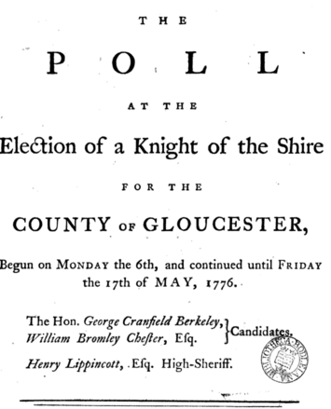
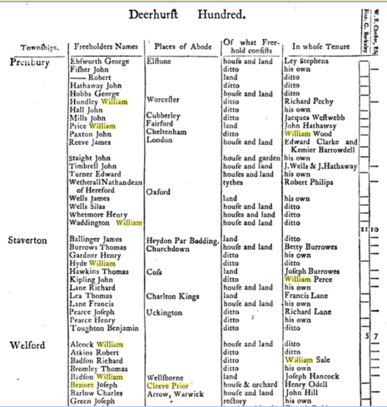

Other Bennett Records
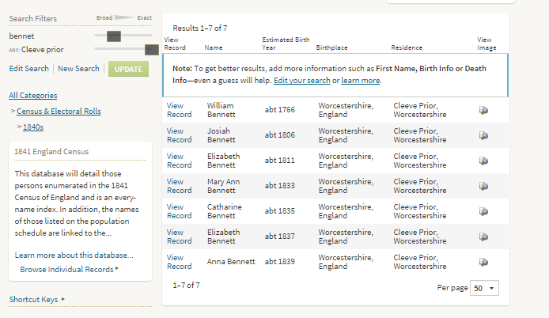
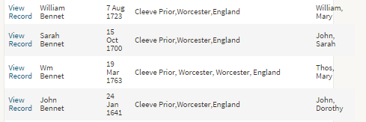

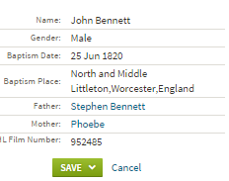
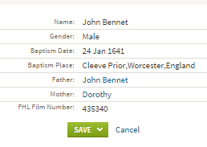
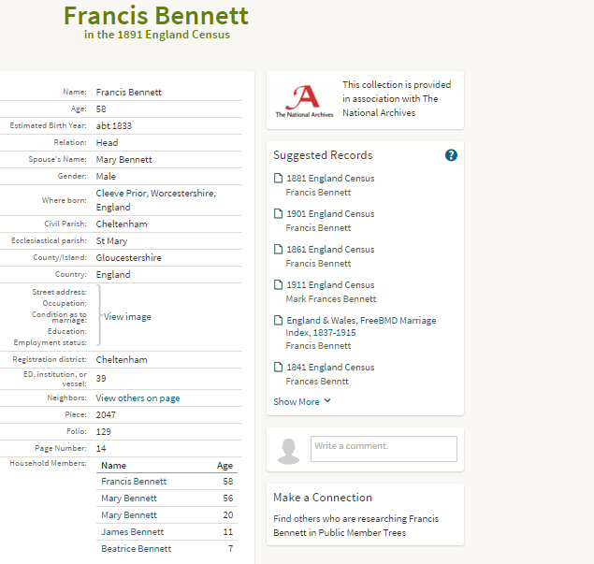
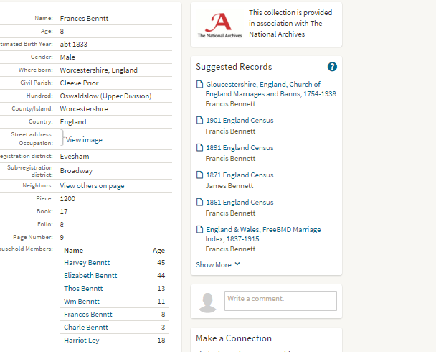
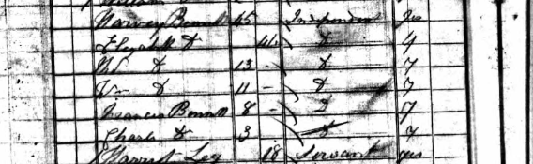

Tomes abstracts from parish registers imply that in 1698 the two principle landed families of Cleeve were allied by the marriage at All Saints Church, Evesham, by licence, of Sarah Charlett, age 17, to John Bennett age 30, The brides age & the fact that the ceremony took place at Evesham though both parties belonged to Cleeve, may have been significant.
They had eleven children, of whom the third, Thomas 1703-85 succeeded his father in 1729, married four years later and had five children. Of these five, one some died in infancy, the other two died without issue, and the estate devolved in 1819 upon the elder daughters grandson, Thomas Bennett Tomes, who was apparently an ancestor of the 1903 investigator.
Register entries show that the last Charlett buried at Cleeve was John, an Evesham surgeon in 1807; the last Bennet, Elizabeth, wife of John [who left the property to Tomes] in 1812. By some descent, not clear at present, the property passed to henry Adkins after the Melins * & the Batemans had been Tenants. Batemans Grandson Charles Lunn, married Adkins daughter: Mrs Charles Lunn owned the Charlett house in 1903 and it remained in her family for some time. It has changed hands several times since and it now belongs to a firm of brewers in Shropshire.

Betteridge

I belong to a family of Betteridge’s that have been living in the Salford Priors, Bidford-On Avon (my father has lived in Broom since 1976) areas of Warwickshire. My Great Grandfather Richard (Dick) Betteridge died approximately 11 years ago under the care of Alcester Hospital which is now I am led to believe an old peoples home (originally a workhouse). There is also a Betteridge in Cleeve Prior Warwickshire whom I know is now relation to our chain of Betteridge. I don't know if this is of any use or is useless information
Genes reunited- Amanda Ward Nee Betteridge

Biddle
1775 Following the enclosure of the fields he & Charles Welch jointly held lands adjacent to John Rouse II. Biddle & welch were also Trustees of the stone quarry
-From the Laurels by Lloyd J Edwards
The wharf was awarded [presumably under the enclosures act to Charles Welch & John Biddle and their heirs to be a “public wharf for the use only of the proprietors and tenants of land within the parish”
Welch & Biddle were long dead & no heirs had come forward, so if the Parish Meeting assumed ownership their claim was unlikely to be disputed
Don Archer

Bomford Benjamin Norris
Born 1894 grandfather Benjamin was cousin to Caroline, wife of George Baylis the son of William, His father, Benjamin [1856-1929 was co-founder of Bomford Brothers.]
31st December 1918 he purchased 11 acres 1 rood 14 perches of meadow land in Cleeve from the Holtom’s. Died 1928
-From the Laurels by Lloyd J Edwards

Bradshaw Samuel

Reference: | MS 3438/ACC 1933-031/406003
Description: | Grant of letters of administration of the estate of Samuel Bradshaw, late of Cleeve Prior, co. Worc., weaver, deceased to William Bradshaw his nephew. With copy of the will dated 4 June, 1825, attached.
Date: | 30 June, 1827
Held by: | Birmingham: Archives, Heritage and Photography Service, not available at The National Archives

Brockington

Brockington William

24th January 1652 he had one land in the East field of Cleeve Prior
6th December 1665 his son William was baptized at Cleeve Prior
-From the Laurels by Lloyd J Edwards

The Brockington Family
The ancestors of William A. Brockington, whom I shall call Will, came from Cleeve Prior in the Vale of Evesham-- we have records for the family there from 1527. The name Brockington actually appears on the tenor bell at the Cleeve Prior parish church, which was recast in 1658: the whole inscription reads ‘THOMAS PILKINGTON EDWARD BROCKINTON CHURCHWARDENS’. The history of the family. He had been born in Cleeve Prior and then lived in nearby Morton Bagot, when his widowed mother remarried
See document Brockington family
From: Lady Kira | 16 Jun 2014
Hi Ian
I am interested in Cleeve Prior. I have very little on there at the moment but it is where my Braggingtons started from. The name has many forms ranging from Brock Brockington Bragynton etc. and many times from the same document. I think there are also a few misinformed trees out there so be careful. The family migrated from there to Petworth then Evenlode before spreading further afield.
Christine
From Genes Re-united

Brooks
Charley Brooks was one, he was a carter at Top Farm. He lived in Nightingale Lane, we called it that because he had six daughters and they sang like nightingales. He used to play the squeeze box and they had socials in Lilac Cottage on Froglands ‘cause they had a big front room
From the recollections of Frank Vickeridge
In the early 1900’s the Long House in Nightingale Lane was three cottages. Charles Brookes lived at the far end, William Taylor in the middle and a Miss Teague in the one nearest the village
Dances, whist drives & sing songs- Charles Brooks who lived in Nightingale Lane had five daughters. They were a musical family and toured the district as “Charles Brookes and his Nightingales” giving concerts and providing music for sing-songs.
From the recollections of Eli Ankers

The Bushells
The most important of the Manor tenants, being in residence through the 17th & 18th Centuries, the will of the first Edward Bushell being dated 1546. The first Thomas Bushell was born in 1594, living at Cleeve Prior; he entered the service of Sir Francis Bacon when 15 & subsequently followed him to court.
After Bacon’s fall from grace in 1621 Bushell took himself off, in the face of allegations of corruption, to the Isle of Wight and then the Calf of Man where he claimed to have lived the life of a hermit subsisting on herbs and whatever else grew nearby for three years. He was able to return to Bacon’s service in the final years of his life and when his mentor died in 1626 Bushell was set up with a marriage to an heiress and was able to take on the small estate in Enstone the same year. He then spent the next decade in improving the property including building the grotto and attached banqueting house, which even at the time astonished his contemporaries with its extravagance given that he only had leasehold on the property[ see Thomas Bushel –Enstone Marvel]. One Lieutenant Hammond who visited in 1635 remarked that it was all ‘a mad gim-cracke sure’.
During this period in 1630 he was fined £13/6/6 for not appearing at the coronation of Charles 1st & accepting a knighthood.
All this lead up to the royal visit of 1636 when Bushell was able to make a pitch to Charles I for the opportunity to take over the royal silver mines in Wales. Is it too cynical to suggest that attracting this kind of royal patronage was part of his motivation for creating the Marvels in the first place? Bushell’s ambitious proposals for the mine workings were clearly not costed and he rapidly ran up huge debts. He was obviously an accomplished salesman for as Aubrey says in his Brief Lives, ‘his tongue was a chaine and drew in so many to be bound for him and to be ingaged in his designes that he ruined a number’. Nevertheless in 1637 the crown issued letters patent to enable him to set up a mint in Aberystwyth from which he issued silver coins. He went on to run similar operations from the Mendips & other locations. At the outbreak of the Civil War the mint was moved to Shrewsbury and in 1643 Bushell and his coining operation followed the king to Oxford.
Charles 1st recognised his assistance & wrote warmly of Thomas Bushell about
“The many valuable services you have actually done for us, such as raising the Derbyshire miners for our bodyguard; supplying us at Oxford & Shrewsbury with mint for the payment of our army, when all the other officers in the Mint of the Tower of London foreswore their attendance. Your providing us with a hundred tons of lead shot for our Army without money, when we pay £20/- per ton; your helping us to 26 pieces of Ordnance; Your contracting with merchants beyond the seas for providing good quantities of powder, pistol carabines and musket in exchange for your own commodities; your clothing of our Life Guard and three regiments more; your invention of Badges of gold & silver for rewarding the Forlorn Hope; And with divers other services”
From there he was sent to Bristol and ended the war as commander of the garrison on Lundy, only surrendering to Parliament in July 1646. He was so important to the country that after the formation of the commonwealth his leases on the mines were renewed by Cromwell.
He tried to float a variety of new mining ventures in the west country during the early years of the Commonwealth and like many Royalists was disappointed by the lack of success he had in trying to press his claims for financial compensation with the newly restored Charles II. All this lead to his final years being ones of perpetual debt and Thomas Bushell died in poverty in 1675 aged 80, but due to his services to the nation he was buried in the cloisters at Westminster Abbey.

In 1696 Robert Bushell was the occupant at the Manor & married Dianna Fettiplace of Swinbrook near Burford. Their son Thomas, born in 1697, who became the sheriff of Worcester in 1729, was the Last in the family line as he succeeded his uncle sir George Fettiplace, and took the Fettiplace name by act of Parliament. In the will Sir George left his estates & properties “To my sister Diana’s son” these amounted to £180,000 in cash and property incomes of £8,000 a year.
From the Internet

The Bushells & the Military
In 1697 after his marriage Robert was a lieutenant in the Worcester militia, important at this time as being one of the major source of land troops at times of conflict. The Militia were called out when the French attempted an invasion of England in 1690, in the reign of William III and Mary, who had, in the previous year, ascended the throne vacated by the unfortunate James II. We see below the list of the officers of the Worcestershire Militia in the year 1697, in the reign of William III. Along with their military strength’

Rank | Name | Military Strength
LORD LIEUTENANT | Charles, Duke of Shrewsbury, K.G. | 60 men
Two Troops of Horse
Captain [first troop] | Lord Herbert of Cherbury
Lieutenant | Thomas Burlton
Cornet | Thomas Perrot
Quartermaster | Godman Attwood
Captain[second troop] | William Bromly | 60 men
Lieutenant | Robert Bushell
Cornet | Posthumous Sheldon
Quartermaster | George Leach
Total Men |  | 120 men
A Regiment of Foot (7 Companies)
Colonel | Charles, Duke of Shrewsbury, K.G. | 72
Lieutenant | Chambers Slaughter
Ensign
Lieutenant-Colonel | Sir James Rushout, Bart | 123
Lieutenant
Ensign
Major | Edmund Lechmere | 116
Lieutenant | John Arthur
Ensign | Frances Withes
Captain | Richard Dowdeswell | 122
Lieutenant | Joseph Jones
Ensign | William Harris
Captain | William Walsh | 113
Lieutenant | Arthur Lowe
Ensign | Richard Orundell
Captain | Samuel Jewkes | 109
Lieutenant | Thomas Bradley
Ensign | Samuel Saunders
Captain | John Sheldon | 131
Lieutenant | Obadiah Orford
Ensign | John Tilsley
Total Men |  | 786
Abstract | A Regiment of Foot, 7 Companies | 786
 | 2 Troops of Horse | 120
TOTAL |  | 906
At this period the only mounted officer was the major, and each company carried a colour. All movements were done in slow time. Officers and sergeants pulled off their hats on marching past the saluting point, the former having previously saluted with their pikes.
The regiment was called out for training annually until the commencement of the reign of George I. Circumstances had altered since the Restoration, and a standing army, which was then so unpopular, was now looked upon as a necessity. Little interest was therefore manifested in the Militia, and it was much neglected.
In 1714 the Militia were armed as follows:- The Horse, a broadsword, a case of pistols (the barrels of the pistols were twelve inches long), and a carbine. The Foot carried a musket fitted with a bayonet (the barrel of the musket being five feet in length), and a sword.
In 1715 the Militia was called out for training, but between that date and the reorganization of the force in 1757—a period of over forty years—there were only two further trainings, in 1734 and 1745; so that the greatest admirers of the Militia could but admit that it had been allowed to fall into a very unsatisfactory state. A writer in the Gentleman's Magazine in January, 1733, says they were not fit at that time for anything "besides furnishing the town with a ridiculous diversion, and cramming their guts at the expense of their industrious fellow-subjects." After the year 1745, no notice whatever was taken of the force; it was not called out for training, and for all practical purposes may be said to have almost ceased to exist (see note below).
Robert & Diana’s grandson, Robert, having assumed the name of Fettiplace, was Lieutenant-Colonel of Worcester Militia, 1770-1775.
See Bushells & the Worcester Regiment

Bushell Anthony
4th March 1612 baptised at CP
1649 He deserted the Royalist army before the battle of Naseby –VCH, vol 3, p310
19th September 1658. A gentleman of Cleeve Prior. In West field of Cleeve Prior he held one land in Churwell, one land near Elmes, one land in Wett Furlong and one land near Richard Charletts hadland. In Cleeve Meadow he held the leyes near the mouth of the river Arrow
From “the Laurels” by Lloyd J Edwards

Bushell, Dorothy
23rd October Dorothy Bushell married John Norton at Cleeve Prior
24th January. Widow. In the fields of Cleeve Prior she held in one land on the Hurst in the South Field. In the North field she held one land on Lowe Hill, and one land shooting towards Dead Furlong Hedge. In the east field she held one land near the Brooke
From “the Laurels” by Lloyd J Edwards

Bushell Edward I
His father rented Cleeve Prior Manor House and its lands from The Dean and Chapter of Worcester
1604 Baptised in CP
Married Elizabeth at CP
Children baptised Ann 30th Dec 1632
Thomas 19th Aug 163?
Edward 8th September 1635
John 30th May 1637
William 8th November 1638
Mathew 13th April 1641
19th September 1658 A gentleman of Cleeve Prior. In West field of Cleeve Prior he held one land near Elmes, one land in Wett Furlong in north field he held one land in Foxhole
From “the Laurels” by Lloyd J Edwards

Bushell Thomas I
1594 possibly the Thomas baptised at Cleeve Prior
Before the civil war he held the royal mines in Cardiganshire and minted money for the king at Aberystwyth Castle. VCH Vol 3 pg. 310
1650 Hid in a hole under one of the floors in Cleeve Prior Manor for Many Months. He later gave Securities for good behavior to the protectorate and obtained a renewal of his lease on the mines.
24th January 1652 A gentleman of Cleeve Prior. In East field of Cleeve Prior he held one land on Lowe Hill in Northfield he held one land in Foxhole
From “the Laurels” by Lloyd J Edwards

Thomas Bushell -The Enstone Marvels
The Bushell family also had a residence at Enstone in the Cotswolds not many miles from Cleeve Prior
The village of Enstone, some 20 kilometres north–west of Oxford was home to one of the most extraordinary collections of water powered special effects or giochi d’aqua as they are termed in Italian, known collectively as the ‘Enstone Marvels’. Completed in 1636 by Thomas Bushell they became known as one of the wonders of the age and were subject to a well-documented visit by King Charles I and his queen Henrietta Maria in that same year. Their fame was enshrined in Robert Plot’s Natural History of Oxfordshire of 1677 which not only had detailed descriptions of the site but also two memorably detailed engravings. Widely illustrated in most books on garden history it has been assumed that the actual site of the Marvels would have little to show given that they were comprehensively demolished in 1846. A preliminary visit in March 2013 has shown that while this may have been the case there is still plenty of material around that, subject to archaeological investigation can reveal more of the nature of this remarkable site
We are told that a natural spring known as the Goldwell was being cleared on the orders of Bushell when it became clear that he had accessed something of a natural phenomenon, in particular a ‘petrifying well’ a source of water high in Calcium which is so ordered that dripping water rapidly coats nearby objects in a layer of calcite
.It is unclear whether Bushell’s intention in settling here was from the outset to create something special or whether it really just a happen chance that Bushell decided to capitalize on. What is obvious is that even today at least half a dozen springs bubble up out of the ground here.

.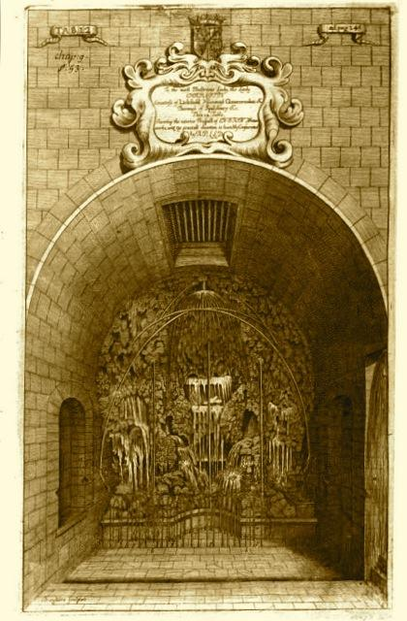 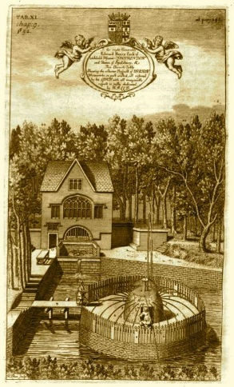
The general location of the Marvels has never been entirely lost. They stood on the northern side of a broad steep sided valley cut in the underlying Chipping Norton Oolitic limestone by the eastward flowing River Glyme.
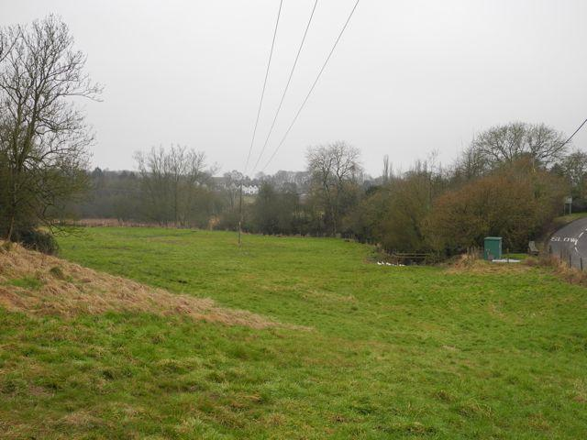
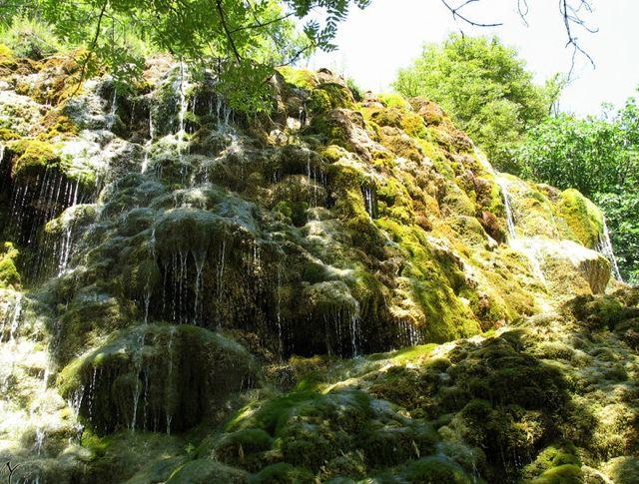
Le Jardin des Fontaines Pétrifiantes near Grenoble in France, could this resemble something Bushell discovered when he cleared the undergrowth?
Enstone, on Stoney Bridge, looking south towards the River Glyme. The Marvels were behind the trees, centre right.

As he is the pivotal figure in the story of the Enstone Marvels it is worth considering in outline the career of their originator Thomas Bushell. The information that follows is taken from the on-line version of the Dictionary of National Biography. There is a more detailed account of his life penned in 1932 by J.W. Gough but I have not yet been able to track down a copy. Bushell was born some time before 1600 to a family of minor gentry from Cleeve Prior near Evesham. He had a chequered childhood with little education and a certain amount of wayward behaviour before, at the age of 15, entering the service of Sir Francis Bacon. Bacon was one of the foremost natural philosophers of the day and his interest in scientific method and technology must have done much to form Bushell’s view of the world. Bacon clearly took to the young Bushell and began to remedy some of the defects in his education. They shared an interest in current technologies and became concerned in the refinement of certain techniques for draining and ventilating mines.
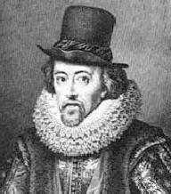 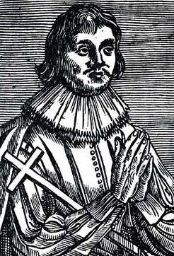
Sir Francis Bacon and his protégé Thomas Bushell
Imprisonment. Finally in 1633 he was granted a position of ‘gentleman of the privy chamber extraordinary’ which gave him some measure of protection. He died in 1674 and was buried in the cloisters of Westminster Abbey.
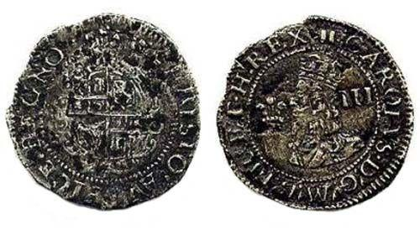
An Aberystwyth silver threepence minted by Bushell
We have little information about Bushell's relationship with Enstone during the Civil War years and afterwards except to note that according to Plot the works had fallen into disrepair and things were not put right until 1674 when presumably upon Bushell’s death the lease reverted to the landowner the newly promoted 11 year old Earl of Lichfield. Sir Edward Lee, the fifth baronet Quarrendon was created earl by Charles II on the occasion of the boy’s betrothal to the King’s illegitimate daughter Charlotte Fitzroy.
Although Bushell was clearly the originator of the Enstone Marvels some of the more remarkable features were added by the Earl of Lichfield which of course poses a number of questions. Given his tender years one wanders on whose advice the decision was taken not only to restore but also extend the Marvels. Was this by way of acknowledging and celebrating the arrival of a new earl by means of a high profile building project which demonstrated how much in touch he was with current technological wonders? It has to be said, however, that by the time of Plot’s visit in the 1670s such things were already looking slightly old-fashioned, perhaps the young earl had not been particularly well advised.
- From: Terence Baker | 17 Jun 2014
Hi Ian,
I have a connection with the Fettiplace (formerly Bushell) family, some of whom lived at Cleeve Prior. Some descendants were the Blandy family of Kingston Bagpuixe, Oxon. Constance Mary Blandy married my great uncle Allan Hugh Sancroft Baker in South Africa where they settled. AHSB fought for the British army in the Boer War there
I shall be out playing in golf events during the next 2 days. In the meantime see my tree on www.rootsweb.com. Select 'Family Trees' at top of screen, then in the 'jump to a specific database' box enter 'annedorothy' (without quotes).
If you have any questions contact me at terrysbaker@gmail.com.
Regards,
Terry Sancroft Baker
From Genes re united

Cannaway

Cannaway William
3rd June 1863 He held lands in the quarry Field at Cleeve Prior. These Lands bounded by Part of the west side of lands held by Charles Baylis and were once held by Thomas Johnson
From “the Laurels” by Lloyd J Edwards

Cannaway George
An Inquest was held at the Kings Arms Inn on the body of George Cannaway, baker of Cleeve Prior, whose body was found in the River Avon on April 12th. Charles Newman of Cleeve Prior, said he knew the deceased & worked for him. He last saw him alive between 8 & 9 o’clock on 12th April. He was leaving the yard and going in the direction of the house. The deceased had been low spirited for 4 – 5 week but the witness did not know the cause of it. About 2 o’clock the witness went to look for the deceased thinking it strange that he did not come home for dinner. The witness went to the Mill and thence along the river side about 200yda where the witness found a hat which led him to believe that the deceased was in the water. The witness then got assistance from the village. Mathew Vicarage, wagoner, deposed to finding the body after a search of about an hour and assisted to carry it home. John Careless of Cleeve Prior, Maltster, said the deceased was brought home and his pockets searched and were found to contain £49.8s.2d and some trifling articles which he now held. The Jury returned a verdict that the deceased droned himself while in a temporary fit of insanity.
Evesham Journal

Careless Kate
Kate CARELESS [Parents] was born in 1853 in North Littleton, Worcestershire, England. She died on 19 Aug 1942 in Sunnyside, [now Suncourt] Cleeve Prior, Worcestershire, England. She married Francis Robert SHEAF in 1884 in Evesham, Worcestershire, England. The family had Baytree Farm

Chalk, James Fell
24th June 1863, he is steward of the Manor of Cleeve
From “the Laurels” by Lloyd J Edwards

Charlett / Charlot
Large landowners in Cleeve Prior & they lived in a large three storey house, known as “Charletts ”on the corner of nightingale lane & the end of the Main street. It lay empty for 130 years from 1830 up to 1959. The house originally owned by john Bennett[ An ancestor of John Bennet of coins fame who married Sarah Charlett; 17] .
According to Robert F Tomes, writing in 1903, the house was originally the home of the Charlett family, who were known in Cleeve Prior as early 1280. Tomes abstracts from parish registers imply that in 1698 the two principle landed families of Cleeve were allied by the marriage at All Saints Church, Evesham, by licence, of Sarah Charlett, age 17, to John Bennett age 30, The brides age & the fact that the ceremony took place at Evesham though both parties belonged to Cleeve, may have been significant.
They had eleven children, of whom the third, Thomas 1703-85 succeeded his father in 1729, married four years later and had five children. Of these five, one some died in infancy, the other two died without issue, and the estate devolved in 1819 upon the elder daughters grandson, Thomas Bennett Tomes, who was apparently an ancestor of the 1903 investigator.
Register entries show that the last Charlett buried at Cleeve was John, an Evesham surgeon in 1807; the last Bennet, Elizabeth, wife of John [who left the property to Tomes] in 1812. By some descent, not clear at present, the property passed to henry Adkins after the Melins * & the Batemans had been Tenants. Batemans Grandson Charles Lunn, married Adkins daughter: Mrs. Charles Lunn owned the property in 1903 and it remained in her family for some time. It has changed hands several times since and it now belongs to a firm of brewers in Shropshire.

Charlett Ann
1775 following the enclosure of the fields in CP she held two yardland’s in the Quarry field of the village. These lands bounded in the part-east and south sides of John Rouses allotment of copyholder land. It also bounded the north & part west of his freehold land
By 1853 her lands had passed to Mrs. Rock
From “the Laurels” by Lloyd J Edwards

Charlett Joane
19th September 1658, widow. In the east field of CP she held one land near Bickmarsh Hedge
From “the Laurels” by Lloyd J Edwards

Charlett John I
24th January 1652. Gentleman of Cleeve Prior. In the South Feld of the village he held one land in the Hurst, one land in long Stepping, and one land shooting towards Littleton Hedge. In the West Field he held another land shooting towards Littleton Hedge and one land in Churwell. In the North Field he held one land shooting towards dead furlong Hedge, in the common meadow he had one broad doale.
19th September 1658 in the north Field he held one land near Red Hill and one land at townes End. In the East Field he held one land at dead furlong corner and one land at the Scrubbs. In the West Field he held one land at Moore Corner and one Lotte in the stones.
1662 paid 2s 0d for hearth tax for two chimneys in CP but “returned one too many”
From “the Laurels” by Lloyd J Edwards

Charlett John II
Probably the son of John Charlett I
From “the Laurels” by Lloyd J Edwards

Charlett Richard
24th January 1652. In the East Fields of Cleeve Prior he held one Close
19th September 1658. In the East Fields of Cleeve Prior he held one Land. In the South field he held one land in the scrubs. In the west field he held one hadland
1662 paid 2s 0d for hearth tax for two chimneys in Cleeve Prior
From “the Laurels” by Lloyd J Edwards

Clements Joseph
22nd June 1799. Occupied the freehold at the Laurels with several pieces of land and several Copyhold land owned by Ann Rouse III
From “the Laurels” by Lloyd J Edwards

Coates
Brodie Halford tells us
The Coates lived in the cottages [ called Coates Cottage”] on the green next to Mill House, the father being the coachman to the Holtoms living at Manor Farm, the son owned the garage
From the Halford Family
The old coachman was Lambeth Coates who had a wife who whistled like a bird
recollections

From: Victoria Cullen | 6 Jul 2014
I know that my grandma, Ann Coates was born in Stratford upon Avon, while as far as I know, the other children were born in Cleeve Prior.
Spouses/Children:
- Harriet Phillips
- Ann Coates+
- Ellen B Coates+
- Mary Cooke Coates
- Lucy Ann Coates
- Ernest Coates
- Eva Isolda Coates
- Clara M Coates
- George Coates
- Albert Coates

Lambert Coates ⁷¹⁹⁷
- Born: Abt 1856, Syde, Gloucestershire, England ⁷²⁰⁰
- Marriage: Harriet Phillips between Oct and Dec 1877 in Cirencester, Gloucestershire, England ⁷¹⁹⁷
- Died: Between Apr and Jun 1935, Bromsgrove dist. ⁷²⁰²
Noted events in his life were:
• Occupation: Agricultural Labourer, 1881.
• Census: Cleeve Prior, Worcestershire, England, 1881.
• Census: Cleeve Prior, Worcestershire, England, 1891
• Occupation: Cleeve Prior, Worcestershire, England, 1891.
• Census: Old Stratford, Warwickshire, 1901.
• Occupation: Agricultural Labourer, 1901.
• Census: Cleeve Prior, Worcestershire, England, 1911.
• Occupation: Groom Gardener, 1911.
Lambert married Harriet Phillips, daughter of Thomas Phillips and Sebra Bellamy, between Oct and Dec 1877 in Cirencester, Gloucestershire, England. Harriet Phillips was born about 1855 in Shelsley Beauchamp, Worcestershire and died between Jan and Mar 1940 in Bromsgrove dist.)

From Genes Reunited

Collett
See on line family history - http://collettfamilyhistory.net/Part-56-The-Alcester-and-Bidford-on-Avon-District-Line-Rev.6.htm
Internet

Dixon
“Now Nappy Dixon he was a funny one , he was the Gardener at the Gertrude Myers Home, and Mr Wellan, he was a busy one, he drove the ambulance and was the church warden.; he was the one that lit the light over the entrance to the churchyard and he also pumped the organ on Sundays”
From the recollections of Eli Ankers

Edwards
Michael Edwards 1950/1960 lived in Sunny Croft, by 1963 he had moved in to the Laurels

Ellis
Ellis Family Cleeve Prior though the National Archives

Ellis William
24th April 1777. He occupied one of three Messuages owned by Charles squire and William Silvester. Silvester was the brother in law of Squire by his marriage to Sara Silvester, he may have been brother in law to William Silvester -will of Charles Squire
14th November 1810 For many years William had occupied a messuage or tenement in Cleeve Prior which had been owned by Charles Silvester for many years. This could be the affore said William Ellis or his son William baptised 26th November 1776.
The following is known about the son. He married Sara Hadcourt at CP on 1st Jan 1799. They had the following children baptised in Cleeve Prior.
Thomas 20th Sept 1801
John 8th April 1803
Charles 23rd June 1805
Ann 14th Dec 1809
Sarah ???
Elizabeth 25th Dec 1813
Charles 19th August 1817
William 10th Dec 1820
Esther 23rd Jan 1825
From “the Laurels” by Lloyd J Edwards

Farley
Then there were carters. They started at 5.30 too, to give the horses bait and to fill up the fodder racks. Charley Adams & Bob Payne were the carters. Lads left school at 11 years old. I [Eli Ankers] with Frank Farley started work driving horses, four in a team, Jolly, Boxer, Sharper and Turpin, ploughing up and down the field, six miles a day. It was better than school. The carter learnt us.
From Eli Ankers recollections

Farr

Farr Frederick William
1840 Witnessed the marriage at CP of Thomas Farr & Elizabeth Holtom
28th Feb 1846. Maltster of Cleeve Prior he purchased the Malthouse in Cleeve Prior from Robert Silvester and Sara Stockford for £170
30th July 1849 Married Sara daughter of Thomas Freer the Elder
1851 aged 29 Maltster & baker born at Cleeve Prior. Wife Sara G aged 29 born at Weethley Warwks.
From “the Laurels” by Lloyd J Edwards

Farr Thomas
20th July 1835 He & Henry Keen were joint owners tenants of the Malthouse and Messuage in Cleeve Prior owned by Robert Silvester [ Bennett’s Directory of Worcestershire 1940 has Robert Silvester as the victualler at Kings head Public Hose Cleeve Prior]
1840 aged 31 yrs. Maltster son of Henry Farr, Grocer, He married Elizabeth, Daughter of N Holtom Farmer. Witnessed by F.W.Farr and Mary Holtom
1841 aged 30 Maltster. Wife Elizabeth aged 35. Also living there Sarah Holtom, 20 and servants Eliza Banning 15 & [ first name unknown] Cook 15
From “the Laurels” by Lloyd J Edwards

Farr Charles Henry
From: John Burford | 13 Jul 2014
Hello Ian,
I only have one tree member, Charles Henry Farr, with a connection to Cleeve Prior. My info on him has come from the IGI, the census for 1901 and 1911 the website FreeBMD.co.uk.
Charles, b 1853, married Jane Burford (b 1857) in 1894 in Alcester district. Jane was my great grandfather's sister.
I have given you access to view my tree on GR.
Please come back if you need further information.
John Bufford.
From Genes Re-United

From: Dennis Grubb <dennis.grubb@adelaide.on.net>
Subject: FARR in Cleeve Prior Worcestersire
Date: Tue, 04 Jul 2000 05:24:54 +0930
I am researching my Farr family who lived in Cleeve Prior Worcester and I have a problem or so I believe. At this stage I have a Henry Farr who lived greater than 100 years - I don't think so. The best theory I have is that I have members mixed up and there is probably 2 generations where I have 1.
My Great grandfather was Edwin James Farr born c1847/8. Now there were twoFarr families living in adjacent houses. Edwin’s father was Henry Thomas Farr born c 1819 and Frederick Farr born c1822 lived next door. Henry and
Frederick could be brothers as they were born 3 years apart.
Now a look through the IGI records brings up at least two Henry Farrs and one Henry Thomas Farr. Now I think this is where the rub is.
Could someone look up the all available census records of Farrs in Cleeve Prior for me? I know I'm asking a lot but someone may be kind enough to help me. It also appears they may have originally come from Alcester and possibly moved over the border to Warwickshire. Henry Thomas Farr gives his birth place as Alcester, Warks.
Henry Thomas Farr in the 1881 census is shown as living with his blind son Charles. If anyone can tell me what happened to Charles after HT Farr's death c1885 I would be grateful. Is there any mention of another Farr family living next door in 1881?
Regards
Dennis Grubb
From Genes Re-United

1881 census
NAME: Frederick Wm. Farr SPOUSE: Sarah Gwinnitt Farr BIRTH: abt 1822 - Cleeve Prior, Worcestershire, England RESIDENCE: 1881 - Bidford, Warwickshire, England
Title: | John (III) Slatter, (son of Thomas (I))
Reference: | DR 165/496
Description: | Maintenance, to William Farr in respect of a bastard child born to Elizabeth Felliner in Salford Priors, 13 May 1811  Maintenance, to Henry Farr in respect of a bastard child born to Elizabeth Dyke in Salford Priors, 22 July 181
Date: | 1811-1861
 | Shakespeare Birthplace Trust, not available at The National Archives

Fettiplace Robert.
1775 following the enclosure of the fields of Cleeve Prior he held the “Ancient inclosed grounds” in the quarry field , bounded on the west side by John Rouses land. In Cleeve Meadow he held an enclosure called” The Milham’s” which was on the south side of John Rouse’s meadow and another “old inclosure called lower Nait” which bounded part of the north-east side of John Rouse’s meadow.
3rd June 1853.reference made to those lands in Quarry Field, now belonging to Charles Baylis, in that field had been bounded on the East side by Robert Fettiplace but were now owned by Miss Webb
from “the Laurels” by Lloyd J Edwards

Field [also see Ankers]
Daniel Field was my 3x great grandfather, my 2x great grandfather being Richard Field, James' eldest known brother. I can supply you with information on the Canadian descendants of Henry Field (Daniel's 2nd known son), as I am in contact with "Field's" over there. I don't know of any descendants of Daniel Field in the USA. The only information I have on your 2x great grandfather James is that he was born in 1855 in Cleeve Prior and married Elisabeth Cooke in 1879. If you would like to exchange information, please e-mail me.

Genes Re-united

Other members of the Field family
FIELD, Dinah (f) bc. 1861, Cleeve Prior, Worcs; . 1901 census
FIELD, Dinah (f) bc. 1861, Worcestershire, Cleeve Prior. 1911 census
FIELD, James (m) bc. 1856, Cleeve Prior, Worcestershire; Agri Lab. 1881 census
FIELD, James (m) bc. 1855, Worcs, Cleeve Prior; Market Gardener. 1891 census
FIELD, James (m) bc. 1857, Cleeve Prior, Worcs; Market Gardener. 1901 census
FIELD, James (m) bc. 1856, Worcestershire, Cleeve Prior; Market Gardener. 1911 census
FIELD, Richard (m) bc. 1840, Worcs, Cleeve Prior; Market Gardener. 1891 census
FIELD, Richard (m) bc. 1841, Cleeve Prior, Worcs; Market Gardener. 1901 census
FIELD, Richard (m) Will May 1909. Probate records

16. Village, Aldington f.75 p.3 [Chapel Cottages, Chapel Lane]
Richard FIELD; Head; married 60 m; Market Gardener (own account); Worcs, Cleeve Prior. [Index]
Mary Ann FIELD; Wife; married 64 f; Worcs, Cookhill. [Index]

From the Index of people who lived in Badsey, Aldington & Wickhamford

Fletcher [Roberts]
When I came back to live I Cleeve in 1995, I spent time with Mrs. Stella Fletcher, who was then I think I her eighties. In my childhood she was Miss Stella Roberts, whose late father had been the village blacksmith. She did all the secretarial work for my father’s [3C] Transport business. She married one of the 3C drivers Chris Fletcher in 1942, [Their son, Clive now lives in North Littleton]
I heard my parents talking about the ‘Motherly Ladies’ in Cleeve and I asked Stella if she knew who they were. She said that her mother, Mrs. Roberts was certainly one, and the only other name she could remember was ‘Ma Nicks’. This was Mrs. Nicholls who lived at No1, the Green, whose husband was shepherd for Chris Gray at the Manor. These ladies did what they could for the 18/19 & 20 year old boys, stationed in Cleeve Prior, before they left for France in 1939. Just what the kindness meant to these young men, most who had never been away from home before, is expressed in a postcard sent to Stella’s mother. I found it so moving that I asked her if she would allow me to copy it:
From Mary Collins Recollections

Freeman
Thomas - born 1818 - Marlcliff, Warwick
Elizabeth (Wife) - 1821 - Cleeve Prior, Worcester
George (Son) - 1850 - Bidford, Warwick
I think this is the family in 1861 (RG9/2236 Folio 38 Page 25)
Address: 154 Marlcliffe, Village Bidford
Thomas FREEMAN, Head, 42, Ag Lab, b. Bidford
Elizabeth FREEMAN, Wife, 40, No Occupation, b. Worcs, Cleeve P
George FREEMAN, Son, 11, Ag Lab, b. Worcs, Marlcliffe
Thomas FREEMAN, Son, 8, Scholar, b. ditto
Jesse FREEMAN, Son, 7, ditto, b. ditto
Silas FREEMAN, Son, 4, b. ditto
Sarah FREEMAN, Daur, 6 mo, b. ditto

I've also found the family in 1871 (RG10/3212 Folio 41 Page 28) still in Bidford and with 2 additional children born after the 1861 census:
Eli FREEMAN, Son, 8, b. Bidford
Jane FREEMAN, Dau, 6, b. ditto
Children Thomas, Silas & Sarah are still living with their parents but no sign of George or Jesse.
1891
,Thomas Freeman, Head,36,Gen Labo, Empl,Marlcliff Warwic
Mary A. Freeman, Wife, 37, Marlcliff Warwickshire,
Agnes Freeman, Dau , 12, Marlcliff Warwickshire
Arthur H. Freeman, son, 8, Marlcliff Warwickshire
George Freeman, son, 7, Marlcliff Warwickshire

In 1901, Thomas is a Widower aged 82, still living at Marlcliff, Bidford with his unmarried daughter Sarah (40) and still working as an Ag Lab! The reference is RG13/2944 Folio 119 Page 5.
One final bit of information which you may already have:
Deaths, December Quarter 1906, FREEMAN, Thomas, Age 87, Alcester 6d 405
Genes reunited

Freeman R
Richard Freeman son of Edward, baptised at CP 1st March 1625
From “the Laurels” by Lloyd J Edwards

Gair
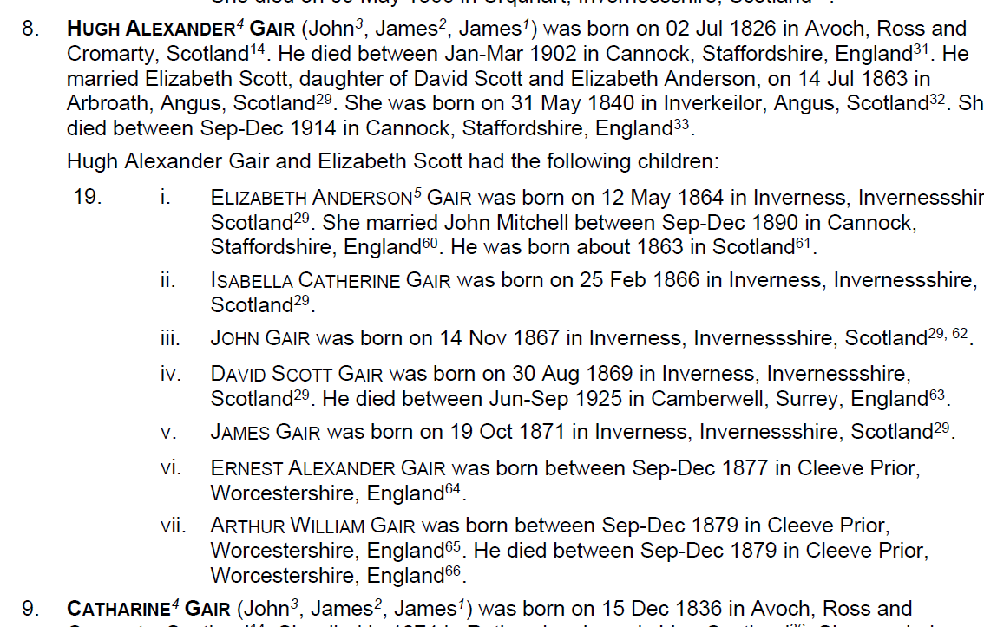
From The internet

Garrett
The top village shop was for a time run by Mrs. Garrett and her husband.
Recollections

Gilbert
From: Heather Merchant | 15 Jun 2014
Hello,
I have opened up access to my tree for you, however, it is a while ago since I worked on it and I have lost the cable to my old laptop so unable to gain access to the full tree at present
Off the top of my head my family history is as follows;
Phoebe Gilbert was born in Cleeve Prior to the Gilberts that are featured regularly throughout the parish registers, she married a John Sollis who was born in Broad Marston, they had four children, Ellen Amelia (I think) who died in infancy, if not at birth, this was recorded in the Broadway district so must have been born in the locality (again can't gain access right now) Lizzie, Harry and William John. Lizzie was born following a move to Leamington Spa, Harry was born in Selly Oak (Birmingham now) and William I think was born in Salford Priors, they moved on to Wyre Piddle, where one of Phoebe's brothers were residing and Harry married Kate Trapp, together they had 8 children; Charlie, Harry, Kathleen, Edward, Alice, Nellie, Patrick James (Jim) and Edith between 1897 and 1918. Harry served as a soldier in the Boer War and first world war whilst also working as a carpenter. His youngest son, Patrick James - born St Patricks day 1915 and died St Patrick’s day 1986, was my great grandad. He married a Dorothy May Beach and had an only daughter, Patricia Mary Sollis (31.01.1936 - 24.05.2009) she had five children, Graham, Patrick Alwyn, Mervyn, Cheryl and Steven. Mervyn is my dad. Phoebe continued to live in Wyre Piddle until her death, although we're not sure of her burial place, as did her son Harry who is buried in the local church yard. The family have continued to live in the village and my parents and younger brother still live there, whilst I live in Lower Moor, the next village along. If you can bear with me a few weeks, I will try and access my laptop as I think I managed to trace the Gilberts in Cleeve Prior back to possibly the 1600's. I hope this is of some help to you, if there is anything else you would like to know please do not hesitate to contact me
Heather
Genes reunited
Mr. Gilbert, the cobbler lived & worked at Pear Tree Cottage
From Mary Collins recollections

Godfrey

Godfrey John I
This appears to be John, son of William, baptised at CP 18th October 1604. He later married Margaret and had the following Children baptised there
Mary: 8th February 1623-4
Sybbell 27th September 1630
John 12th September 1633
William 22nd November 1635
Elizabeth 10th January 1637-8
He is the father of John II & William
24th January. In the West Field of Cleeve Prior he held one land shooting towards Littleton Hedge, and one acre at Gilberts Close End
1658 He held one land in Blackwood in the North field. In the East Field one land in Olden Hill and one land near the brook. In the South Field he held one acre near the Moore way and one acre on Olden Hill. In the Meadow Ground [Cleeve Meadow?] he held one laye at Flax Layes
from “the Laurels” by Lloyd J Edwards
1662 paid 3s.00 hearth tax in CP “returned one too many”
Hearth Tax W.R.O. 7449/i
1672-3 26th February buried in CP in the same plot as his son & daughter in law
Record of Cleeve Prior Grave Stones WRO

Godfrey John II
He is the son of John Godfrey I baptised at CP on 12th September 1633 he is also the brother of William Godfrey.
1702 He was church warden at Cleeve Prior with John Phillips
16th October 1713 he surrendered to the court Baron the copyhold estate comprising,
“Half a yardland, an half a quarter of one yardland late parcel of four Messuages and one yardland and three parts in four parts divided of one yardland with appurtenances in Cleeve Prior
Which had been granted to him in possession by Copy of the court Roll 17th December 1708.
27th October 1713 a document of this date records that on 16th October he had sold the Copyhold Estate to Nathaniel Rouse Gentleman of Newbold-on-Stour. For £40
21st May 1715. Buried in south west part of CP cemetary, in the same plot as his father. Aged 81 years. His widow Annette was buried in the same plot on 19th March 1728-29 aged 79

Godfrey William
He is the son of John Godfrey I and brother to John Godfrey II. He was baptised on 22nd August 1686 at Cleeve Prior
1713 he surrendered to the Court Baron the Reversions granted to them on the same Copyhold estate that his Brother John Godfrey II held in Possession
from “the Laurels” by Lloyd J Edwards

Goodes

Two Miss Goodes lived in Greens Cottage until 1973
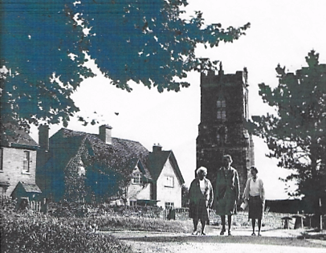
Dolly Holtom/Ruth Chargu [Dodford] /Ida Goode
From the CP Picture archive

Gould
From: Bernard Riches | 15 Jun 2014
Ian Hi
I am guessing you are sending a request to my late cousin Shirley Gould as she used to live at Cleeve Prior.
With the agreement of her husband I took over the Tree that Shirley had worked on so as to make sure it remained accessible to researchers of the Gould and Riches families.
I am sorry but Shirley was my only link with the area.
Sorry to not be able to help as I have lost all address details for her husband.
Bernard
From Genes Re-united
William Gould was the village carpenter who re roofed Charlett’s House when John Sheaf was a boy. William lived in the house now known as a pile of stones.
From Audrey Baylis’s Book

Marriages
Mary Gould married Henry Keen the baker?
Thos. Gould & Mary Mariah Davis, both of Cleeve Prior June 1771
Joseph Gould, b., & Mary Bachelor, both of Cleeve. Prior 18th June 1774
William Gould, b., & Mary Spencer, s., of Cleeve Prior 1st July 1817
John Gould, b., & Lucy Silvester, s., of Cleeve. Prior., 4th Aug 1819
Richard Smith, b., & Dinah Gould, s., of C. P 22nd Apr. 1821
John Holtom, b., & Catherine Gould, s., of C.P 1th Oct. 1821
James Gould, b., & Lydia Harris, s., of C.P 1823
Ernest Gould was the village Carpenter
From Don Archers recollections

Brothers Sam & Tom Gould did all the odd Jobs in the village from Frank Vickeridge Recollections

The Old Coach House in Hoden Lane comprised of three open fronted bays for carriages and two loose boxes. Mr Gould, the wheelwright who lived at a “Pile of Stones”, rented one of the loose boxes for his carpentry work, which included making coffins for the village & the surrounding areas.
He also had another workshop in part of the Cider Mill, where cider was still being made in the 1920’s with a horse pulling the large circular crushing stone, round the trough filled with apples.
Recollections

Grainger
About 1910 a wealthy couple from Birmingham built a large house on the Evesham Road at Cleeve & lived there for a short time. They both died of cancer, their name was Grainger. They left their house to Mrs Meyers who soon also died of cancer & she left the big house to the Women’s Hospital in Birmingham for them to come to after their operations for two weeks. They had their own ambulance and Fred Wellon drove it & done the gardens, it was called Gertrude Meyers Home. When it was closed it was sold off in flats
TBC

Grey
Julia Hiorn sold the Manor to Christopher Grey. We do not know much of the history during Chris Greys time but we do know that he sold the land a mill site to Birmingham Anglers in the 1930’s
Chroniclers research at Land registry
On 26th March 1945 Christopher Grey sold the Manor & cottages known as Manor Farm to Mr A.E Wiley from Sutton Coldfield, the Chairman of Ansell’s Brewery, for £40,000. This comprised of seven parcels of land and property
Manor Deeds

Grubb
Bert Lloyd, the surviving member of the Lloyd family owning the Manor, subsequently sold further properties & lands as follows:
- 29th April 1983 plot 3 Manor Court to Brian Richard Grubb
- 20th December 1983 plots 1& 2 Manor Court to Brian Richard Grubb
- 31st May 1985 plots 4,5 & 6 Manor Court to Brian Richard Grubb
- 24th June 1987, a plot of land as an extension to the church yard of St Andrews Churchyard Cleeve Prior
Manor Deeds

Hale Robert
31st March 1668 he married Sarah Harborne at Cleeve Prior
17th April 1677 Daughter Anne baptised at Cleeve Prior
From “the Laurels” by Lloyd J Edwards

Halford,

Halford, Mary Ann
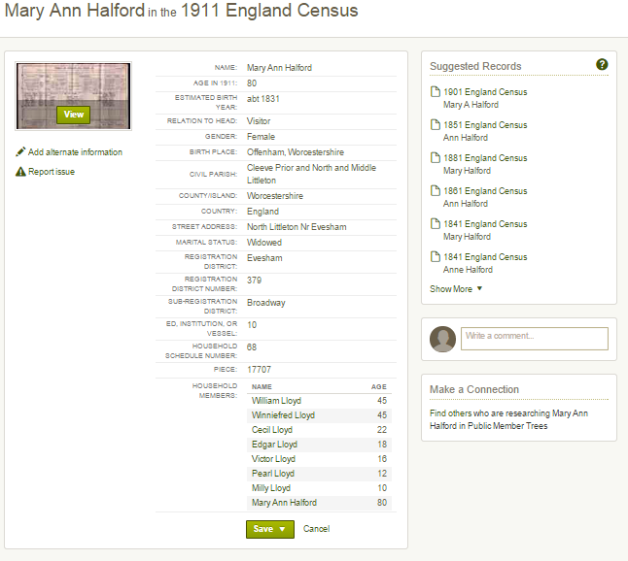

Halford, Eliza

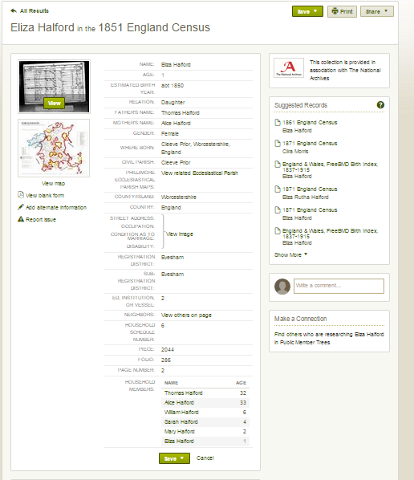

Halford, George & family
Michael Halford tells us of some of the Halford History including that of his grandfather
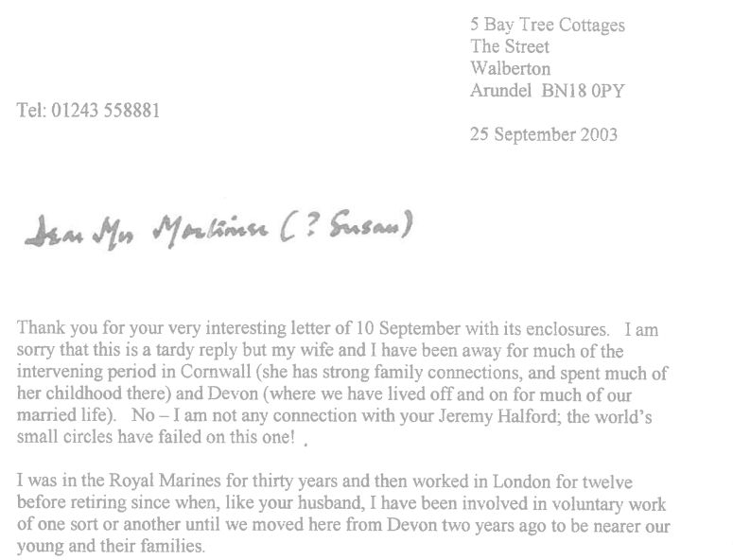
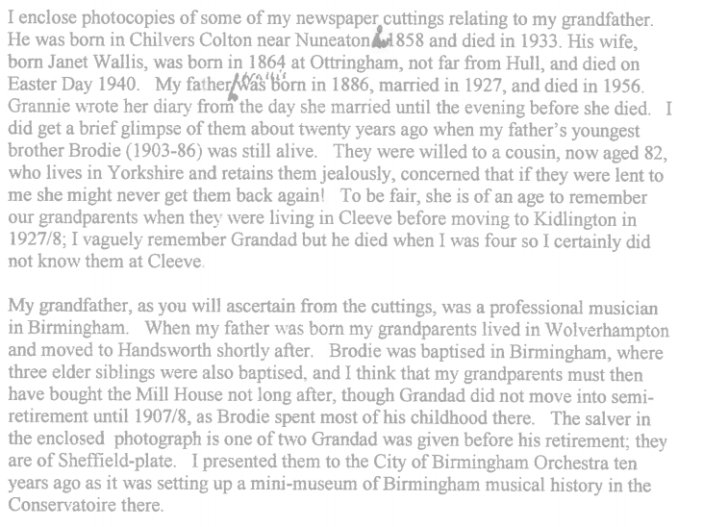
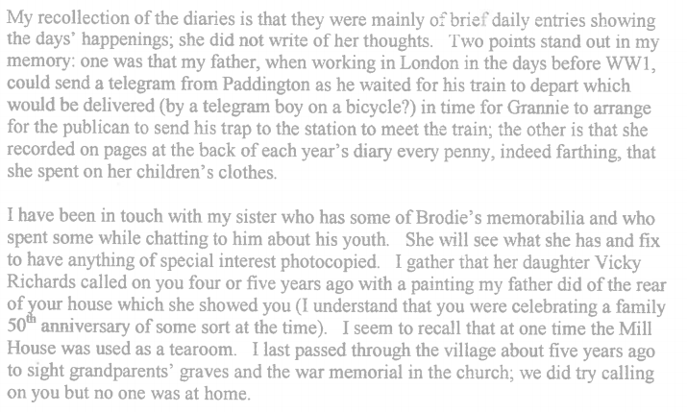
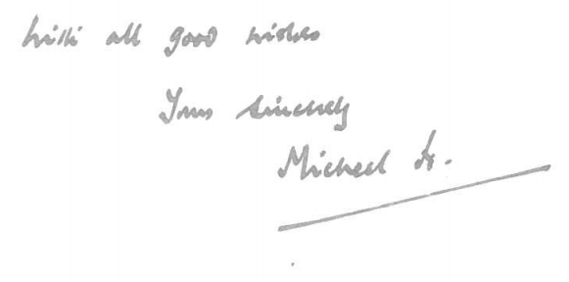

Letters of Michael Halford

The Cuttings

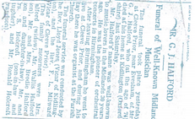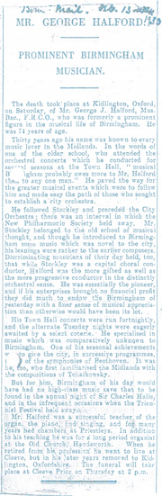

George Halford rented The Mill house in the early 1900’s, and as a famous conductor, composer & organists & he held concerts in the town hall in Birmingham, his main sponsor was the Chamberlain family[whose son was Neville Chamberlain]
He entertained at home famous musicians who used to play with him The picture below shows him entertaining, the solo violinist Ernst Shiever in 1905. He also had to stay with him at this time Fritz Kreisler an Austrian-born violinist and composer, one of the most famous violin masters of his or any other day, and regarded as one of the greatest violinists of all time. It was this concert and a series of American tours from 1901 to 1903 that brought him real acclaim
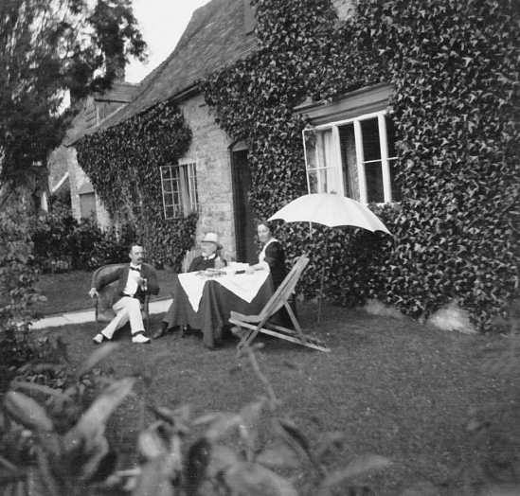
Sitting outside the front of The Mill House with a famous solo violinist called Ernst Shiever.

In 1910, Kreisler gave the premiere of Sir Edward Elgar's Violin Concerto, a work commissioned by and dedicated to him. Edward Elgar was also a particular & personal friend of the Halfords, and in 1915 he came to Cleeve Prior to give a concert in the church as the guest performer, to raise funds for the Red Cross.

The Halford Family had two sons, Wallis & Brodie. Brodie was too young to join up at the outbreak of the war, but Wallace joined the men of the village & went to war.
The family documented several conversations with Brodie in his later years when his memory was good but his speech was poor following several strokes, Some of the following accounts have been taken from “Grandmothers Diaries” which were written from the day she married in 1840 to the evening prior to her death 1940. We are grateful to the family for sharing these with us. It is their belief that George sponsored the war memorial in the Church and the family still have a copy of the role of honour for Cleeve Prior.

Boating on the river
Grandfather had a sailing boat built at Bidford for the family to use on the river at Cleeve Prior, the sail and the mast were so heavy that when there was a puff of wind the boat capsized. Eventually they gave up & just used it for rowing, which Brodie did endlessly as a child.

With the Hiams
Mr. & Mrs. Hiams, farmers at Cleeve, were an elderly childless couple and as a small boy Brodie spent a lot of time with them. They would sit in their parlour, a long room with a fireplace at one end & a window at the other. In between was a long oblong table [to Brodie then]. When the maid came to fetch him home, Mr Hiams would go to the hall, where a rack of crops and whips hung on the wall. He would come in to the room with a large whip, “To try the colt”. With a crack of the whip, Brodie would then run around the table. “Yes I would like to see it go faster” or “Now we will try him the other way”, which was all great fun for Brodie.

Sometimes Brodie would spend the night, & then he would sleep in the room with the maid [perhaps, 20 years old]. When she got up in the morning Brodie would be taken to the Hiams room where he sat between them in the big double bed, and enjoyed great games. In the maids room was a trap door which took him to a passage and to the outside. After crossing the stream, this led up to the monastery which had been used in Charles 1st time or for the Battle of Worcester

Mill House
At Cleeve in the Mill House drawing room, there were three steps which led out of the room into the hall. Frank, Brodie’s Elder brother, would sometime imitate the vicar, standing at the top of the steps, the pulpit, where he “Gave Forth”, much to Brodie’s amusement, and then would pretend to fall down the steps, making Brodie Laugh even more.
An entry in the diaries mentions Granny & Freda [ her daughter] going out in to the fields between the house to pick bunches of cowslips for making wine

Supporting the Troops
On Christmas day 1914, the Grand parents took a train from the junction to New Street, Birmingham, to wait for a trainload of the “wounded” from the front who were passing through, so they could give them a few “comfort”, they then returned to have Christmas Dinner.
In 1915 Grandfather conducted a concert in aid of the Red Cross
In 1917 Doctor, later Sir Edward Elgar came to the village to give a recital to support the war effort.
Wallis was the brother who went to war, and he joined the London Irish on the 3rd day after war was declared.

It was to his brother Brodie, that Wallis used to write & Brodie used to send him letters telling him of life at home.
Shortly after leaving for Aldershot, Brodie sent him a letter saying how, whilst swinging on a tree, and showing off to two little girls staying at the house next door he was propositioned. The story goes that they told him that “if we see you [naked] we will let you see us”
Wallis’s being a bit of an artist included a drawing in his following letter, depicting the story

Insert picture

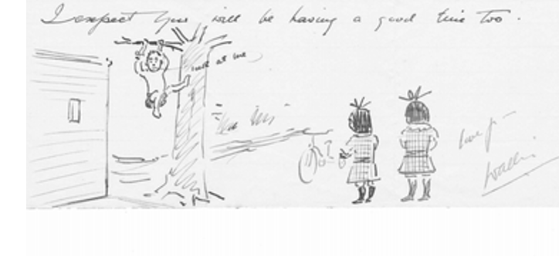

Wallis’s followed this with other pictures in his letters from the front. One poignant one shows a drawing of the dugout in his trench with a plaque above the door saying “Mill House”, a means of bringing something of home to his hell at the front

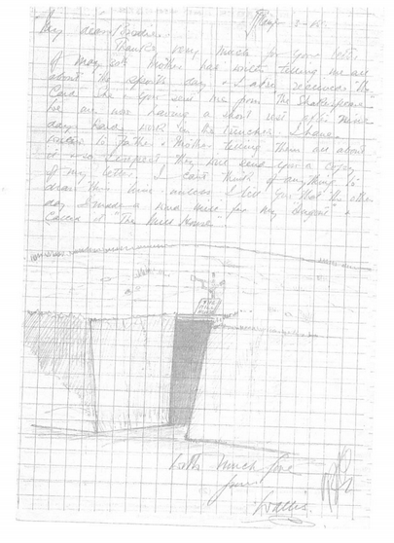
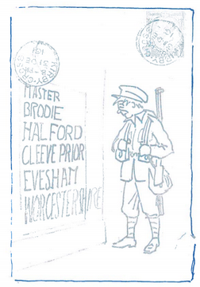

Wallis was very imagiantive in addressing his mail, & he knew how good the postal system was as can be seen from the adressed envelope below he sent to Brodie
He was subsequently badly wounded at the battle of Loos in 1915, and Brodie , now 17, was taken by his mother, on a compassionate ticket to a hospital in Taplow, to see Wallis where he was suffering from septicemia & this led to a long stay in hospital. On leaving hospital he was told he could have an office job, but this was not what he wanted, & he joined the Royal Flying Corps.

On the 3rd December he was awarded one of the first ever Distinguished Flying Crosses for his night flying bombing activities. The citation read:

The London Gazette [Feb 1919]
Captain Wallis Halford [France] This officer has taken part in 90 night bombing raids, frequently under adverse weather conditions and in the fact of heavy anti-aircraft fire.
On the night of 29th -30th June, he carried out 3 such raids dropping bombs on the objective with excellent results. By his keenness and determination, he inspired all who served with him.

The Squadrons of the Royal Air Force [Book] gives us more detail of the action.

His objective was Busigney railway junction, and he flew down very low and got a direct on it. Though the searchlights and anti-aircraft guns were very active. On the eve of the final push, the squadron flew along the lines to mask the noise of the British tanks rumbling in to position. One of the squadron’s raids flew low, but on reaching the target the bombs would not release. Rather than abort the raid lt Anderson crawled along the bottom wing & dropped the bombs by hand. In addition to the congratulations of the GOC, the pilot received immediate promotion and was awarded the Distinguished Flying Cross for his exploits. A few months before, the same pilot had made three trips in one night to Bray and dropped no less than 52 bombs on it

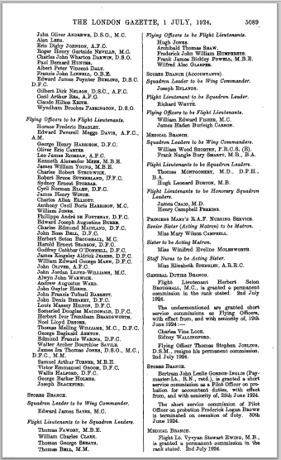
In the London Gazette we are told of the promotion of Wallis from Flying Office to Flt Lieutenant

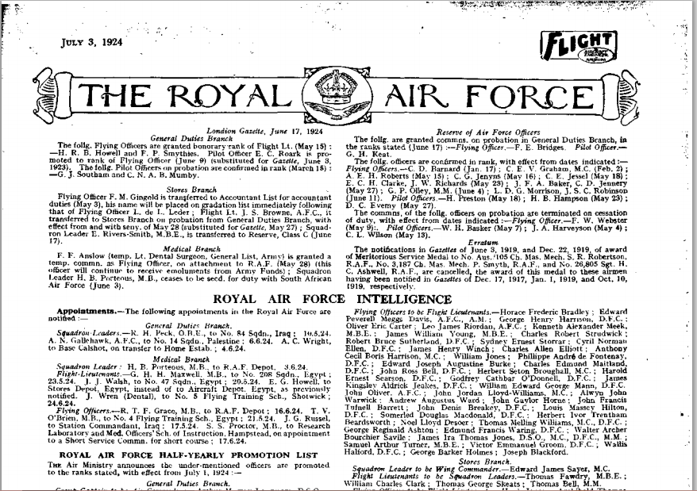
In the July edition of Flight this is also recounted with the additional information that it is in Royal Air force Intelligence

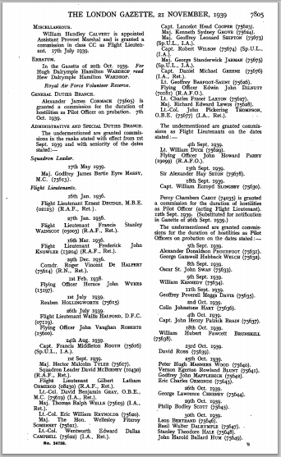
In the September 1939 the announcement is made of Wallis’s promotion to Squadron Leader in the Administrative and Special Duties Organisation

Life at home during the war.
The “Gandmothers Diaries” recount how Granny cycled to Bidford [ from Cleeve Prior ] to see about the butter registration & sugar for jam making.
When Brodie was 12 or 13 during the First World War, he would get up in the holidays at 6am , and help lead the cart horses down to the fields for their daily work. At the lunch break he would then have to feed & water them, and at the end of the day, riding side saddle he would lead the horses home. For this he earned between 3d & 6d a week. After the war Brodie got a job on a farm as a stallion man, riding the carthorse around the farms in the local villages to service the mares.

The diaries also tell us of the field behind Mill House being covered with cowslips, and the of the children gathering them in the summer holidays to make cowslip wine.
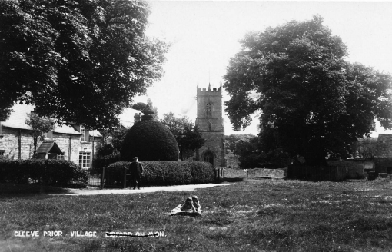
Cleeve Prior Green

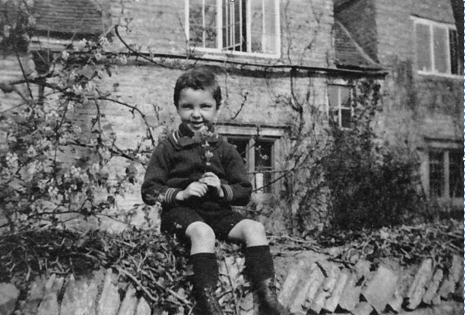
Brodie outside Mill House

Cleeve Prior & the Railways
The diaries tell us of Brodie & his mother going to the junction, to the meet of Hounds. In threse days the Hunt travelled by train either attached to the scheduled service or as a special train. First, Second & Third Class passengers travelled in their respective carriages, with the Hunt servants and hounds, grooms behind with the horses & hunters to the rear.

The Hunt was a great social occasion, and created great excitement with the horses being disembarked by the grooms, and the hounds all being let loose in frantic activity. After “The Meet” the hunt would “move off” in to the countryside followed by the viilagers who would stay with them for the day. In the evening they would return to the sidings & entrain for home.
The diaries reccolect that when Wallis was working in London before the WW1, he would send a telegram from Paddington as he waited for his train to depart which would be delivered by a telgram boy on a bycycle, in time for the publican to send his pony & trap to the station to meet the train.
5th May 1915 Brodie to school [at Stratford] had the Inn trap to take us to Salford Sidings at 2.47pm

Brodie recounted further information about :

Cecil Howard Perkins [Harry], killed 21st July 1918, was the son of George and Janet Halfords great friends. Cecil’s Father was the organist at the old church, Birmingham and often played at Blenheim Palace
Grandmother writes in her diary on the 10th April
“Harry is coming home for the day”
In fact Harry was coming home on leave from the front line and in staying at a billet overnight was wounded in an air raid. He subsequently died from his wounds. The Perkins lived at? “Felton’s”

Coates
The Coates lived in the cottages [ called Coates Cottage”] on the green next to Mill House, the father being the coachman to the Holtoms living at Manor Farm, the son owned the garage

Albert Ankers
Was the gardener to Janet Halford, his father was the miller

Arthur Smithin
Was a farmer who owned Top Farm. He also owned a Hotel in Stratford

Frank Sheaf
His father used to take people to the station in his gig

Nan Holtom
Was the organist at the Church

Other excerpts from Grandmothers Diaries
1914
12th April | Easter Sunday Geoge played the organ
19th April | George played the organ at church in the evening and Brodie & I sta in the “cupboard”
9th August | Sunday George walked to Bidford but got no war news
6th September | George played the organ at 11.00 am & 6.00pm
27th September | Harvest Festival. The vicar of Plumstead preached
11th October | Sunday George went up Hoden Lane in the afternoon to do a sketch
17th December | Cycled to evesham in the morning to do quite a lot of shopping
Letters of Michael | Halford

Haywood

Haywood Henry

25th October 1826 aged 29 of Salford Priors, together with William Lunn he was granted the reversions on the Copyhold estate in Cleeve Prior by the Court Baron in trust for the uses in the will of Thomas Rouse deceased
24th October 1832 aged about 35, re surrenders the above, which were re-granted to him and Charles Baylis for the same purpose.
22nd October 1834 Charles Baylis & he surrendered the above & together with William Lunn he was re-granted possession
25th October 1848 aged 51 he is made tenant
24th June 1863 Together with Charles Baylis and William Robert Smith they surrender the possession and reversions on the above estate.
From “the Laurels” by Lloyd J Edwards

Haywood John II
4th June 1816 the son of John Humphrey and Amy Haywood Baptised at arrow.
22nd October 1834 aged about 18 yrs. together with Charles Bayliss he was granted reversion of Copyhold estate in Cleeve Prior then in the tenure of William Lunn in trust for the uses in the will of Thomas Rouse IV
1842 Son John Humphrey Haywood Farmer he married Mary Ann Tomes the daughter of Tomas Bennett Tomes. Witnessed by Thomas Bennett and Juliana Tomes
25th October 1848 at about 32 surrendered the above Copyhold estate and he and William Robert Smith were re-granted for the same purpose
30th July recently deceased
From “the Laurels” by Lloyd J Edwards

Haywood John Humphrey
1842 His son John Married Ann Tomes daughter of Thomas Bennett Tomes at Cleeve Prior
From “the Laurels” by Lloyd J Edwards

From “the Laurels” by Lloyd J Edwards

Hemming

Hi i am looking for some information on the Hemming family. They named their Daughter Mary Hemming Taylor b1869 .... I believe that George Taylor b1836 who is my Great Great Grandfather married in 1863 Jane b1838 Great Great Grandmother. I think maiden name is Hemming or Heming. , Charles Husband to Caroline all lived in Cleeve Prior Village showing on the 1871 Census....
From Family Tree website

Walter Henry Hemming b. 1860
Having found the Hemming’s in 1861 in Welford on Avon, the census sheet shows:
Emeline Hemming, wid, 42, b. Marlcliffe, Warks
Mary Hemming, daur, unmarried, 19, b. Cleeve Prior
Judith Hemming, daur, unmarried, 13, b. Howden, Warks
Thomas Hemming, son, 9, b. Howden, Warks
Walter H Hemming, grandson, 4m, b. Welford - Avon, Glos*
*bit of a mystery to me how Welford can ever have been in Glos, but now it's in Warks. Anyway ...
The most obvious person to be Walter's mother would be 19yo Mary, and FS has a baptism on 1 Jan 1861 in Welford, of a Walter Henry Hemming s/o Mary Hemming, which almost seals it for me.
Problem is, I can't find a birth reg for the little chap. The only choices seem to be:
Walter Hemming, b. Q4 1860 in Martley, Worcs
Walter Henry Hennings, b. Q4 1860 in Lambeth, London
Walter Hemming, b. Q1 1861 in Stourbridge, Worcs.
I've found Walter on all the relevant census records:
In 1871 he's living with his uncle George Hemming in Cleeve Prior, Worcs Says he was b. Welford
In 1881 he's a lodger in Aston, Birmingham. Says he was b. Cleeve Prior.
In 1882 he marries Amy Jackson in Aston.
In 1891 he's with Amy and children in Aston. Says he was b. Cleeve Prior.
In 1901 he's with Amy and even more children in Aston. Says he was b. Cleeve Prior.
By 1911 Amy is a widow, and there's a death of a Walter H Hemming in 1909 in Birmingham, so that seems to fit.
In 1871 while he's living with his uncle George, his mother Mary, is a servant in London, so I'm wondering if she was in London 10yrs earlier and he's the one b. in Lambeth.
Of course, I've ordered certificates from the GRO before, but never specified a parent, so not entirely sure how to do it.
Do you think the Lambeth one is likely to be the best bet, and if so, how do I specify I only want the cert if the child's mother is a single woman called Mary Hemming?
- Emmeline?
I have Charles Hemming, born abt 1808 in North Littleton, Worcs on the 1851 and 1861 censuses with wife Emmeline (alternative spellings are available, like Emmiline) born abt 1814 and various children, the eldest of whom was born about 1836. Charles died after the census was taken in 1861, and I have her in the 1871, 1881 and 1891 censuses before she died in 1894, but can't find her in the 1841 census.
I've looked for a marriage between Charles Hemming and Emmeline (maiden name unknown), until I've gone cross-eyed, so wondered if anyone here can find something that I can't.
According to various census records for Emmeline she was born at Marlcliff, which is between Bidford on Avon (in Warwickshire) and Cleeve Prior (in Worcestershire). Cleeve Prior is the next village along the road (in the opposite direction from Marlcliff) to North Littleton, so they're all within a five mile radius.
In an ideal world, I'd like to find her maiden name, their marriage and the family in the 1841 census, but I do realise that this is not an ideal world.
In 1851 I have them in Welford, Warks:
Charles Hemming, 45, agricultural labourer, b. North Littleton,
Emmeline, 37, b. Marlcliffe, Worcs
George, 15, b. Cleeve Prior, Worcs
Mary, 9, b. Cleeve Prior, Worcs
Charles, 5, b. Cleeve Prior, Worcs
Judith, 3, b. Cleeve Prior, Worcs
Elizabeth, 1, b. Cleeve Prior, Worcs
Here's the link for those with Ancestry ...
http://search.ancestry.co.uk/iexec?h...id&pid=9496585
but I can't find the family at all in 1861, either as a family or as individuals.
Sometime between 1851 and 1871, Charles Snr dies because on the 1871 census Emmaline is listed as a widow, living with her son Thomas in Welford on Avon, Warks.
http://search.ancestry.co.uk/iexec?h...d&pid=24246387
Another thing that puzzles me, is that I can find a death for Judith (1862, registration district of Stratford, Warks), but I can't find a registration of her birth in 1846/7 anywhere (Cleeve Prior is in the Evesham reg district). Her christening is on the Family Search website as being at Cleeve Prior on 10 May 1847
Genes Reunited

Hiett William
23rd October 1778 aged 22 soap boiler from Shipston on Stour with William Oldacre he was granted the reversions of the Copyhold estate in Cleeve prior in trust to John Rouse
24th October 1821
Aged 65 still soap boiler in Shipston [document says] together with William Lunn he surrendered the reversions and was re-granted with William Oldacre.[ Chronicler thinks the parties have been reversed.] all in trust for Thomas Rouse IV and his sister Mary
From “the Laurels” by Lloyd J Edwards

Hirons

Holtom- The Gentry
There were two Holtom Dynasties born & living in Cleeve Prior.
The Gentry

Holtom William Fifield
In 1827 William Fifield Holtom was born in Alderminster to Stephen Holtom, Farmer, & his wife, and in 1832 he moved with his father & the rest of the family in to the Manor at Cleeve Prior. William married Juliana Tomes [born in 1825 in Cleeve Prior] on the 3rd June 1852, one of two marriages to take place between the families. The union unusually produced only one offspring daughter Julia, who was born in 1854, in 1886 the death of William is recorded at the manor. The Manor stays in the possession of Juliana who died in 1906, & passed to Julia who continued to live in the house. Julia Married William Garfield Hiorns from Honeybourne who bought the Manor & its Lands form the Church & continued in residence till his death In 1921 when he died in Cleeve Prior at the Manor. The Manor was sold & Julia moved in to Mill House which became the possession of the family when they bought the Manor from the Church, along with the Mill by the river. She stayed here till her death in the house on the 28th January 1945
Source TBC
1854-Son of Stephen Holtom farmer he married Juliana Tomes, daughter of Thomas Bennett Tomes at Cleeve Prior
1861 Aged 33 yrs born at Alderminster, lived at the “Farmhouse”[The Laurels] with his wife Juliana aged 36, Daughter Julia aged 3, servant Martha Collett aged 23, Nursery Maid Ann Newman aged 14, and a boarder called Charles Round aged 21 an agricultural apprentice. Holtom farmed 528 acres and employed 17 men & 4 boys [census]
24th June 1863. Tenant of Charles Baylis Copyholder in Cleeve Prior this was held in possession and reversion by Henry Haywood, Charles Baylis & William Robert Smith
9th January 1866, had been a tenant of the above estate for some years
13th June 1870. No longer a tenant of the above estate. [Chroniclers note. His brother purchased the House in 1869 & eventually purchased the Freehold]
14th May 1886 according to the Evesham Journal he died on this date. He was buried at 59 on the 19th may at Cleeve Prior
From “the Laurels” by Lloyd J Edwards

Holtom John Smith
In June 1872 Williams brother, John Smith Holtom, married Anne Thomes, the second marriage in to their family. John Thomes was famous for buying some of the Roman gold coins discovered in a pot in 1811. John being the youngest son was also the Miller, working the Mill down on the wharf on the Avon. In 1975 he bought the Laurels in the village & lived there until his death in 1890, nine years after that of his wife Anne, both recorded as passing away in the village. The children then occupied the house until the death of Nan Holtom, who died in 1963. At this stage we presume this daughter was Anne, as Nan was a common shortening of this name.
Source TBC
6th Dec 1869 , Miller of Cleeve Prior, purchased the Messuage[ The Laurels] and Malthouse in Cleeve Prior from George & Edwin Richard Pearce for £290.0s
13th June 1872
Miller Son of Stephen Holtom married Ann Tomes, daughter of Thomas Bennett Tomes at Cleeve Prior
21st December 1875. Farmer & Mille at Cleeve Prior. He was tenant of Charles Baylis freehold Estate which he has now purchased for £5500 from C.C.Prance
1890 he witnessed the marriage of his niece Julia Holtom to William G Hirons
27th May 1881 His wife Ann was buried at Cleeve Prior
30th August 1890 died of typhoid fever
3rd September he was buried in the North east corner of the Cleeve Prior cemetery aged 54 years
From “the Laurels” by Lloyd J Edwards

Holtom Charles
William had another brother Charles, who moved with his family to Stoke and it was his granddaughter, Dolly Holtom from his son, ironically called William Fifield, another relation of the family from the manor, came back to the village in 1963 to live in the coachman’s house from the Laurels which she called Nancot after her cousin .She lived here until her death in 1970.
Brodie Halford tells how Nan Holtom Was the organist at the Church

Holtom- The Workers

Holtom William
William Holtom & Sarah Vicaridge, s., 3 June [1754] both of C. P in this record spelt differently to other records where it is “VICARIDGE,”

Henry Holtom,
Henry HOLTOM, was born in 1812 in Cleeve Prior, Worcestershire He married Eliza Sanders from Arrow , in 1877 and it was in Arrow that they remained & their family were born.
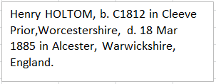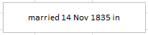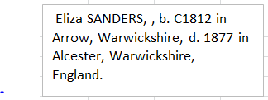
Joanne | Report | 17 Mar 2010 12:36
I have a Henry John Holtom in my tree born c1883, a bit of a scandal my end as he was married to my grandmother, Ellen Thompson, but she had children with another married man surname Fawkes/fawlk/faulk. She died after giving birth to her 3rd child, baby died as well, and her husband on the death certificate is Henry Holtom but the father to her children is William Richard Faulk or Richard William Faulk (I think he was a cad)
Hope you can help?
By the way my nan bless her had no idea her parents were not married and would turn in her grave!
Jo
Re: Henry Holtom, Cleeve prior, Worcestershire
Lynne Mills (View posts)
Posted: 20 Mar 2009 8:43PM
Classification: Query
I have another HOLTOM to add.
Temperance Ann HOLTOM was born abt 1843 - 1845 at Cleve Prior and died Dec 1900 in Warwickshire. She had two daughters Beatrice b1872; and Elizabeth Agatha JEFFS-HOLTOM b1876 at Leamington Priors... Eliz is my ancestor through my grandfather (his mum).
Temperance may have had another daughter Annie b1871?
No fathers name was shown on Eliz B/cert. It appears that Temperance did not marry as her name is still Holtom on 1891 UK census... I have not as yet been able to confirm her parents: possibly father Charles or Thomas; mother Elizabeth?
Any info from you would be wonderful....
Temperance may have had another daughter Annie b1871?
No fathers name was shown on Eliz B/cert. It appears that Temperance did not marry as her name is still Holtom on 1891 UK census... I have not as yet been able to confirm her parents: possibly father Charles or Thomas; mother Elizabeth? Holtom
Generation One
1. Henry HOLTOM, b. C1812 in Cleeve Prior,Worcestershire, d. 18 Mar 1885 in Alcester, Warwickshire, England. He married Eliza SANDERS, married 14 Nov 1835 in Alcester, Warwickshire, England, b. C1812 in Arrow, Warwickshire, d. 1877 in Alcester, Warwickshire, England.
Children:
i. Emma HOLTOM, b. C1837.
ii. Caroline HOLTOM, b. C1839 in Alcester, Warwickshire, England.
iii. George HOLTOM, b. 1840 in Arrow, Warwickshire, England.
iv. Henry HOLTOM, b. 1842 in Arrow, Warwickshire, England.
2. v. Charles HOLTOM b. 13 Jan 1845.
vi. William HOLTOM, b. 1848 in Broom, Warwickshire, England.
vii. Frederick HOLTOM, b. C1860 in Bidford, Warwickshire, England.
Generation Two
2. Charles HOLTOM, b. 13 Jan 1845 in Broom, Warwickshire, England, d. 1918 in Newport Dist, Monmouthshire, Wales. He married Elizabeth COOMER, married 1 Oct 1865 in Bristol, Gloucester, England, b. C1847 in Bristol, Somersetshire.
Children:
i. Emma Sarah HOLTOM b. 1867.
ii. Mary Ann HOLTOM, b. C1869 in Newport, Monmouthshire, Wales.
iii. Charles Henry HOLTOM, b. 6 Jun 1871 in Newport, Monmouthshire, Wales.
iv. William George HOLTOM, b. 28 Jun 1873 in Newport, Monmouthshire, Wales.
v. Alfred James HOLTOM, b. 30 Apr 1875 in Newport, Monmouthshire, Wales.
vi. Albert John HOLTOM b. 24 Dec 1876.
vii. Albert Edward HOLTOM, b. 23 Jan 1879 in Newport, Monmouthshire, Wales.
viii. Thomas Edward HOLTOM b. 9 Jan 1881.
ix. Mary Ann Elizabeth HOLTOM, b. 20 Feb 1883 in Newport, Monmouthshire, Wales.
x. Amelia Annie HOLTOM, b. 7 Oct 1884 in Newport, Monmouthshire, Wales.
xi. Millie HOLTOM, b. 26 Jan 1887 in Newport, Monmouthshire, Wales.
xii. Alice HOLTOM, b. 15 May 1888 in Newport, Monmouthshire, Wales.
xiii. Bertie HOLTOM, b. 14 May 1890 in Newport, Monmouthshire, Wales.
xiv. Olive HOLTON, b. 8 Sep 1891 in Newport, Monmouthshire, Wales, d. 1918 in Newport, Monmouthshire, Wales.
xv. Arthur HOLTOM, b. 8 Nov 1895 in Newport, Monmouthshire, Wales, d. 17 Feb 1896 in Newport, Monmouthshire, Wales.
Genes Reunited

Homer
On the 28th of April 1989 the executors of the Lloyd estate sold the Manor and surrounding lands, 36.68 acres in total to Barrie & Anita Homer, who then developed the site as we see it today
IR Manor Deeds

Howe
Don Archer remembers the post office & two shops in the village, “Prior Close” was a sweet shop [on west end] run by a Mrs. Howes. She had a hard life- an invalid husband and two sons & a daughter.
Don Archer recollections

Huband

Huband John
4th April 1878 he married Mary Rouse widow of John Rouse II by licence at Cleeve Prior
1788 land tax returns show that he occupied land in Cleeve Prior owned by his wife and son Thomas Rouse III and taxed at £2 19s 7d
1789 land tax returns show that he occupied land in Cleeve Prior owned by his step son Thomas Rouse III and taxed at £2 19s 7d
30th January 1797 Buried near the South West Wall of Cleeve Prior Church aged 52yrs. His wife was buried there two days later on the 1st February
From “the Laurels” by Lloyd J Edwards

Huband William
17/08/1815 Cleeve Prior aged 14
Source TBC

Humphries George
28th November 1810. Tenant in his own right he warranted to Charles & Mary Silvester the three Messuages and Malthouse etc. at Cleeve Prior at the court of common Pleas
From “the Laurels” by Lloyd J Edwards

Hunt Alice
24th January 1652 in the East field of cleeve prior she held one land on Lowe Hill
From “the Laurels” by Lloyd J Edwards

Hunt Hugh
28th November 1810. In the court of Common pleas it was alleged that he had dispossessed William Montriou of the three Messuages and Malthouse etc. in Cleeve Prior at some time over the previous thirty years.
From “the Laurels” by Lloyd J Edwards

Hutton

James
From the recollections of Frank Vickeridge
Nurse James, who lived at Pebworth, delivered the babies and “laid out” the deceased as well as ministering to the sick. She travelled the villagers in an Austin Seven, and from the 20’s to the 50’s she was the popular & dedicated district nurse.

Johnson, Thomas
1775 following the enclosure of the fields of Cleeve Prior he held the land adjoining the north & west sides of the land of John Rouse II in Quarry Field
3rd June 1853 Recorded that he had held the lands in Quarry Field on the west side of the lands held by Charles Baylis. These lands of Johnson were now held by William Cannaway

Jones
- From: Stephen Gilbey
Hi
I do have an entry in my tree for a very distant relative who was born in Cleeve Prior. His name was Daniel Jones born 1813. He appears to have lived much of his life in Salford Prior where he was employed as an agricultural labourer. He had a large family together with his wife who I have recorded as Elizabeth Beeman. I have no earlier records relating to his parents nor any documented evidence of birth or baptism. His connection to Cleeve Prior however seems strong as it is mentioned as his place of birth in all the 4 census records from 1841 to 1871. He died in 1878 and was buried in the Parish of Alcester.
I hope this is of some use to you. If you need any more detail please let me know.
Genes Reunited

Keck Family
Ann Keck of Cleeve Prior, wife of William Thomas Keck, bricklayer. Lived in “The cottage “and is detailed on the house deeds
William Thomas Keck Builder died on 23rd June 1916 leaving his effects of £457 3s to his widow Ann,
Source TBC

Keen Henry
Henry Keen married Mary Gould
There is a record of a Henry Keen, baker in Cleeve Prior
In the 1820 Lewis Directory
14th November 1810 He occupies the Messuage or tenement and Malthouse in Cleeve Prior formerly owned by Charles Squire and now owned by Charles Silvester
1st and 2nd February 1811, he occupied the above Malthouse with buildings yard & garden in Cleeve Prior
11th April 1822 he still occupies the above but now owned by Robert Silvester
1835, He and Thomas Farr were joint tenants of Robert Silvester in the Malthouse.
From “the Laurels” by Lloyd J Edwards

1841 aged 75 Baker at the above address. Daughters Mary ,35 and Roberta 18yrs. In another household lived his daughter in law Ann Keen, 36 yeaar old widow with Children Charles 6 And Sarah 3. They lived with Eleanor Hemming, Widow, 68 yrs old
Census

Laughton

Laughton Thomas
1775 following the enclosure of the fields of Cleeve prior he held lands in Quarry Field on the North & East sides of that of John Rouse II. John Rouse’s lands included compensation for the “corn Tythes” of the said John Rouse arising out o and issuing out of four ridges of freehold land in the said field belonging to the said Thomas Laughton.
In Cleeve Prior Churchyard a tombstone reads:
“Sacred to the memory of Thomas Laughton who died November 13th 1852 aged 62 years Sarah Relic of Thomas Laughton died Jany 1st 1877 Aged 88 years”
This may be a grandson of the above Thomas Laughton
3rd June 1853.Deceased. His land bounded that of the close of the Laurels in Cleeve Prior. He had also lands in Quarry Field which bounded part of the east side of those of Charles Baylis.
From “the Laurels” by Lloyd J Edwards

Laughton Ann
There was also an Ann Laughton aged 75 at the time of the 1841 census, who also had a son called Thomas Laughton, who was a 40 year old farmer
Census

Lester Samuel
1830 Michaelmas Lester Samuel Cleeve Prior stealing wheat, straw and grain belonging to Ann and Robert Lunn labourer
Source TBC -internet

Lloyd
The Lloyds bought the manor in 1960 From Mr. Wylie. There were three brothers & a sister
An elder brother, name unknown, May the sister, , David & Bert the younger brothers

Lunn
Helen Wentworth <hpuwentworth@gmail.com> | Nov 19 (3 days ago)
to me

I have very little regarding the Lunns of Cleeve Prior, seems to be mostly births as they appear to have moved away. Of course, at the ages of 9-11, I never thought to ask my Granny (Lunn) Todd about her family. One doesn't at that age sadly.

The only thing I do have is a photo of Robert Lunn b. 1798, a photo of a portrait of Elizabeth Bateman who married Robert, and a photo of a portrait of Robert Bateman, father of Elizabeth. I also have one of John Robert Lunn, my Gt Grandfather, b.1831

I have an old Breeches Bible with a number of early entries of Lunn births and marriages. Unfortunately no parish is mentioned, but the female names are Mary Rock (b. Cleeve Prior) Sarah Sherif, Ann Yarnold, and Lucy Redfern. These were the early names, 1696- 1760. There are later entries 1830s+ but I don't think they are Cleeve Prior families.
If any of this is of interest, I can scan and send them to you.
Sorry it is rather thin, but perhaps you have better luck elsewhere.

Helen (Todd) Wentworth
Amherst New Hampshire USA
I only have a direct line entered, but a John Lunn 1770-1799, was one of 9 brothers and one sister- and these Lunns were from Cleeve Prior, Worcester. John's parents were Robert Lunn and Mary Rock. Worcester is a bit south of Birmingham. Wish I could be more precise
John Robert Lunn
Genes Reunited

William Lunn
b. abt 1780, married abt 1805 to Margaret (nee Lunn?) b. abt 1785. Children included Mary, Robert William, Eliza, William, Kezia
24th October 1821. yeoman of Norton and Lenchwick, aged 46. With Thomas Rouse IV was granted the reversion of the latter’s Copy hold estate in Cleeve Prior to hold in trust for Thomas rouse & his sister Mary.
25th October 1826. Yeoman of Norton and Lenchwick, aged 51. At the Court Baron of Cleeve Prior and Broad Marston he surrendered the above reversions. They were then granted to him & Henry Haywood in trust for the will of Thomas Rouse IV
24th October 1832. Yeoman of Norton and Lenchwick, aged 56. At the Court Baron of Cleeve Prior and Broad Marston he surrendered the above reversions. They were then granted to him & William Oldacre in trust for the will of Thomas Rouse IV
25th October 1848. Dead by this date.
From “the Laurels” by Lloyd J Edwards

Lunn Robert- Farmer
Robert Lunn was a farmer and with his wife Elizabeth Bateman they lived in in Cleeve Prior
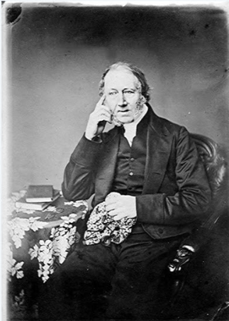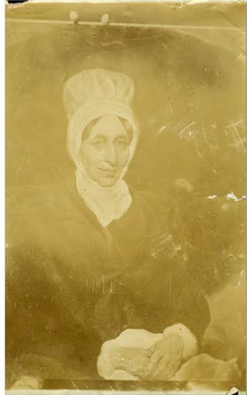
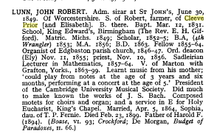

Lunn Robert- Labourer
1830 Michaelmas, Lester Samuel Cleeve Prior stealing wheat, straw and grain belonging to Ann and Robert Lunn labourer

Lunn Revd. John Robert Lunn
8 March 1831 - 1899 was an organist and clergyman based in England.^{[1]}
He was born on 8 March 1831 at Cleeve Prior, Worcestershire. He received music lessons from age 4 in organ under G. Hollins and piano from W.H. Sharman.
He was educated at King Edward VI School and was appointed organist of Edgbaston Parish Church age 15.
He went up to Cambridge University in 1849. He graduated B.A. (fourth wrangler) 1853; M.A., 1856. He was ordained Deacon in the Church of England, 1855, and priest in 18.56.
He was Fellow, and Sadlerian Lecturer, St. John's College, Cambridge and President of the University Musical Society
He was appointed vicar of Marton-cum-Grafton, Yorkshire in 1863.
Appointments
- Organist of St Bartholomew's Church, Edgbaston Birmingham 1846 - 1847
- Vicar of Marton-cum-Grafton 1863 – 1899
His compositions include:
- Oratorio, St. Paulinus of York 1892
- Two Motets, for two choirs and organ
- Motet, Heaven is my throne, eight-part chorus (MS.)
- Communion Service in E, King's Chapel, Cambridge, 1 November 1861.
- Te Deum and Benedictus in E, for two choirs and organ, Cambridge, 1862.
- Priest's part for Aylward's Responses
- Hymn tunes, etc.
- Arrangements for pianoforte 4 hands and harmonium, of Bennett's Woman of Samaria, and other works

Married at Cleeve Prior on 17th July by the rev Robert Lunn Vicar of Marton cum Grafton, York’s, brother of the bridegroom Charles Lunn of Edgbaston to Amelia Sophia, only daughter of Henry Adkins of Cleeve Prior
From Evesham Journal July 1866

Nichols /
Allbright Stephens b1814- seems to disappear he married Ann Nicholls/Nichols and had a son Andrew (b1848)
Update Dec 07: found Allbright died 1850 and Ann baptised children after his death, including one illegitimate child Albert Jesse

My grandfather Edwin Jesse Nicholls came from Cleeve Prior.
I have information that says that in 1839 Joseph Nicholls a stonemason married Emmeline Lester who died and that he remarried Sarah Teague a widow. By 1843 it appears that he was widowed again and went on to marry Lucy Edwin. They had 5 children. The youngest Edwin was my grandfather killed in the Ist World War and was awarded the Military Cross. Doesn't help you but kind of interesting all the same.
Genes Reunited/Stephens Family links in Cleeve Prior
Chroniclers Note: See first World War Casualties & the details of the Grave Search In the First World War
Recollections
When I came back to live I Cleeve in 1995, I spent time with Mrs Stella Fletcher, who was then I think I her eighties. In my childhood she was Miss Stella Roberts, whose late father had been the village blacksmith. She did all the secretarial work for my father’s [3C] Transport business. She married one of the 3C drivers Chris Fletcher in 1942, [Their son, Clive now lives in North Littleton]
I heard my parents talking about the ‘Motherly Ladies’ in Cleeve and I asked Stella if she knew who they were. She said that her mother, Mrs Roberts was certainly one, and the only other name she could remember was ‘Ma Nicks’. This was Mrs Nicholls who lived at No1, the Green, whose husband was shepherd for Chris Gray at the Manor. These ladies did what they could for the 18/19 & 20 year old boys, stationed in Cleeve Prior, before they left for France in 1939. Just what the kindness meant to these young men, most who had never been away from home before, is expressed in a postcard sent to Stella’s mother. I found it so moving that I asked her if she would allow me to copy it:
From Mary Collins Recollections

Ted Nicholls joined the territorials in 1939 at the age of 16 and served in the army until 1945, most of the time in Europe. He was on the Normandy Beaches.
From Margery Garrett Recollections

Majer/Mayer Thomas
Just before the war a man called Tom Mayer came to live in Cleeve. He was a millionaire and he brought the first car to the village. It was a Lanchester and a man called Phostin drove it for him, when he went to Broom Station or Birmingham. Kids used to see it come home at night a rare sight in those days. He made nuts & bolts in Birmingham.
After the war folk got together and talked about a village hall. Could enough money be raised to build it? Then the owner of the Old Malt House offered to sell it if enough money could be raised to buy it. It would cost a £1000. So whist drives and dances, fetes & concerts were organised to raise funds which went well. Then out of the blue came an offer of £500 from Mr. Tom Mayer, and the old Malt house was transformed into the beautiful village hall which is used to this day enjoyed by all.
Recollections
31st December 1918. Tomas Majer purchased 52 acre 3 roods 28 perches of arable land in Cleeve Prior from the daughters of the Late John Smith Holtom
From “the Laurels” by Lloyd J Edwards

Double Military wedding. Smithin-Mayer and Ball- Sheaf
From The Evesham Journal Feb 28th 1920

Manning
On June 1951 Arthur Wiley, from the Manor, conveyed to Elizabeth Manning a cottage called Greystones [formerly Temple Croft] and surrounding land an area of 2100 sq. yd.

Meyer
About 1910 a wealthy couple from Birmingham built a large house on the Evesham Road at Cleeve & lived there for a short time. They both died of cancer, their name was Grainger. They left their house to Mrs Meyers who soon also died of cancer & she left the big house to the Women’s Hospital in Birmingham for them to come to after their operations for two weeks. They had their own ambulance and Fred Wellon drove it & done the gardens, it was called Gertrude Meyers Home. When it was closed it was sold off in flats
Recollections

Milward
The Lloyd Brothers bought the Manor & lands on the 15th December 1961, and as part of the deal on the same day they sold off a property, which was, 1 The Green to Robert & Elaine Milward
Manor Deeds

Montriou William
15th November 1810 Gentleman of 19, Margaret Street Marylebone. He was partner with Willim Seymour at the same address. He agreed to sue William Seymour in the High Court for Chancery for
“one or more writ or writs of entry sur de seizing on le Post returnable before his Majesty’s Justice of the Court of Common Please at Westminster”
And demand of him the full recovery of a messuage or tenement and Malthouse and two other Messuages in Cleeve Prior. All were agreed that the recovery should be done
“With all possible dispatch”
It appears that the procedure at the court of Common recovery took place on the 10th November 1810, and he was awarded the possession of the Messuage and Malthouse two other Messages, three gardens, three acres of land and common Pasture for all manner of cattle, with appurtenances, in Cleeve Prior.
1st & 2nd February 1811. Together with Charles Silvester he leased and released the above messuage and Malthouse to Robert Silvester for £300. 10s
From “the Laurels” by Lloyd J Edwards

Newman
22nd November 1809. Parish registers suggest that this is Thomas Newman who married Mary daughter of William Silvester on this date at Cleeve Prior
14th November 1810. He occupied the messuage or tenement in Cleeve Prior formerly occupied by William Silvester and owned by Charles Silvester
From “the Laurels” by Lloyd J Edwards

Norden
Mid 1900’s Mill lane Nurseries were at this time run by Mr Norden
Recollections

Norton, Dorothy
23rd October Dorothy Bushell married John Norton at Cleeve Prior
24th January. Widow. In the fields of Cleeve Prior she held in one land on the Hurst in the South Field. In the North field she held one land on Lowe Hill, and one land shooting towards Dead Furlong Hedge. In the east field she held one land near the Brooke
From “the Laurels” by Lloyd J Edwards

Oakey
Was the blacksmith
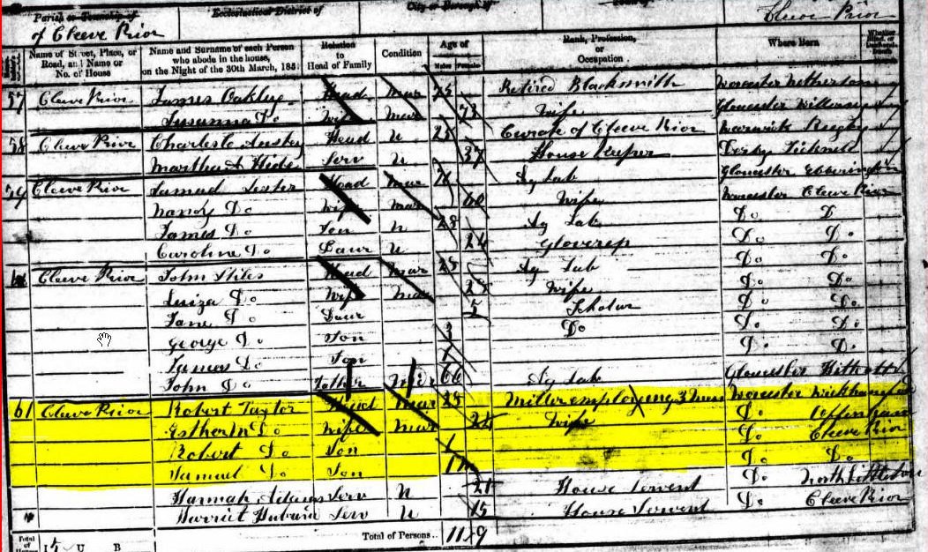
see Census

Oldacre, William
4th November 1750 Son of Charles and Elizabeth Issard Oldacre baptised at Cleeve Prior
20th October 1775 aged 20 yrs. Miller of Cleeve Prior. At the court Baron of Cleeve Prior & Broadmarston, he and John Walker were granted the Reversions of Ann Rouse’s Copyhold land in Cleeve Prior to hold in trust for her son John Rouse II
23rd October 1778. Yeoman of Cleeve Prior. At the court Baron of Cleeve Prior & Broad Marston, he and John Walker were surrendered the Reversions they were regranted to him & William Hiett to hold in trust for her son John Rouse II
24th October 1821. Gentleman of Stratford-on-Avon, aged 71. At the court Baron of Cleeve Prior & Broad Marston, he and John Walker were surrendered the Reversions they were regranted to him & William Hiett to hold in trust for her Thomas & Mary Rouse. He was admitted as tenant
24th October 1832 , of Stratford-on-Avon, aged82. At the court Baron of Cleeve Prior & Broad Marston, he surrendered possession of the above land. It was regranted to him & William Lunn for the uses of the Will of Thomas Rouse IV deceased. He was admitted as tenant
From “the Laurels” by Lloyd J Edwards

Payne
Then there were carters. They started at 5.30 too, to give the horses bait and to fill up the fodder racks. Charley Adams & Bob Payne were the carters. Lads left school at 11 years old. I [Eli Ankers] with Frank Farley started work driving horses, four in a team, Jolly, Boxer, Sharper and Turpin, ploughing up and down the field, six miles a day. It was better than school. The carter learnt us.
From Eli Ankers recollections

Pearce Edwin Richard
30th June 1869. Draper of Birmingham. Together with Geo. Pearce he paid James Hawley the £350 & £300 owed for the mortgages of John Fishe Tomes on the Messuage & Malthouse at Cleeve Prior
6th December. John Fisher Tomes died owing him and Geo,. Pearcr the above monies. After vain attepts to sell the property by Public Auction, they sold it to John Smith Holtom.

Perkins C.W.
Brodie recounted further information about his friend Cecil Howard Perkins [Harry], killed 21st July 1918, was the son of George and Janet Halfords great friends. Cecil’s Father was the organist at the old church, Birmingham and often played at Blenheim Palace
Grandmother writes in her diary on the 10th April
“Harry is coming home for the day”
In fact Harry was coming home on leave from the front line and in staying at a billet overnight was wounded in an air raid. He subsequently died from his wounds. The Perkins lived at? “Felton’s”
His Father
No. 11. - MR CHARLES WILLIAM PERKINS
(THE CITY ORGANIST).
SHAKESPEARE has told us for what the man is fit
"That hath no music in himself,
Nor is not moved with concord of sweet sounds."
The subject of our present sketch not only has "music in himself," but he has the glorious power of moving others with the "concord of sweet sounds." He is a master of that divine art which proves that
"Music and sweet poetry agree,
As they most needs, the sister and the brother,"
and this brief record of his life will be welcomed by all our readers.
Mr Charles William Perkins is a native of Birmingham, but has resided in Handsworth the greater part of his life. His musical tendency was manifested when quite young and at the age of fourteen he began the study of the organ under the tutorship of Mr. Andrew Deakin, to whose thoroughness, earnestness and systematic training he considers that most of his success as a player is due. Every one who knows Mr. Deakin as a teacher will fully agree with this opinion of his eminent pupil.
Mr Perkins studied pianoforte playing and the theory of music under Dr. C. Swinnerton Heap and was again fortunate in his teacher and with a commendable sense of his obligations he also speaks of Mr. Heap, as of Mr. Deakin, in terms of the highest admiration as a highly accomplished musician.
Mr. Perkins received his first recognition as a player by an appointment as organist to the Swedenborgian Congregation, which then met at the chapel in Summer Lane.
In 1884, through the influence of Mr. G. H. Johnstone, whose thoughtful kindliness of feeling foresaw the value of such training, Mr. Perkins was accepted by Dr. Bridge as one of his assistant pupils at Westminster Abbey and shortly afterwards received the appointment of Organist and Choir-master of Immanuel Church, Streatham Common. This appointment he vacated in about six months for one of the most important West End Churches - St. Michael and All Angels, Paddington. While in London Mr. Perkins gave many recitals at the Crystal Palace and at the Albert Hall; this experience with the additional advantage of frequently playing the organs of St. Paul's Cathedral and Westminster Abbey, gave him a command in the manipulation (shall we say also pedipulation?) of large organs which has stood him in good stead in dealing with our own Town Hall organ and the organ at St. George's Hall, Liverpool. At the latter place Mr. Perkins is a well-known and highly appreciated player. In London he also held the appointment of Conductor of the Epsom Choral Society, an appointment now held by Mr. Overton Collard.
In 1888, the joint committees of the Birmingham Town Council and General Hospital advertised for an organist for the Town Hall. On the strength of testimonials from Sir John Stainer (St. Paul's), Sir Walter Parrett (Windsor), Dr. Bridge (Westminster Abbey) and others, Mr. Perkins was one of the candidates chosen to compete for the appointment. In this competition he was successful and immediately entered upon the duties of his responsible position by playing at the Birmingham Musical Festival of 1888.
The Town Hall organ was at this time in a most decrepid condition. An accident, known to organists and organ builders as "cypher," happened on the Thursday morning of that festival, which considerably hastened on the question of rebuilding the instrument, a proposal which had been previously brought forward. During the two crochet-rests before the final "Hallelujah" in the chorus of that name, a horribly discordant note rang out from the loudest stops of the organ - the "tuba mirabilis." Defective mechanism being the cause of this unfortunate incident, the matter was earnestly taken up and the organ rebuilt by public subscription, Councillors Beale and Johnstone setting a fine example, both by their subscriptions and their zealous exertions in this labour of love. The organ, which has previously belonged to the General Hospital, was transferred to the Corporation at an inaugural performance on March 29th, 1890.
Mr. Perkins has been the organist of the Wretham Road Church since Mr. Cotton proceeded to the Old Meeting Church in the Bristol Road, an office which he still retains to the entire satisfaction and delight of the congregation. He is also one of the teachers of the organ at the Midland Institute School of Music.
During the year Mr. Perkins gives thirty-four free organ recitals at the Town Hall. These are largely attended and the pleasure which they afford and the good effected by such splendid performances of the highest and best music must be incalculable. At the one given on the occasion of the funeral of the highly esteemed and worthily honoured Dr. Dale, on March 18th, 1895, there was a very large attendance and the rendering of the Dead March in Saul produced an effect, which was really transcendent. No one who was privileged to hear the magnificent rendering of that magnificent March can ever forget the mighty power of music over the heart and feelings of all who are moved with the "concord or sweet sounds."
In the lives of our artists there are no "moving accidents by flood and field." No "hair-breadth 'scrapes i' the immanent deadly breach" to record. And that of Mr. Perkins is no exception to the rule. It is a simple record of hard study and regular labour, slowly but surely rising to success. This success in this case has been worthily attained and all our readers will join us in the hope that for many years yet to come Mr. Perkins will continue to give pleasure and the purest delight to unnumbered thousands by his renderings of the most effective and the most universal of all the Arts.
============================
Attachments area
Preview attachment image001.png
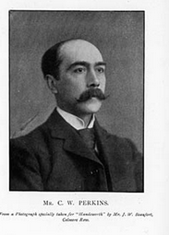
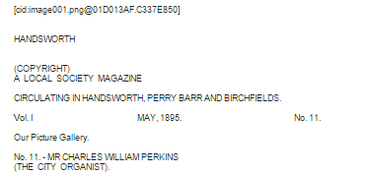
image001.png

Pitt
Evesham Journal July 5th 1919
Bloore Pitt. July 2nd at Cleeve Prior parish church by Rev James Knipe, Thomas Bloore of Saltley, Birmingham, to Kate daughter of Charles Pitt, Cleeve Prior.

Phillips

Phillips, John
26th January 1865 he married Elizabeth Charlett at Cleeve Prior
From “the Laurels” by Lloyd J Edwards

1702. He and John Godfrey were Church wardens in Cleeve Prior
1710 was churchwarden and overseer with Edward Brockington II
Parish list
16th October 1713 together with William Godfrey he surrendered to the Court Baron of Cleeve Prior & Broad Marston the reversions on a copyhold estate granted 17th December 1708
From “the Laurels” by Lloyd J Edwards
1710 was churchwarden and overseer with Richard Brockington
Parish list

Phillips William I
1662. together with John Charlett [probably II] paid 2s.0d for three chimneys in Cleeve Prior but “returned one too many”
Hearth Tax WRO 7449/i

Phillips William II
22nd May 1771 He married Mary Silvester Cleeve Prior
1775 Following the enclosure of the fields he held land in Cleeve Meadow to the east and Part North of meadow allotted to John Rouse II
From “the Laurels” by Lloyd J Edwards

Pilkington

Pilkington Ann I
6th October 1555. final concord document conveying with her husband Christopher one messuage to John Asteley[The Laurels] one cottage, two gardens, one dovecote, one orchard, 8o acres of arable, 8 acres of meadow and 1 acre of wood in Cleeve Prior. Asteley was to hold this in trust that in the event of their death their children were to inherit, in the event of them being childless Christopher’s heirs to inherit
From “the Laurels” by Lloyd J Edwards

Pilkington Ann II
27th November 1668. The daughter of Thomas Pilkington I. She was left £20 0s in his will.
20th February 1669-70. The eldest daughter of Thomas Pilkington I. and his wife Joan. Their mother gave her & her sister Joane, one cottage each in Cleeve Prior as part of their fathers will.
11th May 1671 she married Thomas Ingles at Cleeve Prior
From “the Laurels” by Lloyd J Edwards
1st January 1685. Widowed by the death of her husband, buried in CP.
29th August 1716 Wife of Thomas ingles buried in Cleeve Prior.
Parish Register

Pilkington Christopher
See Pilkington Ann I
From “the Laurels” by Lloyd J Edwards

Pilkington Edward I
He may be the son of John Pilkington & his wife Margery who were buried at Cleeve Prior on 31st August & 9th September 1615 respectively, and probably grandson of Christopher Pilkington.
5th May 1617. Final concord document. Together with his wife Jane he conveyed to Thomas Harborne and John Walker, 50 acres of arable, 8 acres of pasture, plus common pasture in Cleeve Prior and Littleton to hold in trust.
24th January 1652. Yeoman of Cleeve Prior, Father of Thomas Pilkington I. Together with his son Thomas & daughter-in-law Joane he sold Halfyard A to Charles Bennett for £167 10s
15th April 1652. Final concord document for above sale.. States that the Pilkington’s had sold 16 acres 1 rood of arable, 2 acres of Meadow and common of pasture in Cleeve Prior to Charles Bennett & John Squire.
From “the Laurels” by Lloyd J Edwards

Pilkington Edward II
21st July 1632. The son of Thomas Pilkington he was baptised in Cleeve Prior.
From “the Laurels” by Lloyd J Edwards

Pilkington George
4th son of Thomas Pilkington I
From “the Laurels” by Lloyd J Edwards

Pilkington Jane
See Edward Pilkington I
From “the Laurels” by Lloyd J Edwards

Pilkington Joane I
26th January 1618, daughter of Rowland Gibbes. Baptised at Bourton on the hill
22nd September married Thomas Pilkington I at Bourton on the hill
24th January 1652. Together with Father of Thomas Pilkington I. Together with his son Thomas, Joane sold Halfyard A to Charles Bennett for £167 10s
15th April 1652. Final concord document for above sale.. States that the Pilkington’s had sold 16 acres 1 rood of arable, 2 acres of Meadow and common of pasture in Cleeve Prior to Charles Bennett & John Squire.
27th November 1669 her husband’s will stated that after bequests she was to be left the remainder of the estate
28th February 1670. She was now the widow and relict of Thomas. She conveyed two cottages in Cleeve to her daughter Ann II and Joane II as part of the estate. She conveyed the messuage [Laurels] yardland, dovehouse and cottage to her son Thomas II, but these were placed in the guardianship of her brother John Gibbes, and Nicholas Smith, until all other bequests were paid.
22nd December 1675. Together with her son Thomas II and daughter in Law Mary II she sold th messuage [laurels], yardland dovehouse, cottage and tythes from four lands in Cleeve Prior held by Richard Squire for £500 0s to William Rouse I
20th January 1676. Final concord document regarding above sale ,itemizes as sold , messuage, cottage, dovecote, two gardens, two orchards, 70 acre of arable, 6 acres of meadow, 4 acres of pasture, and common pasture in Cleeve Prior.
29th March, received final payment of £300 from William Rouse I
From “the Laurels” by Lloyd J Edwards

Pilkington Joane II
See Pilkington Ann II
From “the Laurels” by Lloyd J Edwards

Pilkington John
12th September Thomas son of John Baptised in CP
From “the Laurels” by Lloyd J Edwards

Pilkington Margaret
27th November 1669, third daughter of Thomas I left bequest in his will.
From “the Laurels” by Lloyd J Edwards

Pilkington Mary I
7th July 1662, the daughter of Thomas I baptised at Cleeve Prior.
From “the Laurels” by Lloyd J Edwards
20th February youngest daughter of Thomas I left £20.0s in his will

Pilkington Mary II
6th October 1673, Mary Ashwin aged 23 maiden of Elmley Castle, Married Thomas Pilkington II of Cleve Prior. See Thomas Pilkington II
From “the Laurels” by Lloyd J Edwards

Pilkington Thomas I
6th My 1612 baptised at CP.
1637 Married Joane Gibbs
Baptism of their children:
Edward 21st July 1638
John 12th September 1639
Mary 7th July 1662
Their son Rowland was buried 10th April 1663
24th January. He was the son and heir of Edward Pilkington I who married Joane Pilkington I. Together they sold Halfyardland A to Charles Bennett for £167.10s.
Elsewhere in the fields of Cleeve Prior he also held one land in Churwell in the west field and one through shooter near the brook in East Field.
15th April 1652. Final concord document regarding the above sale. See Charles Bennett.
1658. He and Edward Brockington were churchwardens of Cleeve Prior. Their names are inscribed on the tenor bell of St Andrews church
1662 he paid £3.0s for 3 chimneys.
2nd June 1668 he leased the cottage with well and garden to William Ward for 21 years.
15th November1669 When he married Joane he had received a “marriage porcion” of £260 0s. Since then they had 8 Children, Thomas promised brother John Gibbes that after his death certain lands would pass to Joane and her heirs forever.
27th November 1669, in his will of this date made certain Bequests.
Son Thomas - all land and houses in CP
Son Edward - £ 50. 0s
Son George - £ 20. 0s
Son John - £ 10. 0s
Daug Margaret - £ 20. 0s
Daug Ann - £ 20. 0s
Daug Mary - £ 20. 0s
He left 5s to the church to repai his seat and 5s0d to the Poor of the parish. His wife Joane received the rest.
15th January 1670 Buried
From “the Laurels” by Lloyd J Edwards

Pilkington Thomas II
27th November 1669. The son of Thomas Pilkington II and left all land and houses in Cleeve Prior
The third son of Thomas I and Joane had to honour all his father’s bequests otherwise he would not inherit &. In the event of failure to do so the inheritance would go to John Gibbes & Nicholas Smith.
6th October 1673 aged 22 he married Mary Ashwin 23 of Elmley Castle
24th October 1674 his daughter Mary was baptised in Cleeve Prior
22nd December 1675. Yeoman. Together with his mother, Joane I and wife Mary II, he sold the messuage[Laurels], dovehouse, cottage, yardland, close, and tythes from four lands of Richard Squire in C.P> These tythes had been held or enjoyed by the pilkingtons for the previous 20 years.
20th January 1676.documents completed for the sale of one messuage, one dovecote, one cottage, two gardens, two orchards, 70 acres of arable,6 acres of meadow 4 acres of pasture and common of pasture
29th March 1676 received final payment of £300 from William Rouse I for the above property.
Prance Courtenay Connell.
11th May 1874 solicitor in Evesham. He bought the mortgage £4000 for the Laurels held against Charles Bayliss, to whom he loaned a further £1000.
9th January1875. He bought mortgages for Charles Baylis on farms in Bidford for the value of £1460.0s
21st December Charles Baylis defaulted on Mortgages & Prance sold the Laurels and the freehold estate to John Smith Holtom,
From “the Laurels” by Lloyd J Edwards

Pollitt
My Grandfather who was Mr. Harris bought Sharrow in 1917 for £300 from another Mr. Harris who owned land in Cleeve Prior. It is about 3-400yrs old , and it was a weekend and holiday home.
Before he bought the house, my Grandfather got his wife and daughter to come down by train to Salford Priors which is on the wrong side of the river. They asked the way to Cleeve Prior and they had to walk across the fields. It was raining and dark and they had to cross the river over a plank across the top of the weir.
I was born in 1921 and I came to stay regularly as a child during weekends and in the summer until I was about 12 yrs. old. I remember the old mill. It had two big wheels but it was not working. There was a weir built across the mill and this bought water up to 5-6 feet. Before the weir was collapsed the old farmer living there used to drive his shire horse across at the ford.
The land close to the mill was very busy during weekends. There were steam boats and river trips. Most of the activity was on the Cleeve Prior side and several people including my Grandfather had boat houses.
People came from Birmingham at the weekends and there could be up to 40 cars parked by the riverside. People also swam in the river. There were also landing stages for punts and a café at the mill which was always very busy.
A man from the village was always there at the weekends. He was a self -appointed car park attendant and he got tips from everyone. He had a huge beard which covered his face and he terrified me as a child.
My father had a motorbike on which he drove down to Cleeve Prior. He was a bit of a madcap and he was known as Hell Fire Jack from Sharrow. I can’t remember the make of the bike but I think it was Indian.
There was an incident as he was one of the first to get an outboard motor for his boat. He used to go blasting down the river making a lot of noise. He left the motor in the boathouse but it was stolen, so he got a much bigger one and made even more noise.
I was the only one who swam in the river with our two Alsatian dogs. One of the dogs was called Wolf and he was my best friend and very important to me. My father trained him and he was my minder.
I remember the village and the cows being brought in for milking just by the bend by Sharrow up to the home farm. I can remember it took a long time to get the cows round the bend. I got to know the stock family very well. The girls from the Stock family were friends of my mothers. Jack and Cecil ran the farm. One of the older girls married a Bomford. Colin Bomford is one of their children. The stock family lived in the Victorian house next to Sharrow. They had a riding school. I can remember my uncle saying Mrs. Stock senior was a very stern lady sitting in her chair knitting. We used to get milk and cream from the dairy. I can remember a man with a horse drawn wagon coming to the village. He sold paraffin and sharpened knives and scissors.
After WW2 the mill had gone. There is a story that soldiers had practiced putting up baily bridges and knocked it about and that local people had helped themselves to stone for houses.
When I was at medical school in Birmingham I cycled to Cleeve Prior with a friend and we came back with a sack of onions tied to the back of our bikes.
I was allowed to take interior photos of the Manor before it was sold for housing. The structure is very like the inside of Sharrow. I was also involved in the Cleeve Prior Heritage Trust from the early days. Lyn and Don Warren started it by showing people how to be self-sufficient. They got bands of volunteers together and grants were given for the restoration of Field Barn. The volunteers even cleared a part down by the mill and there were some plays put on. I have taken photos of the events and the rebuilding of Field Barn.
Interview with Dr. .Peter Pollitt. 9th June 2014

Potter
Mrs Potter had the milk round & remembered her parents living in Squirrel Cottage In the mid 1900’s , and selling their home made cakes, buns & milk down by the mill
recollections

Robbins, Francis
21st December 1875 he had been the tenant of Charles Baylis freehold Estate in Cleeve Prior, after Baylis and before John Smith
From “the Laurels” by Lloyd J Edwards

Rock

Rock Elizabeth
Wife of John Rock who may have been the grandson of Thomas Rock. They had the following children baptised at Cleeve Prior.
John -23rd May 1815
Cornelia -13th August 1816
Elizabeth -12th February 1818
Mathew -16th April 1820
Sophia - 9th June 1822

3rd June 1853. She held lands in Quarry Field on the north and part west sides of land held by Charles Baylis. She held other lands in that field which bounded on the east and south sides of Charles Baylis Copyhold land. These had been formerly held by Ann Charlett.
From “the Laurels” by Lloyd J Edwards

Rock Thomas
Following the enclosure of the fields of Cleve Prior he held land in Cleeve meadow, which bounded on the North and west sides of John Rouse II;s freehold allotment there
He may be the father of John Rock, who Married Anne. Their son John [ possibly the John who later married Elizabeth ] was baptised at Cleeve Prior 19th January 1781
From “the Laurels” by Lloyd J Edwards

Rouse

Rouse Ann I
According to a letter of Rowland Rouse, son of Samuel Rouse, dated 22nd April 1767, it was thought that the Rouse of Newbold-on –Stour, Worcs. Had lived there since the Reformation, but were a branch of the Rouse Family or Rouse Lench, Worcs.
20th January 1720 daughter of John Bacon of Armscott, Worcs., wife of John Rouse I, their son William was baptised at Tredington Worcs.
6th Jan 1725 their son Nathaniel baptised at Ettington Warwks.
3rd August 1735 their son Nathaniel was baptised at Tredington Worcs.
16th July 1738 their son Thomas was baptised at Tredington Worcs.
7th April 1748 she became the widow of John Rouse I
12th October 1764, widow, aged about 60 yrs. of Little Wolford, at the Court Baron of Cleeve Prior & Broad Marston, she surrendered her Freebench of the Copyhold estate in Cleeve Prior late in the tenure of John Rouse which had been granted to him on 16th October 1713. She was admitted Tenant and together with her brother in law Samuel Rouse was granted possession in trust for her so John Rouse II of Little Wolford.
Mother of John II & Thomas who were granted Reversions in the Copyhold Estate in Cleeve Prior to hold in trust for John II.
20th October 1775. At the Court of Baron of Cleeve Prior & Broad Marston she surrendered the possession & copyhold estate granted on 12th October 1774. It was regranted to her and her son John II and she was admitted Tenant.
From “the Laurels” by Lloyd J Edwards

Rouse Ann II
16th March 1793 As Ann Clements she married Thomas Rouse III at Cleeve Prior.
1st May 1794, Daughter of Ann & Thomas III baptised at Cleeve Prior.
2nd January 1798, widow of Thomas Rouse III son Thomas baptised at Cleeve Prior.
22nd June 1799, she obtained a Certificate of the Contract for the redemption of Land Tax on a freehold Messuage [The Laurels], several pieces of land and several pieces of Copyhold land in Cleeve Prior and all occupied by Joseph Clements.
21st May 1804. Of Cleeve prior. The Widow of Thomas Rouse III, Gentleman of Cleeve Prior. On his death she had been entitled to her dower in his Freehold estate and of his Copyhold estate in Cleeve Prior. The Latter was to be forfeited on her intended marriage to William Baylis. However, part of that Copyhold estate was personal and she was entitled to one third provided that her late husband’s interest in it was continued. She was also entitled to one third of his personal estate, but much of that had been used for clearing his debt. On her forthcoming marriage she set over all her interests in the estates to John Haywood and William Cowley to hold in Trust for her & her assigns.
4th June she marries William Baylis, a butcher of Bidford-upon- Avon by special licence at Cleeve prior. Witnesses George Baylis I & Mary Hutton.
4th February 1825. According to the will of her son, Thomas Rouse IV, she was to look after her daughter Mary [his sister] at the Farm House in Cleeve Prior [Laurels]. On Mary’s death she was to have all the monies from his estates in the village, administered by his executors, to look after her. She was also to have the use of his furniture, bedding & household goods
20th April of Bengeworth she was buried at Salford Priors aged 79

9th June 1853, She had married William Baylis and had children, Charles, George & Ann had died 14th April 1852 and was buried at Salford Priors
From “the Laurels” by Lloyd J Edwards
Title: | HAYWOOD, John (d. 1863)
Reference: | DR 165/305/6
Description: | Settlement on the marriage of Ann Rouse of Cleeve Prior, co. Worcs.  (Widow of Thomas Rouse, late of the same, gent.) and William Baylis  of Bidford, butcher (of which John Haywood of Salford, gent., was trustee)  concerning lands in Cleeve Prior, 21 May 1804; with abstract from the  Cleeve Prior Enclosure Award, (1774-5) showing John Rouse's allotment.
Held by: | Shakespeare Birthplace Trust, not available at The National Archives

Rouse Hannah
24th May 1670 as Hannah Hibden [also spelt Hidon] of Barcheston, Warwickshire She Married William Rouse I
15th June 1671. Wife of William Rouse I, Their son Nathaniel I was baptised at Tredington.
1st May 1677. Wife of William Rouse I, Their son William II was baptised at Tredington.
17th October 1679 Widow of William Rouse I, In return for payment of £47.0s paid by her to Woodchurch & Thomas Bennet they transferred the remainder of their lease on the messuage [ The Laurels], yardland and halfyardland A in Cleeve Prior to Samuel Currier.
21st October 1698 Widow deceased of Newbold on Stour. In her will of 7th April 1681, she had stated that her son Nathaniel I should have the leasehold estates at Newbold, nearby Armscott and Darlingscott. Her son William was to have the freehold estate at Cleeve Prior
From “the Laurels” by Lloyd J Edwards

Rouse John I,
Gentleman of Newbold on Stour. At the Court Baron of Cleeve Prior and Broad Marston, he and his brother Nathaniel II, aged 16 were granted possession of their fathers newly obtained Copyhold Estates in Cleeve Prior
10th May 1699 The son of Nathaniel Rouse I and his wife Ann. Baptised at Tredington.
16th October 1713 aged 14 years. The son of Nathaniel Rouse I
20th January 1720. Married to Ann I, their son William III was baptised at Tredington
16th March 1720. He had a freehold estate [The Laurels etc.] in Cleeve Prior which is held in trust for himself & Ann by his uncle William Rouse II, and his father-in-law’s brother, William Bacon
6th January 1726, Husband of Ann I, Son Nathaniel III was baptised at Ettington, Worcestershire
3rd August 1735, Husband of Ann I, Son Thomas II was baptised at Tredington.
16th July 1738, Husband of Ann I, Son John II was baptised at Tredington.
3rd July 1747, Gentleman of Newbold on Stour. The son of Nathaniel Rouse I. His sister Ann was to wed John Evetts of Stratford-upon-Avon.
7th April 1748, Deceased. Late of the parish of Wolford, his widow was Ann Rouse I.
21st September 1823. He is described as a deceased gentleman of Newbold, the father of John Rouse a deceased Yeoman of Cleeve Prior, who in turn was the father of Thomas Rouse deceased Gentleman of Cleeve Prior. He was the father of Thomas Rouse IV gentleman of Cleeve Prior, who later died in 1825.
From “the Laurels” by Lloyd J Edwards

Rouse John II
- 16th July, the son of Ann & John Rouse I he was baptised at Tredington
12th October 1764, the son of Ann & John Rouse I. At the Court Baron of Cleeve Prior & Broad Marston, his mother and uncle, Samuel Rouse, were granted possession of the Copyhold estate in Cleeve Prior to hold in trust for him.
On the same day and place he was described as aged about 24 years of little Wolford, the son of, Ann rouse, widow, and brother of Thomas II, aged about 26 years of the same place. He and Thomas were granted Reversions of the Copyhold estate with Thomas holding them in trust for John.
17th October 1766. Aged about 26 yeoman of Little Wolford. At the Court Baron of Cleeve Prior & Broad Marston, he surrendered the Reversions granted on the 12th October 1764. His brother Thomas has since died. He was regranted them together with John Walker.
18th April 1767, of Little Wolford. The son of Ann Rouse, and younger brother of Nathaniel III & William III. The lease of their farmhouse anf four yardlands in Little Wolford [held from John Ingram Esq] was transferred to him by his mother
“In consideration of natural love and affection for her son John, and wishing to establish him in business”
In return he agreed to provide for his brother Nathaniel III
“Sufficient habitation, proper attendance and also fit and competent Meat, Drink, Washing, Lodging, Apparel and all other necessary’s during the lifetime of the said Nathaniel…..and cause him to be interred in a Christian-like manner”
He was also to allow his eldest brother, William III to live with him at the farm at Little Wolford, or wherever else John may live, and
“Assist to his said brother and take care of him as has been usual heretofore”
In return William was to pay John for
“His board and lodging, what shall be reasonable or shall be agreed between themselves”
If his mother, Ann went and lived elsewhere he was to allow her:
“Good sufficient for furnishing a room during her lifetime, such as she shall choose but for no other purpose whatsoever”
These were to be returned to John or his executors or Administrators, when she died. For a further 10s.0d, which he paid his mother, he also received all the horses, mares, geldings, colts, cows, heifers, bulls, calves, pigs, wagons, carts, ploughs, harrows, corn, and grain, sown or unsown, hay household goods and implements of household and husbandry, and all other personal estate and effects belonging to the dwelling house, lands and premises in Little Wolford or elsewhere. John was to yield, pay, do and perform the rents, reservations, covenants and agreements on behalf of his mother.
26th December 1768. He married Mary Hiatt at Great Wolford
20th October 1775. Aged 35 Yeoman of Cleeve Prior. Together with John Walker he surrendered the reversions on the Copyhold of the estate to the Court Baron of Cleeve Prior & Broad Marston, granted there on 17th October 1766. With his mother he was granted possession, with his mother holding hers in trust for him.
1775. Following the enclosure of the fields in Cleeve Prior he was allotted:-
Copyhold 25 acres 1 rood 32 perches
Freehold 40 acres 2 roods 37 perches
23rd October 1778. Aged 38, at Court Baron of Cleeve Prior & Broad Marston he surrendered the Possession of the Copyhold Estate granted on 20th October 1775. It was regranted to him and John Walker, with the latter holding it in trust for him. John Rouse was admitted as Tenant.
1781. Land Tax returns show that he was the proprietor and occupier of land at Armscott taxed at £2 10s 9 ½; and is described as of Darlingscott. He was the proprietor of land in Cleeve Prior occupied by Tomas Welen and taxed at £2 19s 7d. He was Proprietor of land at Darlingscott occupied by Thomas Taylor and taxed at 18s 0d. He was the proprietor of land at Newbold and Talton occupied by Mr. Jacques and taxed at £5 6s 9d.
18th October 1786. Of Cleeve Prior. The Husband of Mary Rouse I. He had died since the last Court Baron of Cleeve Prior & Broad Marston and possession was now granted to his widow as his Freebench. He had died intestate and administration was granted to Mary his widow and Relict.
From “the Laurels” by Lloyd J Edwards

Rouse Mary I
26th December 1768 as Mary Hiatt she married John Rouse II at Gt Wolford
18th October 1868, widow & Relict of John Wolford II. At Court Baron of Cleeve Prior & Broad Marston she was granted his tenancy and possession of the Copyhold estate in Cleeve Prior as her Freebench. A later undated endorsement states that this was forfeited on her marriage to John Huband. On the same date she was granted his administration.
Land and Tax returns show that she was the proprietor of land in Cleeve Prior occupied by Thomas Welen and taxed at 4s.0d. Since 1871 the rouses have disposed of their lands in Armscott, Darlingscott & Newbold.
4th April 1788. The widow of John Rouse II , she married John Huband by special licence in Cleeve Prior
Parish Registers
Land Tax Returns show that she and her son Thomas Rouse II were the proprietor of land in Cleeve Prior occupied by her husband, John Huband, and taxed at £2 19s 7d. In Newbold and Talton, the land once owned by the Rouses now belonged to a Mr Jordon and was taxed at £2 10s 9 ½
1st February 1797. Buried next to her husband John Huband, at Cleeve Prior. He had been buried just two days earlier
From “the Laurels” by Lloyd J Edwards

Mary Rouse II
1st May 1794. The daughter of Thomas III Ann Rouse II baptised.
21st May 1804. The daughter of Thomas III Ann Rouse II,. She was the elder sister of Thomas Rouse IV and future Step daughter of William Bayliss of Bidford-on-Avon. Her guardians were John Haywood & William Cowley.
4th February 1825. In her brother’s will she is described as being “deprived of her natural Faculties” Monies from his estate in Cleeve Prior were to be used by his executors to look after her in the “farmhouse” [The Laurels]. She was to be looked after by her mother, Ann, or in the event of their death, by their half-sister, Ann Baylis. She was to have the use of his mahogany and household furniture, linen, bedding, and household goods, and enjoy every comfort her property would allow. On her death she was to be buried in Cleeve Prior
2nd July 1830. Spinster. Died intestate art Cleve Prior aged 36 and was buried there on 8th July. [She was the sister of Thomas Rouse IV and half-sister of Charles, George & Ann Baylis
From “the Laurels” by Lloyd J Edwards

Rouse Nathaniel I
15th June 1671 the son of William Rouse I & Hannah, baptised at Tredington.
11th May 1693. He Married Ann the daughter of Thomas Underhill, and Relict of Francis Capel of Brails Warwks, at Ettington.
31st July 1695. Their son William was baptised at Tredington [dead by 1711]
17th September 1696. Their son Thomas was baptised at Tredington [dead by December 1697]
24th December 1697 . Their sons Nathaniel II &Thomas was baptised at Tredington [Thomas was dead by March 1702]
20th October 1698. As Yeoman of Newbold on Stour, son & heir of Willima Rouse I deceased, he is left in his mother hannahs’s will of 7th April 1681 the leashold lands in Newbold, Armscott & Darlingscott. For “a competent sume of lawfull money” , he leased, released and quitclaimed to his brother, Willim II, the freehold lands in Cleeve Prior i.e.
“All that messuage or tenement, with stables, barnes, dovehouse, outhouses, garden, orchard and backside thereunto belonging. And all that Close or inclosure of arable or pasture ground and one yardland of arable, meadow and pasture ground……now or heretofore in the possession or occupation of Joanne & Thomas Pilkington…..and also that tenement or cottage situated in Cleeve Prior now or heretofore in the occupation of one William Ward. And all manner of Tythes and Tenthes yearly arising….from the Close yardland and any other premises and out of and from ffour other lands Ridges or Selions situated in the Commonfields of Cleeve Prior…..heretofore of one Richard Squire and now of Thomas Squire…….all which said premises were purchased by William Rouse, father of Nathaniel, from Joane, Thomas and Mary Pilkington by indenture of ffeofment bearing date 22nd December 1675”
Also Halfyardland ’A’ purchased from Thomas, Frances and Thomas Bennett [ the second Thomas is probably an error & should read William] by indenture of ffeofment dated 16th March 1675.
10th May 1699, Husband of Ann. Their son John was baptised at Tredington
31st March 1702, Husband of Ann. Their son Thomas II was baptised at Tredington
1st April 1702 he purchased the freehold properties in Cleeve Prior from his Brother William for £600

13th August 1705, Husband of Ann. Their son Samuel was baptised at Tredington
28th June 1711, Husband of Ann. Their son William was baptised at Tredington[ believed to have died in childhood]
27th October 1713. Gentleman OF Newbold. At the Court Baron of Cleeve Prior and Broad Marston held on 16th October 1713, he purchased a copyhold estate in Cleeve Prior from John Godfrey II for 4 Lives[ 2 in possession & 2 in reversion] for the sum of £40.His sons John I aged 14years & Nathaniel II aged 16 years, have been granted the Possessions, whilst sons Thomas I aged about 10 years & Samuel aged about 8 had been granted the reversions. These were to hold in trust for their brother John I.
15th March 1719. Gentleman of Newbold. In consideration of £300 paid to him by John Bacon and a further £100 paid by Bacon to his son John I, he leased hi & quitclaimed the freehold messuage [The Laurels] and other properties and lands in Cleeve Prior to his Brother William Rouse II and William Bacon to hold in trust for John Rouse I and his bride Ann Rouse I ne Bacon.
10th August 1723 Married Mary ? at Ettington.
13th March 1725, Husband of Mary, their daughter Ann was baptised at Tredington3rd Jul Gentleman of Newbold, daughter Ann marries John Evetts of Stratford.

Rouse Nathaniel II
24th December 1697 . was baptised at Tredington
See Nathaniel I for transactions in Nathaniel II lifetime.
From “the Laurels” by Lloyd J Edwards

Rouse Nathaniel III
6th January 1725 . The son of John I & Ann I rousewas baptised at Ettington
18th April 1767 After their mother transferred their leasehold farmhouse & four yardland’s in little Wolford to his brother John, the latter was to provide him with
“Sufficient habitation, proper attendance and also fit and competent Meat, Drink, Washing, Lodging, Apparel and all other necessary’s during the lifetime of the said Nathaniel…..and cause him to be interred in a Christian-like manner”
From “the Laurels” by Lloyd J Edwards

Rouse Samuel I
13th August 1705, Husband of Ann. Their son Samuel was baptised at Tredington
16th October 1713 “see Nathanial I”
12th October 1764, Aged 58 of Market Harborough. Following the death of brother Thomas he surrendered the above reversions to the Court Baron of Cleeve Prior. He and his sister in law Ann Rouse I were granted possession of the copy estate in trust for his nephew John Rouse II
Samuel had a son called Rowland who was a draper,auctioneer and sub distributer of stamps. The Histories & Antiquities of Leicestershire, 1800, by Nichols, gives the following information :
Samuel Rouse died 14th January 1775, aged 70, bankrupt. His wife Susannah died 21st June 1793 aged 86 eldest son Samuel died 16th September 1777 aged 44.Son William Rowland died 30th January 1738 aged 4 months and 22 days.
From “the Laurels” by Lloyd J Edwards

Rouse Thomas I
See Nathaniel Rouse I
12th October 1764 he was deceased by this date
From “the Laurels” by Lloyd J Edwards

Rouse Thomas II
See Nathaniel Rouse I
12th October 1764 he was deceased by this date
From “the Laurels” by Lloyd J Edwards

Rouse Thomas III
18th October 1786, we believe Thomas is 17 of Cleeve, son of Mary, Now wife of John Huband formerly Rouse.
1788. Land Tax returns show that he and his mother were proprietors of land in Cleeve Prior occupied by his step father, John Huband, and taxed at £2 19s 7d. Land once belonged to the Rouses in Newbold & Talton was now owned by a Mr. Jordon.
1789 Land Tax returns show that he and his mother were proprietors of land in Cleeve Prior occupied by his step father, John Huband, and taxed at £2 19s 7d.
13th June 1797, Buried at Cleeve Prior
From “the Laurels” by Lloyd J Edwards
21st May 1804, Deceased Gentleman of Cleeve Prior. Husband of Ann Rouse and father of Mary Rouse III and Thomas Rouse IV, at the time of his death he had a considerable freehold estate in Cleeve Prior, a Copy Holder estate in Cleeve Prior held by Copies of Court Roll at the Manor of Cleeve Prior, and a personal estate of stock, implements of husbandry and household furniture. He died intestate as his son Thomas Rouse IV was born after his death.
From the parish register

Rouse Thomas IV
2nd January 1798, the son of Thomas Rouse III and Ann Rouse II
He was born after his father’s death. His future step father was William Baylis of Bidford-on-Avon, his guardians were John Haywood I and William Cowley.
24th October 1821. Aged 24, a druggist from Cheltenham. At the Court Baron of Cleeve Prior and Broad Marston, he and William Lunn were granted reversions of the copyhold estate in Cleeve Prior to hold in Trust for himself & his sister Mary.
4th March 1825. A bachelor in poor health he made his will. At this time his freehold and copyhold estates were rented by Messrs. Wheeler at £92.10s per annum, paid half yearly. He left to his sister Mary III all the yearly rents, issues and profits of his freehold estate, houses, buildings and appurtenances, and the same of his Copyhold estate in Cleeve Prior, for life. These were to be paid half yearly to his executors, who would then administer them. Mary was “deprived of her natural faculties” and the executors were to ensure that she had every comfort that her property would allow. She was to be looked after by her mother, Ann, in the farmhouse [the Laurels], or in the event of their death, by their half-sister, Ann Baylis. She was to have the use of his mahogany and household furniture, linen, bedding, and household goods, and enjoy every comfort her property would allow. On her death she was to be buried in Cleeve Prior. Following the deaths of both Mary & their mother the estates were to pass to his half-brother Charles Baylis. His other half-brother & half-sister, George & Ann Bayliss were each to receive £200.0s at the same time. His executors were Mr. S.E. Pratt, John Haywood II and Thomas Bennett Tomes.
25th November 1825 he died & was buried in Cleeve Prior
From “the Laurels” by Lloyd J Edwards

Rouse William I
24th May 1670 Married Hannah Hibdon at Barcheston, Warwickshire.
15th June 1671, Wife Hannah, Son Nathaniel I baptised at Tredington
22nd December 1675. Yeoman of Newbold on Stour, he paid Thomas Pilkington II a competent sum of money for the remainder of the 99 year mortgage on Halfyardland B.
On the same day he agreed to pay Joane Pilkington I, Thomas Pilkington II and his wife Mary, £500 for their Messuage and Tenement[The Laurels] dovehouse, close, yardland cottage, now or late in the occupation of one William Ward, tythes relating to their lands plus the tythes from four lands belonging to Richard Squire in Cleeve Prior. The Tythes of Richard Squire had been “held or enjoyed” by the Pilkington’s for the previous 20 years.
6th January 1675
Yeoman of Newbold on Stour, he agreed to purchase Half yardland A plus one acre of meadow ground in Cleeve Prior from Thomas & William Bennet for £148 before the following 10th March
15th March Yeoman of Newbold he paid Edward Perkes £52 for Thomas & William Bennett’s defaulted mortgage on Halfyardland A. He then directed Edward Perkes to assign the mortgage to John Baylis to hold in trust for him.
16th March 1675, he purchased the Freehold of halfyardland ‘A’ from Thomas, Frances and William Bennett for £148.0s. He then paid them £75 cash plus a bond to pay £70.0s by the 1st October 1676 at the dwelling house of Thomas Mills i.e. the Unicorne Public House in Stratford on Avon. At that time Woodchurch Bennett was the tenant of Half Yardland ‘A’ .
29th March Thomas II and Joane II Pilkington acknowledged the final payment of £300 from him to complete the £5000 purchase of their various properties in Cleeve Prior on 22nd Dec 1675.
10th April 1676. Final Concord document for the halfyardland A described as 16 acres of arable, 1 acre of meadow and 2 acres of Pasture, plus common of pasture in Cleeve Prior.
20th May 1676. Yeoman of Newbold on Stour, he leased to Woodchurch & Thomas Bennett the following property in Cleeve Prior that he had purchased from Thomas II, Joane I and Mary II Pilkington. Firstly his capital messuage or tenement, [The Laurels] with its barns, stables, outhouses, dovehouse, garden, orchard, yard, backside and Close of arable or pasture with appurtenances. Secondly the one yardland of arable, meadow and pasture. Thirdly, Half yardland A recently purchased from Thomas Bennett. The lease to run for four years at an annual rent of £28 paid in equal portions 29th September & 25th March.
22nd December 1676. Yeoman of Newbold on Stour. Elianor Lane , nee Bennett, and her husband William agreed to levy a “fine sur cowrans de droit” at the common Court of Westminster to him for 16acres of land, one acre of meadow, two acres of pasture and common of pasture for all manner of cattle, with appurtenances in Cleeve Prior-that is Halfyardland A. By this they would surrender all interest and title that they might have in the land to William Rouse.
29th January 1677 “for valuable considerations” Elizabeth Bennett quitclaimed her rights and interests in Halfyardland A to him.
3rd February he paid Thomas Bennett £22 of the outstanding £70 for Halfyardland A.
29th February he completed the payment to Thomas Bennett of £145 for the absolute purchase of halfyardland A
17th October 1679 Wife Hannah was a widow by this date.
From “the Laurels” by Lloyd J Edwards

Rouse William II
1st May 1677 Son of William I and Hannah Rouse
21st October 1698, Tanner of Bicester, Oxfordshire. Son of William Rouse I, Brother of Nathaniel Rouse I. In his mothers will of 7th April 1681 he was to inherit his father’s freehold lands at Cleeve Prior. At that time he was an infant, but was now aged 21years. He paid a “competent sume” to his brother for the lease & release of that property
5th November 1698 he mortgaged his lands at Cleeve Prior to Richard Heydon and Richard Fowler for £400.0c.0d for 500 years
2nd April he leased & released the lands back to his brother Nathaniel I for £600.0s.0d
1706 Married Marjory West at Bicester
22nd December 1707 Son William baptised at Bicester
16th March 1719. His brother Nathaniel I leased & quitclaimed to him and William Bacon his freehold estates in Cleeve Prior, to hold in trust for Nathaniel’s son John I and his wife Ann I nee Bacon.
From “the Laurels” by Lloyd J Edwards

Roberts- The School Mistress

From the recollections of Frank Vickeridge
The School
This was one large room divide by a curtain. Within the two sections the pupils were split into groups according to age. Children received their whole education here and left at fourteen. The building was heated by an old coke stove and so was very cold in winter. Hands were washed under a cold tap in the coke store, and the elder children took it in turns to fetch a bucket of coke to keep the stove going. The lavatories were outside & were of the non-flush type. In the 20’s the teachers were Miss Roberts & Miss White
Chronicler asks if this Miss Roberts became Mrs. Fletcher

Rock
June 1st 1867
‘Grass & seed keeping for sale. Apply John Rock, Cleeve Prior.’
June 1st 1867 ‘To be sold b auction on Wednesday June 12th 1867, the abundant crop of Cherries and early peas now growing in the orchard adjoining the farm building of John Rock, Cleeve Prior. Sale at 4.o’clock.’

September 28th 1867 ‘To be sold at auction 6 acres of mangold wurzel [to go off] a capital crop and in convenient loads as staked out now growing in far ground adjoining the Evesham Turnpike Road, a rick of wee ended hay, to go off, about 15 tons now standing at fox hill, also the fruit and walnuts growing in the Home orchard, by order of Mr J Rock.

Sale
1713 | Birth of George Sale  Cleeve Prior, Worcester, England
JAN 1  1726 | Marriage of George Sale and Mary Kemp  Cleeve Prior, Worcester, England

Seymour, William
14th November 1810. Gentleman of Marylebone, he leased a messuage or tenement and Malthouse, formerly in the tenure of Charles Squire, but now in that of …Keen [probably Richard or his father]; a messuage or tenement for many years in the tenure or occupation of William Silvester, but now in that of….Newman, all in Cleeve Prior from Charles Silvester for 5s.0d for one year
15th November 1810. Gentleman of Margaret Street. He was Partner in business to William Montriou of the same address. He paid 10s0d to Charles Silvester to release to him the above properties to have and to hold during the joint natural lives of himself and Charles Silvester, with the intent that he should be the “perfect tenant of the freehold of the properties”. He was also to allow William Montriou, or some other person, at the expense of Charles Silvester to sue him at the High Court of Chancery for “ one or more writ of writs of Entry sur de seizing on le Post returnable before his Majesties Justice of the Court of Common Please at Westminster” and demand of him the above properties[or properties of similar qualities]. Silvester and his wife Mary, were to agree and allow Montriou to “recover” the above properties. All parties were agreed that the recovery would be done “with all possible dispatch”
This was done and William Montriou gained full seizing of Three Messuages, one Malthouse, three gardens, three acres of land and common of pasture for all manner of cattle, in Cleeve Prior. [The Chronicler believes that this was the Kings Arms and the two cottages later bought by Richard Keen from the Ecclesiastical Commissioners]
From “the Laurels” by Lloyd J Edwards

Sheaf
Brodie Halford tells how Frank Sheaf’s father used to take people to the station in his gig

Francis Robert Sheaf [Parents] was born in 1852 in Bidford, Warwickshire, England. He died in 1893 in Cleeve Prior, Worcestershire, England. He married Kate CARELESS in 1884 in Evesham, Worcestershire, England.
Kate Careless [Parents] was born in 1853 in North Littleton, Worcestershire, England. She died on 19 Aug 1942 in Sunnyside, Cleeve Prior, Worcestershire, England. She married Francis Robert Sheaf in 1884 in Evesham, Worcestershire, England.
They had the following children:
 |  | M | i | John Sheaf was born in 1886 in Cleeve Prior, Worcestershire, England.
 |  | M | ii | Frank Sheaf was born in 1887 in Cleeve Prior, Worcestershire, England.
 |  | F | iii | Anne Sheaf was born in 1889 in Cleeve Prior, Worcestershire, England.
 |  | M | iv | Thomas Cyril Sheaf was born in 1890 in Cleeve Prior, Worcestershire, England.
 |  | F | v | Kate N. Sheaf was born in 1892 in Cleeve Prior, Worcestershire, England.

http://www.goodbytree.org/Genealogy/ninasgene/pafg94.htm#5532

Silvester

Silvester, Charles Squire.
[The Chronicler asks you to refer back to the account of William Seymour.]
14th November 1810 he was a stonemason of Westmorland Mews, Great Marlybone Street, and he leased to William Seymour buildings in Cleeve Prior for 5s.0d
On the 15th of November he was the “tenant-in-tail”of the properties, and he intended to be released and “suffer a recovery” limiting the same to the use of William Montriou. His wife Mary gave up her right of title of dower in the properties
2nd February 1811. Together with William Montriou he sold the messuage and Malthouse with buildings, yard and garden, by auction at the White Lion Inn at Bidford on Avon. It was purchased by Robert Silvester for £300.0s
From “the Laurels” by Lloyd J Edwards

Silvester, Mary I
16th March 1719. “now or late” tenant of cottage in Cleeve Prior [probably that once occupied by William Ward] owned by Nathaniel Rouse I
From “the Laurels” by Lloyd J Edwards

Silvester Robert.
1st February 1811. Gentleman of Cleeve Prior, he leased the messuge and Malthouse with buildings, yard and garden in Cleeve Prior from William Montriou
2nd February he purchased the above at an auction in Bidford [see Charles Squire Silvester] John Bennett of Cleeve Prior acted as his Trustee.
11th April 1822 as Maltster of Cleeve Prior he occupied the Malthouse. Henry Keen was his Tenant.
20th July 1835 the property was occupied by Henry Keen and Thomas Farr
From “the Laurels” by Lloyd J Edwards
1840 Victualler at Kings Head Public House Cleeve Prior
From “Bennett’s Directory of Worcestershire 1840”

28th February 1846
As Maltster of Cleeve Prior he still owed the original sum of £250 plus a considerable amount of interest on a mortgage assigned to Sarah Stockford in 1835. The premises were in a bad state of repair and had decreased in value. It was eventually agreed to sell the premises to Frederick William Farr for £170.0s
From “the Laurels” by Lloyd J Edwards

Silvester William I
31st July 1758 Married Anne Squire at Cleeve Prior
15th May 1768 Daughter Sarah baptised at CP.
21st June 1772, two sons William & John baptised at CP.
14th April 1774, Daughter Mary baptised at CP.
6th December 1775, sister [?] Sarah married William Ellis at Cleeve Prior
16th February 1777 Daughter Lucia baptised at CP.
24th April 1777. They occupied one of three Messuages owned by Charles Squire, brother of his wife Ann[ the other Messuages were occupied by Charles Squire & William Ellis]. Their eldest son Charles was to inherit the propertie of Charles Squire if he died Childless, after the death or remarriage of his widow Ann. They had two other sons William & John who were twins.
6th February 1793, Ann Squire was buried in Cleeve Prior
Will of Charles Squire
22nd May 1809 Daughter Mary Married Thomas Newman
14th November 1810 he formerly occupied a messuage owned by Charles Silvester and now occupied by ….Newman [probably Thomas his son-in-law]
From “the Laurels” by Lloyd J Edwards

Smith William I
30th July 1849 he was an Innholder of Evesham. He Loaned Frederick William Farr £600.0s at 5% interest against the messuage and Malthouse in Cleeve Prior, His Copyhold messuage in Bidford –on-Avon, and the covenants of Farr, Thomas, Freer the Elder, Thomas Freer the Younger, George Vardy and Robert Walker. Farr became his tenant at the Malthouse for £22.0s per year.
21st March 1857, Husband of Sarah & father of John & Henry William Smith, he died and in his will of 16th November 1853 he gave to his Trustee, Herbert New, all estates & interests, other than those bequeathed to his son John. New & Sarah were executors to be joined by Henry William on 27th February 1856
From “the Laurels” by Lloyd J Edwards

Smith-Smith Emiah & Mary

The family employed two servants, Jane Laight (general) and Thomas Bowels (farm). The 1884 Kelly’s Directory of Worcestershire listed Emiah as a farmer at Oden, Cleeve Prior, E Emiah died in Cleeve Prior in 1885, aged just 44 years. Mary was left to raise their three remaining children by herself.

Emiah and Mary Smith document on the internet [has copyright statement permission to be sought if it is to be used]

Smithin
Double Military wedding. Smithin-Mayer and Ball- Sheaf
From The Evesham Journal Feb 28th 1920

Information is available from the family web sites below

Smithin 1 Smithin 2

Smyth Edward
26th November 1623 Son of Richard Smith Baptised at Cleeve Prior.
1662 He paid 1s.0d for two chimneys in Cleeve Prior “ but returned one too many”
Hearth Tax. WRO 7449/I ; From “the Laurels” by Lloyd J Edwards
20th February 16699 he witnessed the family Settlement of Thomas Pilkington’s Estate.
16th March he witnessed the transfer of sale of Halfyardland A by Thomas, Frances and William Bennet to William Rouse I
From “the Laurels” by Lloyd J Edwards

Squire

Charles Squire
1772 he was the freeholder of a “House Garden and Malthouse” at the southern end of Cleeve Prior, This is now part of the Kings arms Public House
A Plan & Survey of the Parish of Cleeve Prior in the County of Worcester by John Snape; From “the Laurels” by Lloyd J Edwards
24th May 1776, he entered into a Lease and Release Tripartite in which he was the first part, William Harbridge and John Slatter were the Second Part, and Ann Price was the Third Part. In this he placed his three Messuages or tenements, Malthouse and gardens in Cleeve Prior, which were occupied by himself, William Silvester and William Ellis in trust to Harbridge and Slatter. They were to hold it in trust for Charles Squire and his wife to be for the rest of his life , and then for the rest of her life, or until she remarried.
Will of Charles Squire ; From “the Laurels” by Lloyd J Edwards
27th May 1776 he married Annie Price of Huddleston[?at CP]
24th April he made his will stating that
“should there be no children from their marriage then the Above property would go to his nephew Charles Silvester, Son of His brother- in-law William & Sister Anne. At this time the property was to be held in trust by John Bennet & John Rock, Gentlemen of Cleeve Prior. Should Charles Silvester die Childless then it should pass to his brother William. Should he die childless then it should pass to his brother John, and in the event of him dying childless it should go to the heirs of Charles Squire. His Widow Ann was also to receive all his personal estate, other than a blue bed and hanging press which was to go to Charles Silvester”
Will of Charles Squire; From “the Laurels” by Lloyd J Edwards
28th June 1777 he was buried at Cleeve Prior his widow was buried on 1st April 1779
From “the Laurels” by Lloyd J Edwards

Squire Edward

2nd June 1668 He witnessed Thomas Pilkington I lease a cottage in Cleeve Prior to William Ward.
16th December 1674 he married Mary Assan at CP
15th June son John baptised at CP
19th February 1681 daughter Mary baptised at CP
16th September son Robert baptised at CP
From “the Laurels” by Lloyd J Edwards

Squire Francis I
13th April 1662 son Francis baptised at CP
1671, married Ann Grimmit at CP
16th January 1676 son John baptised at CP
24th March 1677 daughter Margaret baptised at CP
25th March 1679 son Francis baptised at CP.
[note it might be that there are two Francis Squires here father & son]
From “the Laurels” by Lloyd J Edwards

Squire John
1662 paid nothing for one chimney “Pauper”
Hearth Tax. WRO 7449/I ; From “the Laurels” by Lloyd J Edwards
17th July1664 daughter Margaret baptised at Cleeve Prior
21st October 1671 Died His tombstone in Cleeve Prior reads
Here lieth the body of John Squire who departed this life the 21st day Octbr Ad 1671

From “the Laurels” by Lloyd J Edwards

Squire Richard
He is known to have had the following children baptised at Cleeve Prior:
Martha 4th Feb 1661-2
Margaret 8th October 1665
Hannah 11th December 1667
Hannah 11th January 1670-1

22nd December 1675 he had “ffower other lands or Selions” [in Cleeve Prior] the Tythes and tenthes of which had been held or enjoyed by the Pilkington’s for the previous twenty years. As part of the sale of their to William Rouse I
From “the Laurels” by Lloyd J Edwards

Squire Thomas
20th October 1698 he now held the four lands or selions that once belonged to Richard Squire
From “the Laurels” by Lloyd J Edwards

Stevens

From Frank Vickeridge recollections

There was a shop in a thatched hut near the mill, which sold soft drinks and ice cream. This was run by Mr. Stevens who also had a shop at what is now Squirrel Cottage

Stiche Ralph
24th January 1651-2 Gentleman of Cleeve Prior. In West field of the village he had one land near the Brook
From “the Laurels” by Lloyd J Edwards

Stock
Harry Stock farmed from Hadrill’s property which was the farm house, and his land went right along Hoden Lane. Cecil Stock was a real famer, working for the love of the land & not the money.
Don Archer

Styles
201 From Jonathan Stephens

I'm not sure that I can help that much. I guess the person you are interested in is Mary Ann Styles. She married into the Lampitt family of Fladbury, who are distant cousins of mine. I don't research details of people who marry into my family, so I can't tell you much about her, although I do have quite a lot of information about the Lampitts if you are interested.
This is the information I have for Mary Ann Styles
Year of birth: 1854 Date of baptism: May 14 1854
Birth registered either Evesham qtr June 1854 vol 6c page 329 or Pershore qtr Sep 1855 vol 6c page 320.(verify).
Marriage (Free BMD) Sep 1874 Lampitt Henry & Styles Mary Ann Pershore 6c 482
Marriage: Aug 17 1874
Notes: 1861 census recorded as `Mary Stiles` aged 6, ie born 1855. 1881 census shown as Chequers Inn (wife aged 29, ie. born 1852)
(Henry was visitor in Malvern). 1891 census shows age 39 & 1901 shows age 49, so she appears to have exagerated her age by two or three years throughout her adulthood, and was not of `full age` as declared on her certificate of marriage to Henry Lampitt in August 1874.
Henry Lampitt was the Railway Station Master as Fladbury. Mary & Henry had 11 children.
Among the grandchildren:
Ronald Lampitt, artist (see http://mikedempsey.typepad.com/graphic_journey_blog/2010/02/ronald-lampitt-1906-1988-rural-idle.html)
Leslie Frank ('Bill') Lampitt Journalist, Script writer for TV and author. Married to the novelist Dinah LAMPITT.
Best Regards

Taylor

Taylor Henry John
From Roger Sanford
hi Ian, a little more info--I notice I didn’t give you the name of person who married Elizabeth Sanford, he was Henry John Taylor. They married at Welford-on-Avon, Henry was born at Marlcliff, his parents were, Alfred Job Taylor , b. 1857 C/Prior, Mary Priscilla Allchurch b.1855,
Bretforton,
I have photo of Alfred/Priscilla
Roger

Taylor Jack
Jack Taylor was the village boatman and he used to hire out the flat bottomed boats with cushions & a gramophone to go up the river. He was also the village pig killer as a lot of the cottagers had a pig at the bottom of their gardens in a sty
From Don Archers recollections

Lilac Cottage in Main Street was the home of Jack Taylor, the local pig killer. Most families kept a pig, and Jack was called in to kill it when it was considered fat enough to provide the family with meat for the following year. Jack also looked after the boats on the river by the mill, hiring them to visitors. He directed the parking of cars [the mill was very busy with visitors at the week-ends] and charged anyone who would pay.
From Frank Vickeridge’s recollections

William Taylor
In the early 1900’s the Long House in Nightingale Lane was three cottages. Charles Brookes lived at the far end, William Taylor in the middle and a Miss Teague in the one nearest the village
From the recollections of Frank Vickeridge

Teague
In the early 1900’s the Long House in Nightingale Lane was three cottages. Charles Brookes lived at the far end, William Taylor in the middle and a Miss Teague in the one nearest the village
From the recollections of Frank Vickeridge

Tomes

General information
John Tomes b. May 1736, Probably, Long Marston, Gloucestershire, England married Sarah Bennet of Cleeve Prior in 1758 they had four children
1. TOMES, John, b. May 1736, Probably, Long Marston, Gloucestershire, England
- TOMES, S.
3. TOMES, Ellizabeth, b. Probably, Long Marston, Gloucestershire, England , d. Yes, date unknown
4. TOMES, John, b. 1763, Long Marston, Gloucestershire, England , d. Stratford On Avon, Warwickshire, England
5. TOMES, Temperance, b. 20 Oct 1770, Probably, Long Marston, Gloucestershire, England , d. 28 Jul 1837, Mickleton, Gloucester, England

John Thomes, & Thomas Bennet Thomes purchased some of the gold coins from John Bennet , 1811

Tomes John Fisher

20th November 1860, Tanner of Cleeve Prior, he had married on 25th January 1859. On the 18th August 1860 he paid Robert Walker and Frederick Farr £310.0s at public auctionat the “White Lion Inn “ Bidford-on-Avon for the messuage and Malthouse at Cleeve Prior
31st July 1861 he mortgaged his Messuage & Malthouse for £350 plus interest. 28th November 1864 he was advanced further mortgage on the property bringing the total sum borrowed to £650.0s plus interest
10th April 1868 he was buried in Cleeve Prior aged 33.
30th June 1869, his Mortgages on the messuage & malthouse were re assigned.
6th December it was declared that John Fisher Tomes had died intestate in April 1868 whilst in default of the said mortgages.
From “the Laurels” by Lloyd J Edwards

Tomes Thomas Bennett I
4th December 1825 of Cleeve Prior he was an executor of the will of William Rouse IV
1841 he was 40 and a farmer not of county Wife Margaret not of county
Children Thomas Bennett 20 years
Mary Ann 19 years
Juliana 17 years
Susan 15 years
Alfred 13 years
Temperance 11 years
John 7 years
Sarah 5 years
Ann 2 years
1841 census
1842 Daughter Mary Married John Haywood
1851 aged 56 born at Long Marston farms 393 acres and employs 12 men
Juliana 27
John 16
Sarah 14
Ann 12
Are all still at home.
3rd June 1853, his lands border the close of Charles Baylis Farmstead “the Laurels” in Cleeve Prior
[The Chronicler wonders if this was the property later known as Kemises Farm in Cleeve Prior]
3rd June 1854 Daughter Juliana marries William Fifield Holtom at Cleeve Prior
13th June 1872 Daughter Ann marries John Smith Holtom in Cleeve Prior
17th July 1878 buried at Cleeve Prior aged 82
From “the Laurels” by Lloyd J Edwards

Draft declaration of William Fifield Holton of Cleeve Prior concerning Thomas Bennett...
This record is held by Worcestershire Archive and Archaeology Service
See contact details
Reference: | 705:414/10076/3
Description: | Draft declaration of William Fifield Holton of Cleeve Prior concerning Thomas Bennett Tomes.
Date: | 1 May 1876
Held by: | Worcestershire Archive and Archaeology Service, not available at The National Archives
Language: | English

Vellender
In the year between the two world wars the quarry was owned by Mr. Smithin who lived at Kingsmoor Farm. It was managed by Charles Vickeridge. His brother, Samuel also worked at the quarry. He was a stonemason who made and engraved many of the gravestones in the churchyard. Samuels’s son Harry worked with his father. The stone was extracted by hand and was used for building in Cleeve Prior & villagers as far away as Broadway. In the 1920’s and 30’s, Edgar Vellender was in charge of the transport of the stone, which was all done by horse & cart. He was assisted by Alec Sisam. The pond on the millennium green is the site of the last working quarry, [as each site was worked the soil & residue was used to fill the previous]. The quarry finally closed in the mid 1930’s From the recollections of Frank Vickeridge

Vesey
Living in “Felton” Mill lane kept goats & made cheeses, which he sold from a stall near the mill
Recollections

Vickaridge/Vickeridge/

General
Vickaridge, Mary, Born ABT 1819 in Bidford on Avon, Warwickshire, Died 1848 in Stratford on Avon
Vickerage, Emma, Born BEF Dec 25 1823 in Exhall, Warwickshire, Died Jul 26 1877 in 37a Guild St. Stratford on Avon, Warwickshire
Vickerage, George, Born BEF Jun 07 1818 in Exhall, Warwickshire, Died 1883 in Hatton Lunatic Asylum, Warwick
Vickerage, James, Born ABT 1754 in Cleeve Prior, Worcestershire, Died May 01 1754 in Cleeve Prior, Worcestershire
Vickerage, Joseph, Born ABT 1792 in North Littleton, Worcestershire, Died Jan 12 1873 in Exhall, Warwickshire
Vickerage, Mary, Born ABT 1752 in Cleeve Prior, Worcestershire, Died May 17 1754 in Cleeve Prior, Worcestershire
Vickerage, Mary, Born BEF Dec 25 1828 in Exhall, Warwickshire, Died 1909
Vickerage, Michael, Born ABT 1761 in Cleeve Prior, Worcestershire, Died Nov 20 1763 in Cleeve Prior, Worcestershire
There is a "Vickerage" listed, 17 years of age, working as a servant in Cleeve Prior
1851 census
The 20th Century
In the year between the two world wars the quarry was owned by Mr. Smithin who lived at Kingsmoor Farm. It was managed by Charles Vickeridge. His brother, Samuel also worked at the quarry. He was a stonemason who made and engraved many of the gravestones in the churchyard. Samuels’s son Harry worked with his father. The stone was extracted by hand and was used for building in Cleeve Prior & villagers as far away as Broadway. In the 1920’s and 30’s, Edgar Vellender was in charge of the transport of the stone, which was all done by horse & cart. He was assisted by Alec Sisam. The pond on the millennium green is the site of the last working quarry, [as each site was worked the soil & residue was used to fill the previous]. The quarry finally closed in the mid 1930’s From the recollections of Frank Vickeridge

Vickeridge of Cleeve Prior (from the Phillimores Marriage Index of Cleeve Prior)
The earliest record we have is from the Phillimores Marriage Index of Cleeve Prior.
On the 28 October 1722 Henry Vickaridge marries Sarah Dyer and they have two children the first presumably dies in infancy as they are both given the same name
HANNAH VICARIDGE, Christening: 03 JUL 1723 Cleeve Prior HANNAH VICARIDGE Christening: 24 JAN 1724 Cleeve Prior [Hannah VICKARIDGE later marries John WEBB on the 22 November 1748 ]
Presumably Sarah dies & Henry marries Ann Ballard, also of Cleeve Prior on 2nd February 1729 they have five children
Mary Vickaridge Christened: 09 DEC 1730 Cleeve Prior who died the day after birth
Henry Vickaridge Christened: 23 JUL 1732 Cleeve Prior
Mary Vickaridge Christened: 22 FEB 1733 Cleeve Prior
Sarah Vickaridge Christened: 15 OCT 1735 Cleeve Prior
Elizabeth Vickaridge Christened: 05 JAN 1737 Cleeve Prior Death: 18 JAN 1737
The records tell us for the first time of the Holtom Family through William Holtom, presumably the grandfather of Henry Holtom who married Sarah Vickaridge on 3 June 1754.
We have records of a Sarah & Richard Vickaridge having the following children
William Vicaridge Christened 17th Aug 1750 Cleeve Prior
John Vicaridge Christened 24th Nov 1751 Cleeve Prior
Mary Vicaridge Christened 31st Dec 1752 Cleeve Prior died at 17months on: 17h May 1754
James Vicaridge Christened 13th Jan 1754 Cleeve Prior Death: 1st May 1754
Richard Vicaridge Christened 31st Mar 1755 Cleeve Prior [the chronicler calls him the younger] Thomas Vicaridge Christened: 25th Oct 1757, Cleeve Prior
John Vicaridge Christened 6th Jan 1760, Cleeve Prior Michael Vicaridge Christened 27th May 1761,Cleeve Prior , died 20th Nov 1763 Elizabeth Vickaridge Christened: 27th May 1764 Cleeve Prior [marries Edward Osborne by licence on 31st December 1792 . Birth of a child John Vickrage christened 16th Jan 1808 Cleeve Prior, with only the mother recorded as Elizabeth Vickrage, but no father].
There is evidence of the marriages of a Richard & Mary Vickaridge. There is also a marriage at South Littleton on 2 March 1785 of a Richard Vickeridge & Mary Harris both of South Littleton and one at Bushley on 13 October 1763 of James Jackson, parish of Longdon & Mary Vicarage
We also read of Thomas who with his partner, a widow, Ann Lampit also of Cleeve Prior, had started their family with their first child William in 1780.
William Vickrige Christened, 18th Feb 1780 Cleeve Prior. John Vickrige Christened: 16th Dec 1781 Cleeve Prior
William later marries Ann & has
Joshua christened 8th June 1823 Cleeve Prior
Juliana Christened 18th Sep 1825 Cleeve Prior [Juliana married Joseph Smith 16th Oct 1856 Cleeve Prior]
Mathew Christened 23rd Dec 1827 Cleeve Prior[Mathew married Emma Fairfax 4th Aug 1857 Cleeve Prior]
Richard Christened 6th Dec 1829 Cleeve Prior
John Christened 27th Jan 1833 Cleeve Prior [ John married Sarah Mason 16th Jul 1857 Cleeve Prior ]
Jacob Christened 20th Jul 1835 Cleeve Prior
Deborah Christened 1st Dec 1839 Cleeve Prior. Death: 02 APR 1844
Note see appendix A Vickeridge for Mathew & Emma’s Children
Back to Thomas an Ann who finally get married on 24th April 1802 and have further children, firstly the twins:
Elizabeth Vicrage christened 18th Sept 1803 Cleeve Prior
Henry Vicrage Christened 18th Sept 1803 Cleeve Prior [Henry married Mary Ann, surname & date unknown. They had a daughter Ann christened 3rd April 1825 in Cleeve Prior]
. James Vicrage Christened 07th Apr 1805 Cleeve Prior
. Sarah Vicrage Christened 08th Nov 1807 Cleeve Prior
We have evidence of Joseph Vickerage, , Born ABT 1792 in North Littleton, Worcestershire, Died Jan 12 1873 in Exhall, Warwickshire. At this stage we are not sure of the parents
Father: JOHN VICARIDGE
Mother: SARAH
William Vicaridge Christened 20 Aug 1794 Saint Martin
Elizabeth Vicaridge Christened 28 Dec 1788 Cleeve Prior [married17th March 1812 to William WILLIS]
John Vicaridge Christened 27 Jan1793 Cleeve Prior
Susannah Vicaridge Christened 25 Oct 1795 Cleeve Prior
Sarah Vicaridge Christened 22 July 1798 Cleeve Prior
Appendix 1
JOSHUA VICKRIDGE Christened 28 SEP 1857 Cleeve Prior [married Emily Jane Brookes 13th Oct1885 Cleeve Prior]
CHARLES VICKRIGE Christened 16 OCT 1859 Cleeve Prior
JOHN VICKRIGE Christened 28 APR 1861 Cleeve Prior
SAMUEL VICKRIGE Christened 15 JAN 1865 Cleeve Prior
WILLIAM VICKRIGE Christened 03 FEB 1867 Cleeve Prior
HENRY VICKRIGE Christened 14 FEB 1869 Cleeve Prior
JULIA ANN VICKRIGE Christened 20 AUG 1871 Cleeve Prior
THOMAS VICKERIDGE Christened 07 SEP 1873 Cleeve Prior
ALFRED VICKERIDGE Christened 25 JUL 1875 Cleeve Prior Death: 19 AUG 1879
From the Phillimores Marriage Index of Cleeve Prior

The Vicaridge
24th January 1651-2. In the south field of Cleeve Prior it held one land in Long Stepping, one land shooting towards Littleton Hedge, and two other lands in the same furlong. In the north field it held one land in Yellow furlong and one land in Foxhole. In the east field it had one land shooting towards Ullington Hedge.
19th September in the South field it held one land near Moore Way and one land on Oden Hill. In north field it had one land in Blackwood, one at the Varnell and one land at Townes End. In the East field it had one land at Dead Furlong Corner. In the West field it had one land near Moore Corner
1775 Following the enclosure of the fields of Cleeve Prior it had lands in Cleeve Meadow bounding those of John Rouse II
From “the Laurels” by Lloyd J Edwards

Walker John
5th May 1617. Final concord document. He and Thomas Harborne had 50 acres of arable, 8 acres of Meadow, 16acres of Pasture and common of pasture in Cleeve Prior and Littleton conveyed to them in trust by Edward I & Joane I Pilkington
From “the Laurels” by Lloyd J Edwards

Walker Robert
30th July 1849 he was a grocer in Stratford. Together with Thomas Freer I, Thomas Freer II and George Vardy he gave a covenant to help Frederick William Farr obtain a mortgage of £600 from William Smith.
25th May he had the Frederick William Farr mortgage assigned to him plus a further charge of £32 11s 6d to cover outstanding interests & costs
20th November Farr defaulted on his Mortgage and Robert Walker had to recover his debts. The Messuage and Malthouse was put up for sale at the White Lion Inn on 18th August 1860 and was sold to John Fisher Tomes for £310

From “the Laurels” by Lloyd J Edwards

WATERS family of Cleeve Prior and Warwick
Henry Waters born 1768 on the 1841 census he was classed as a labourer of 73.
John Waters born 1808 is also on the 1842 census he is also a 33 year old labourer presumably Roberts brother.
Robert now known as Bob, is 30 & also down as a labourer from Cleeve Prior, Worcestershire

Robert and Mary Waters of Cleeve Prior born about 1810. They have their children
Husband
Robert Waters
Birth: 1811 Clieve Prior, Worcester, England
Death: 24 MAY 1885 Clieve Prior, , Worcester,
Wife
Mary Mathews
Birth: 14 APR 1816 South Littleton, Worcester,
Father: Joseph Mathews
Mother: Nancy or Ann Berrick

George, Ann, Luke, and Rosanna living with them. Their children were born about 1840-1850.
Georges Details

Husband
GEORGE WATERS
Birth: About 1841
Christening:
Marriage: About 1866 Worcester, Worcester, England
Father: ROBERT WATERS
Mother: MARY MATTHEWS

Wife
MARY ANN HEROD
Birth: 1842
Christening:
Marriage: About 1866 Worcester, Worcester, England
Father: CHARLES HEROD
Mother: ANN

Children
1.George Waters Birth: 07 AUG 1842 Clieve Prior, Worcester,
Death: 25 JUL 1921
2.Ann Waters Birth: 05 SEP 1845 Clieve Prior, Worcester,
3.Luke Waters Birth: 23 APR 1847 Clieve Prior, Worcester,
4.Hannah Waters Birth: 07 AUG 1850 Cleeve Prior, Worcester,
5.Luke registered - in EVESHAM - Volume 18 - page number either 360 or 310 - Jun qtr 1847
Robert and Mary also had their grand-children living with them. Grand-children b abt 1870.
John Waters 9 months old and Mary Ann Waters 4 Months, 1871 census Cleeve Prior Village, Cleeve Prior Town,
John born Hampton(in 1871 census) Mary Ann Worcester (shire is crossed out)
1881 census show a Mary Ann and a Charles living parents (George & Mary)

Waters family life is shared through the census details
In 1841- The two sons are still living in the village with their aging parents along with Roberts future wife who is recorded under her Maiden name as being 24 which is not her correct age according to other records,
In 1851- Robert is recorded as being an agricultural labourer with his wife Mary, from Littleton and their children,- George 8, Annie 5, Luke 3, Hannah 7 months in Cleeve Prior Worcestershire. There is no record of their parents
In 1861-Robert & Mary still have Ann, Luke , and a new child Rosehanna 7 at home, but no George or Hannah, it records all the children born in a Private House in Cleeve Prior. The census tells us that George, 18, Servant Cleeve Prior with the Hunt Household in Evesham, Worcestershire
In 1871-Robert & Mary are still in Cleeve, they have Luke at home who is now 24 and recorded as being a miller. Two grandchildren have moved in with them. These are the children of widowed George They are, John 9 months [Hampton Worcs] (G/son), Mary Ann 4 months [Worcs] (G/dau). Probable birth for John, Sept quarter 1870, Registered in Evesham, Volume 6c, Page 328

Rose Hannah his sister is 17 and is living in Wylds Lane, St Peters, Worcestershire, along with a 3 year old child Charles , of whom we have no detail
In 1881- Robert is recorded as being 69 & a disabled agricultural Labourer, so presumably he cannot work. He is living with Mary, the children no longer in the house.
George is down as 38 & his trade is “Refreshment House Keeper” presumably he is running a pub in St Peters Worcester. We also see living with him, Mary Ann 30, presumably his wife a newly recorded child, Charles 13 & his daughter Mary Anne 10 , previously living with his grandparents. As Mary Ann the wife has not previously been mentioned then Charles is logically a son of hers from a previous relationship. John, 10, who was previously living with Robert is seen to be boarding with one other, aged 7, in Evesham where he was at school, and he was living with a John Barnes & wife.
In 1891- George 48 is again recorded as a miller from Worcestershire. Mary 40, Hereford; now
54 Martins place, Worcester. There are no records of John Locally as he would now be 20 & be working. There is a record of a labourer (just says born England) in St James St, St Thomas, Liverpool boarding with lots of others.

In 1901-George 59 is the Caretaker at the Flour Mill Cleeve Prior, Mary Ann 49 is recorded as being at the Albion Flour Mill, Mill Street, St Peter Worcester
In the 1901 census John re appears in Berkshire where he appears to be a fruiter, Married to Louisa 27, Checkington, Berks. They appear to have moved around as the eldest child James,7, was born in Berks, whereas the rest, Beatrice 6, John 4, Lillie 2 & Lucy 1 month were born at 410 Park Road, Birmingham

1911 George and Mary Ann are still caretakers of the flour mill
There is John Waters’ born about 1870 who did marry Louisa Moore. They lived in Warwick, Kings Norton, and Smethwick. The family cannot find the Parents, or any other family connections to our John born about 1870- no parents, siblings etc. They are told that one of our "waters" went to the south seas and brought back children he sired there

WATERS family of Cleeve Prior- Ancestry bulletin Board

Re: WATERS family of Cleeve Prior
My cousin Jack Waters (son of Cyril Waters 1915-1971) said that his grandfather John Waters (b. 1870) was the product of an alliance between a sea captain and his great-grandmother Anne Waters. (1845-1875).
In the 1881 Cleeve Prior census Ann aged 25 is unmarried and living with her parents, Robert and Mary Waters. .Also in the family is 9monthold John. Baby Mary Ann 4 mths. belongs to widowed George.
This is the story that his father Cy, youngest child of John Waters and Louisa Moore told him. Uncle Cy's older siblings also said the same thing about their father and grandmother.
Two of my cousin Jack's sisters look like no one else in the family. They almost look Polynesian while the rest of the children had light coloured curly hair and whiter skin.
In the 1871 census for Cleeve Prior, the last column says that Luke Waters was an imbicile...
I am not a Waters but I am researching the family for my late Uncle Cyril's kids.
Jo Ann Burton (Victoria, BC, Canada)[ contact the Chronicler for details]

William Ward
2nd June 1668. Labourer in Cleeve Prior. Leased a cottage with well, garden,trees and gutter at back door from Thomas Pilkington I for 21 years. He had already occupied the cottage.
20th February 1670 Tenant of cottage, he paid 6d to John Gibbes and Nicholas Smith “in the name or by way of attornment”
27th April 1677 his wife Martha was buried in the Churhyard.
Note this is probably the cottage that continued to be part of the estate until it was sold to Mr White sometime after 1904 & became the Shop & post office
From “the Laurels” by Lloyd J Edwards

Webb Miss
3rd June 1853 some of her lands in Cleeve Prior bounded the close behind Charles Baylis’ farmstead [The Laurels] Others formerly owned by Robert Fettiplace, were in Quarry field and bounded by both the west and the east sides of Baylis’ land
From “the Laurels” by Lloyd J Edwards

Welch Charles
1775 following the enclosure of the fields of Cleeve Prior he and James Biddle jointly held the lands to the west of John Rouse II’s allotment of meadow in Cleeve Prior. They were also trustees for the stone quarry on the north side of Roses meadow
From “the Laurels” by Lloyd J Edwards
The wharf was awarded [presumably under the enclosures act to Charles Welch & John Biddle and their heirs to be a “public wharf for the use only of the proprietors and tenants of land within the parish”
Welch & Biddle were long dead & no heirs had come forward, so if the Parish Meeting assumed ownership their claim was unlikely to be disputed.
Don Archer

Wellon [Wellan]
“Now Nappy Dixon he was a funny one , he was the Gardener at the Gertrude Myers Home, and Mr Wellan, he was a busy one, he drove the ambulance and was the church warden.; he was the one that lit the light over the entrance to the churchyard and he also pumped the organ on Sundays”
From the recollections of Eli Ankers

Wheeler

Wheeler William
29th September 1823. He leased and occupied the freehold and Copyhold estates in Cleeve Prior of Thomas Rouse IV including the farmhouse the Laurels
4th February 1825. Continued to lease the Laurels for an annual rent of £92. 10s
From “the Laurels” by Lloyd J Edwards

Jack Wheeler –
Jack Wheeler was born in North Littleton, near Evesham, Worcestershire.^{[1][2]} He died in Queen's Medical Centre, Nottingham on 10 January 2009 at the age of 89.^{[3]} A minute's applause was observed before Notts County's League Two game with Exeter City later the same day.^{[4]}
Playing career[edit]
Wheeler started playing in village and mid week football in the Evesham area for teams such as Cleeve Prior Amateurs and Evesham Early Closers, he also played in the Evesham Town reserve team before returning to mid week football.^{[citation needed]} While at Evesham Early Closers he had a trial with Coventry City. He joined Cheltenham Town in the summer of 1937 and played for them in the Southern League before joining First Division Birmingham as a professional in 1938. He was signed as understudy and potential successor to England goalkeeper Harry Hibbs, but played only five first-team matches – as the youngest goalkeeper in the First Division^{[5]} – before the Second World War interrupted his career. During the war he served in the 6th Armoured Division in North Africa and Italy,^{[6]} but when he returned to his club, future England international Gil Merrick had established himself as first-choice goalkeeper.^{[7]} Wheeler played six matches in Birmingham's Second Division championship-winning 1947–48 season when Merrick was injured,^{[5]} but before the next season started he was transferred to Huddersfield Town.
Wheeler had to spend some time in the reserves before becoming a first-team regular at Huddersfield.^{[8]} They were relegated in 1952, but promoted back to the First Division in the following season. Wheeler and the five defenders in the side (Ron Staniforth, Laurie Kelly, Bill McGarry, Don McEvoy and Len Quested) shared the distinction of playing every game of the club's 42-match promotion campaign, a league record.^{[9]}
In 1956 he joined Southern League club Kettering Town, where the former England international Tommy Lawton was player-manager. Though the club had struggled the previous season, Wheeler helped them win the Southern League title in 1956–57,^{[10]} playing 47 matches in all competitions.^{[11]} When Lawton took over as manager of Notts County at the end of that season, he asked Wheeler to come with him as coach and trainer.^{[12]}
Notts County[edit]
Between joining the club in 1957 and retirement enforced by arthritis in the hip in 1983, during which time he filled numerous roles including trainer, coach, caretaker manager and scout, Wheeler never missed a first-team match – 1,152 consecutive games. In recognition of such service, the club awarded him life membership and a permanent seat in the Meadow Lane directors' box, and had announced plans to rename their clubhouse "Wheeler's" in his honour.^{[12][13]}
The Internet

White
The School
This was one large room divide by a curtain. Within the two sections the pupils were split into groups according to age. Children received their whole education here and left at fourteen. The building was heated by an old coke stove and so was very cold in winter. Hands were washed under a cold tap in the coke store, and the elder children took it in turns to fetch a bucket of coke to keep the stove going. The lavatories were outside & were of the non-flush type. In the 20’s the teachers were Miss Roberts & Miss White
From the recollections of Frank Vickeridge

Wiley
On 26th March 1945 Christopher Grey sold the Manor & cottages known as Manor Farm to Mr. A.E Wiley from Sutton Coldfield, the Chairman of Ansell’s Brewery, for £40,000. This comprised of seven parcels of land and property
Manor Deeds Ian Robinson

Willes William
1663 The Minister or assistant curate of Cleeve Prior, he made a charge against the church wardens of
“not restraining the youth & young people in the parish from profane sporting’s on the Sabbath”
Braby, P 1975 p64; from “the Laurels” by Lloyd J Edwards
1729 A silver Chalice was engraved with
“The gift of Mrs. Elizth. Bromwell Daughter of ye Revd. Mr. Wm Willis late Rector of this Church of Cleeve”
Was given to the St Andrews Church
Rev. Richard Evans; From “the Laurels” by Lloyd J Edwards

Willey
Will, Mr. Joseph Willey Suffield of Froglands Cottage, Cleeve Prior, left £640
From the Evesham Journal-July 12th 1919

Wilshaw
Between the wars the mill was run as a successful restaurant by Mrs. Wilshaw, the landlady of the Pleasure Boat public house in Bidford. Dances were also run there.

From Frank Vickeridge recollections

Withy Mr.
19th September 1658. In the south field of Cleeve Prior he held one land on Oden Hill. In Cleeve Meadow he had one leye at Flax Leyes and one leye near the Hurst
From “the Laurels” by Lloyd J Edwards

Workman Benjamin

28th February 1846. Gentleman of Great Hampton Evesham. He loaned Frederick William Farr £170.0s required for the purchase of the Messuage and Malthouse in Cleeve Prior. The Mortgage was then granted to him.

From “the Laurels” by Lloyd J Edwards

Wright Richard
1622 -1673 He was vicar of Cleeve Prior
24th January 1652, listed as a clerk. In the fields of Cleeve Prior he had one land in North Field, one land at Filberts Close End, in West Field, and one broad doale in Cleeve Meadow
Miller, 1890 volume 2 p245: From “the Laurels” by Lloyd J Edwards

Wylie
Mr. Wylie, Managing Director of Ansell’s Brewery, bought the Manor in 1945, from a Mr. Grey who had owned the Manor since the Hiorns. Mr. Wylie spent a great deal of money on the Manor during his 15 year stay, including the Home Farm buildings which were completely renovated & brought up to date. Also in his ownership at this time was the Mill by the river, and even though it had stood since 1745, it was now in a serious state of decay, with the roof ruined by vandals. The decision was taken to demolish the building and the stone was used to enlarge the building known as “Greystone’s on the Bidford road.

General Information

Worcester wills
1615 Benett, Richard, husbandman, Cleeve Prior.
1612 Gybbes William
1615 Pilking^on, John, Cleeve Prior. Com.
1617 Bushell, Edward, Cleeve Prior
1618 Charlette John Weaver Cleeve Prior
1619 James, Sibble Spinster Cleeve Prior
1619 Benett, Elizabeth, widow, Cleeve Prior. W. I
Bufden a/s. Perrie, Jn., Cleeve Prior.
1620 Richardson, John, fuller, Cleeve Prior.
Godfrey, William, yeoman, Cleeve Prior.
1623 Brinkley, William, Cleeve Prior.
Charlett, Alice widow, Cleeve Prior. W.
1629 Gibbs Elinor widow, Cleeve Prior. W.
Gibbs Thomas Cleeve Prior. W.
1631 Bennett, Mary, widow. Priors Cleeve.
1633
1635 Bennett, Thomas, sen., Cleeve Prior. W.
1640 Charlett, John, yeoman. Priors Cleeve

Cleeve Prior Lewis Worcestershire Directory 1820
Baylis William, farmer
Baylis Henry, farmer
Bradshaw Samuel, gent.
Drury – , shopkeeper
Farr Henry, shopkeeper
Hulbert Harriet, mason
Keen Henry, baker
Lunn Ann, farmer
Nicholls Joseph, mason
Silvester Henry, mason
Tomes Thomas, farmer
Source: S Lewis Worcestershire General and Commercial Directory for 1820.

Typical Land Deed from Harvington

