At the turn of the Century the Manor & Lands belonged to the Ecclesiastical Commissioners for England. In 1832 William Fifield Holtom, who was born in Alderminster to Stephen Holtom, Farmer, & his wife, moved with the rest of the family in to Cleeve Prior where they rented the Manor House & Estates. William married Juliana Tomes [born in 1825 in Cleeve Prior] on the 3rd June 1852, one of two marriages to take place between the families. The union unusually produced only one offspring daughter Julia, who was born in 1854. In 1886 the death of William is recorded at the Manor and the Manor stayed in the possession of Juliana who died in 1906, when It passed to Julia who continued to live in the house.
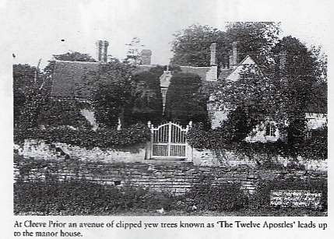

Julia married William Garfield Hiorns from Honeybourne who bought the Manor & its Lands from the Church on the 18th October 1917 & they continued in residence till his death at the Manor In 1921. The Manor was sold & Julia moved in to Mill House which became the possession of the family when they bought the Manor from the Church, along with the Mill by the river. She stayed here till her death in the house on the 28th January 1945
Julia Sold the Manor to Christopher Grey. We do not know much of the history during Chris Greys time but we do know that he sold the land a mill site to Birmingham Anglers in the 1930’s
On 26th March 1945 Christopher Grey sold the Manor & cottages known as Manor Farm to Mr A.E Wiley from Sutton Coldfield, the Chairman of Ansell’s Brewery, for £40,000. This comprised of seven parcels of land and property
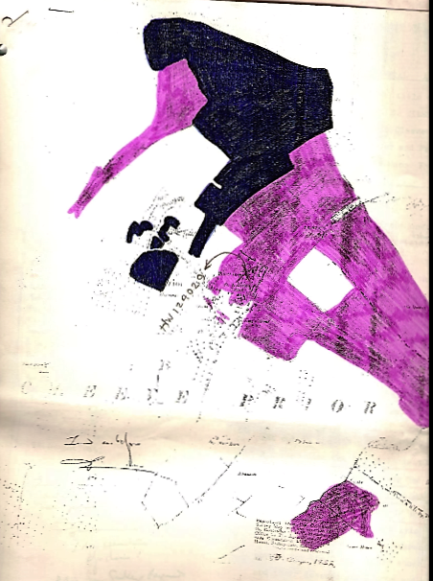

- The purchase covered the Manor and all lands in the Parish of Cleeve Prior and the Parish of Salford Priors [area Pink]
Cleeve Prior
County | No | Description | Area in Acres | Cultivation | Conveyance Dec 1961 to Lloyds  £40k | Mortgaged by Lloyds in 1966 for £12k | Mortgaged by Lloyds in 1969 for £10k
Worcs | 22 | Second Allotment | 11.65 | Arable
Worcs | 23 | The Breach | 12.44 | Arable
Worcs | 41 | Thoughter Ground | 31.499 | Arable | 1 | 1 | 1
Worcs | 98 | The Low Hill | 26.574 | Pasture | 1 | 1 | 1
Worcs | 100 | Far Dead Furlong | 13.13 | Arable | 1 | 1 | 1
Worcs | 144 | Green Dead Furlong | 14.93 | Pasture | 1 | 1 | 1
Worcs | 146 | Farm Buildings road etc. | .85 | Farm Buildings | 1 | 1 | 1
Worcs | 147 | Farm Buildings Yard etc. | .733 | Farm Yard etc. | 1 | 1 | 1
Worcs | Part 148 | Crow Close | 11.90 | Pasture | 1 | 1 | 1
Worcs | 150 | Stack Yard | .39 | Rick Yard | 1 | 1 | 1
Worcs | 151 | Barn & Stack yard | .457 | Rick Yard | 1 | 1 | 1
Worcs | 152 | Pond | .155 | pond | 1 | 1 | 1
Worcs | 153 | Manor House & Buildings | 1.054 | Manor Hse & Blds | 1 | 1 | 1
Worcs | 154 | Garden | .275 | Garden | 1 | 1 | 1
Worcs | 155 | Orchard | 1.374 | Orchard | 1 | 1 | 1
Worcs | 157 | Well Close | 5.364 | Pasture | 1 | 1 | 1
Worcs | Part 161 | 4 cottages & Gardens | .660 | cottages & Gardens | 1 | 1 | 1
Worcs | Part 195 a | Mill Coppice | 2.031 | scrub
Worcs | Part 198 | Hill Ground & Boathouse Site | 6.743 | scrub
Worcs | 219 | Fox Hill | 11.513 | Pasture
Worcs | 221 a | Lock Island | .132 | Scrub
Worcs | 222 | Horse Pleck | 4.144 | Pasture
Worcs | 224 | Part of Millams | 25.364 | Pasture
Worcs | 226 | Fourth Allotment | 7.458 | Pasture
Worcs | 236 | Fox Hill Meadow | 11.095 | Pasture
Worcs | Part 246 | Part of Pasture | 0.31 | Pond
Worcs | 247 | Osier Bed | .310 | Island
Worcs | 197 | Mill & cottages | .247 | Mill
 | Part 135 | Two Cottages & Gardens | .382 | Cottages
Warwick’s  Salford Priors | 23 | Whitley Bed Osiers | .125 | Island

- All the building equipment pasture & arable land described as Kemises Farm [coloured blue]
County | No | Description | Area in Acres | Cultivation | Conveyance Dec 1961 to Lloyds  £40k | Mortgaged by Lloyds in 1966 for £12k | Mortgaged by Lloyds in 1969 for £10k
Worcs | 213 | Lime Kiln | 5.69 | Arable | 1 | 1 | 1
Worcs | 149 | Ran Close | 3.579 | Pasture | 1 | 1 | 1
Worcs | 103 | The Dicken | 11..142 | Arable | 1 | 1 | 1
Worcs | 214 | Seed Ground | 8.618 | Arable | 1 | 1 | 1
Worcs | 105 | Temple Ground | 13.121 | Arable | 1 | 1 | 1
Worcs | 106 | Bidford Ground | 13.392 | Arable | 1
Worcs | 250 | Meadow | 8.910 | Pasture
Worcs | 230 | Meadow | .615 | Pasture
Worcs | 232 | Hurst Leys | .587 | Pasture
Worcs | 233 | Meadow | .619 | Pasture
Worcs | 235 | Meadow | 1.795 | Pasture
Worcs | 220 | Meadow Land | 11.309 | Pasture
Worcs | 231 | Part of Hurst Leys | 2.026 | Pasture
Worcs | 234 | The Leys | 1.894 | Pasture
Worcs | 259 | Avon Meadow | 7.869 | Pasture
Worcs | 260 | Lower Meadow | 15.755 | Pasture
Worcs | 261 | Cleeve Meadow | 4.239 | Pasture
 | 101 | ? | 15.00 |  |  | 1 | 1

- The cottage, garden & outbuildings belonging to the Smithy.

- All the 11.177 acres of land & pasture in the county of Warwickshire, being vineyard

- 43.128 acres of land in the Parish of Salford Priors in 6 parcels

County | No | Description | Area in Acres | Cultivation | Conveyance Dec 1961 to Lloyds  £40k | Mortgaged by Lloyds in 1966 for £12k | Mortgaged by Lloyds in 1969 for £10k
Worcs | 235 | Meadow | 1.795 | Pasture
Worcs | 220 | Meadow Land | 11.309 | Pasture
Worcs | 231 | Part of Hurst Leys | 2.026 | Pasture
Worcs | 234 | The Leys | 1.894 | Pasture
Worcs | 259 | Avon Meadow | 7.869 | Pasture
Worcs | 260 | Lower Meadow | 15.755 | Pasture
Worcs | 261 | Cleeve Meadow | 4.239 | Pasture

- 6.224 acres Meadow & Pasture land situated near Salford Priors in the Parish of Cleeve Prior
- The cottage called Temple Croft & 69.148 acres in the Hamlet of Marlcliffe in the Parish of Bidford
County | No | Description | Area in Acres | Cultivation | Conveyance Dec 1961 to Lloyds  £40k | Mortgaged by Lloyds in 1966 for £12k | Mortgaged by Lloyds in 1969 for £10k
Warwick | 12 | Brook Furlong [Incl Quarry] | 17.89 | Pasture | 1 | 1 | 1
Warwick | 13 | Brook leys | 9.132 | Pasture | 1 | 1 | 1
Warwick | 28 | The Hill Ground | 13.487 | Pasture | 1 | 1 | 1
Warwick | 29 | Long Furlong | 22.237 | Pasture | 1 | 1 | 1
Warwick | Part 31 | Barn Ground | 5.806 | Arable | 1 | 1 | 1
 | 31 a/b | ? |  |  | .833 | .833 | .673
Warwick | 32 | Barn Buildings and Fold Yard | .445 | Barns | 1 | 1 | 1
Warwick | 33 | Temple Cottage & Garden | .151 | Cottage
 |  |  |  |  | 234.551 | 236.159 | 235.809

[Chroniclers note where there is a “1” in the table this notes that the original area was still current, if there is any other figure this is the amount recorded in the document]

On June 1951 Arthur Wiley conveyed to Elizabeth Manning a cottage called Greystones [formerly Temple Croft] and surrounding land an area of 2100 sq. yd.

The Lloyd Brothers bought the Manor & lands on the 15th December 1961.

As part of the deal on the same day they sold off a property, which was, 1 The Green to Robert & Elaine Milward

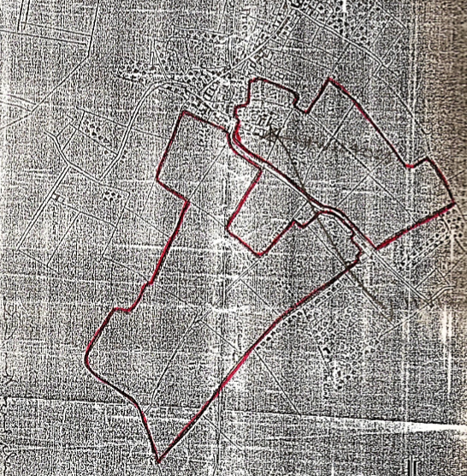

We can see from the picture below the layout of the Manor & farm at this time

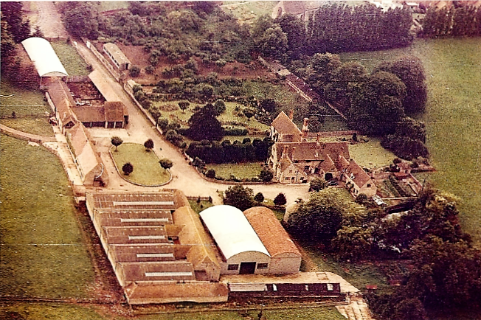

Bert Lloyd, the surviving member of the Lloyd family, subsequently sold further properties & lands as follows:
- 29th April 1983 plot 3 Manor Court to Brian Richard Grubb
- 20th December 1983 plots 1& 2 Manor Court to Brian Richard Grubb
- 31st May 1985 plots 4,5 & 6 Manor Court to Brian Richard Grubb
- 24th June 1987, a plot of land as an extension to the church yard of St Andrews Churchyard Cleeve Prior
- 30th October 1987 165.77 acres of land to the Bowen family

- On the 28th of April 1989 the executors of the Lloyd estate sold the Manor and surrounding lands,36.68 acres in total to Barrie & Anita Homer, who then developed the site as we see it today

